UNDER EMBARGO UNTIL 00:01AM 15TH NOVEMBER 2017

RED KITE TOURING PARK NAMED AA CAMPSITE OF THE YEAR
FOR WALES

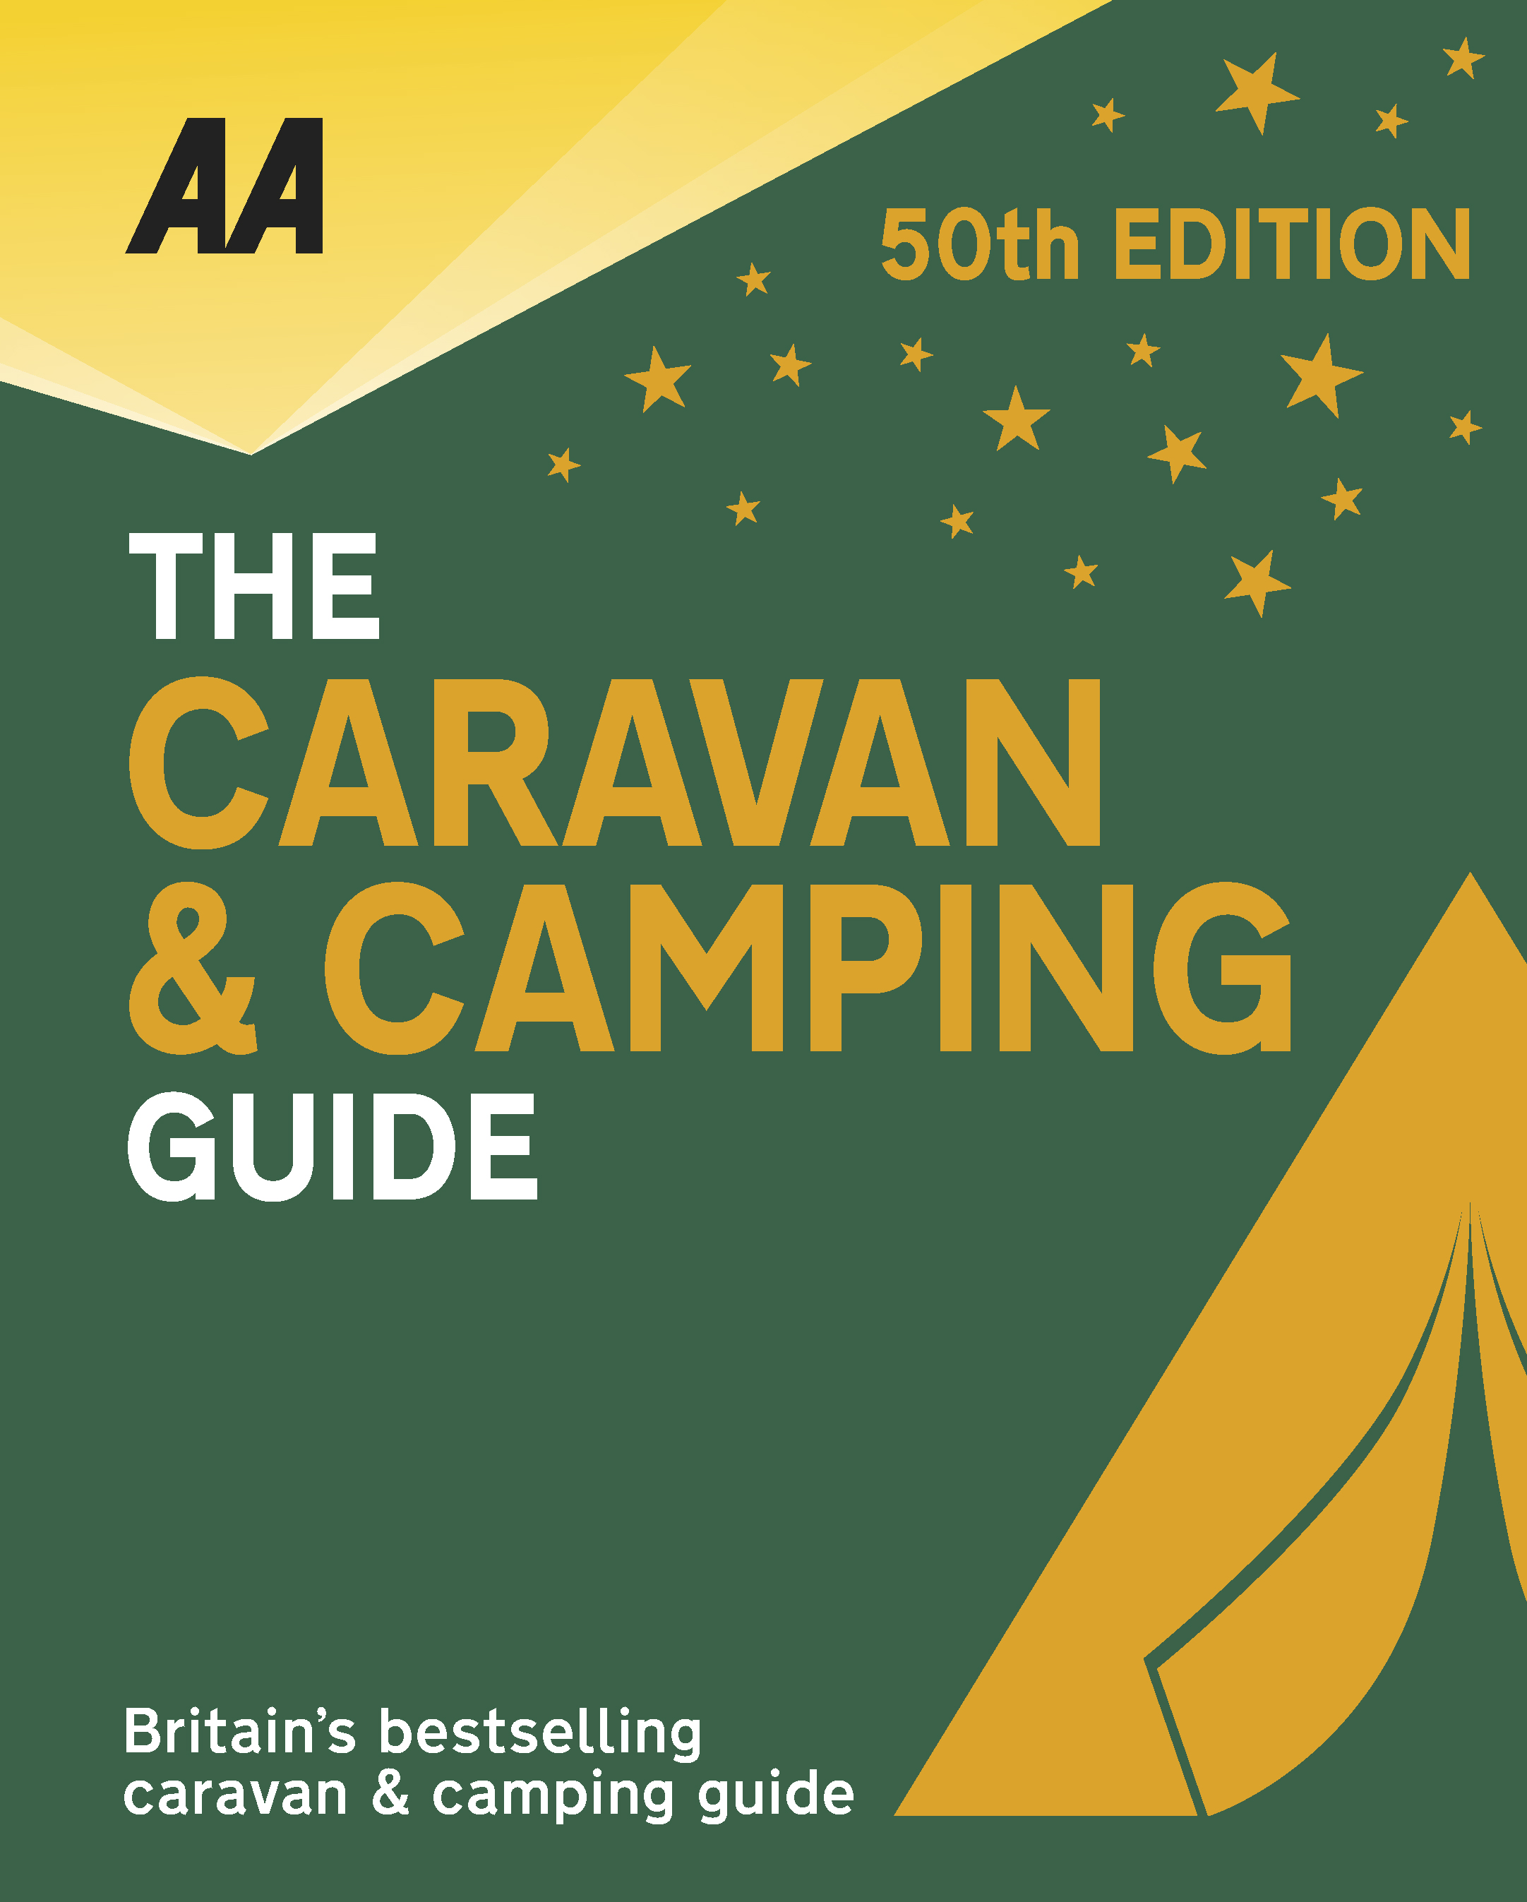
The very best spots for British caravanning and camping have been revealed today as the AA announce the winners of the AA Caravan and Camping Awards 2018. Amongst those celebrating is Red Kite Touring Park in Llanidloes, Powys, winners of AA Campsite of the Year for Wales 2018.

Brexit and the fall in the value of the pound has helped contribute to the rise of glamping and luxury options available, helping to ensure these camping and caravanning sites remain firm family favourites for holiday destinations. More and more sites now provide the likes of luxury yurts and huts in addition to the more traditional family holiday options.

Inspired landscaping at this newly developed and superbly situated park, which opened in 2016, has created an excellent leisure destination that is within easy walking distance of, Llanidloes. An adults-only site, Red Kite Touring Park benefits from clever terracing of the well-spaced pitches, which are large and fully serviced, and include green fluid waste and TV hook-up; a motorhome service area is also available for non-green waste disposal and water top-ups. Optimum privacy is assured due to the well-considered pitch density, along with maturing hedge- and shrub-planting; all benefit from superb country views.
A combination of both neat and wild areas provides the perfect habitat for indigenous flora and fauna, and the lower areas include two lakes where all forms of wildlife, including newts and birds, can be seen. A combined reception and shop, selling essentials and local produce, is located by the security barrier and CCTV point. The purpose-built and large amenity block adorned with pretty seasonal hanging baskets, blends perfectly with the surrounding countryside − inside, the decor is stylish, and there’s underfloor heating, excellent fixtures and fittings and generous privacy options for both men and women.

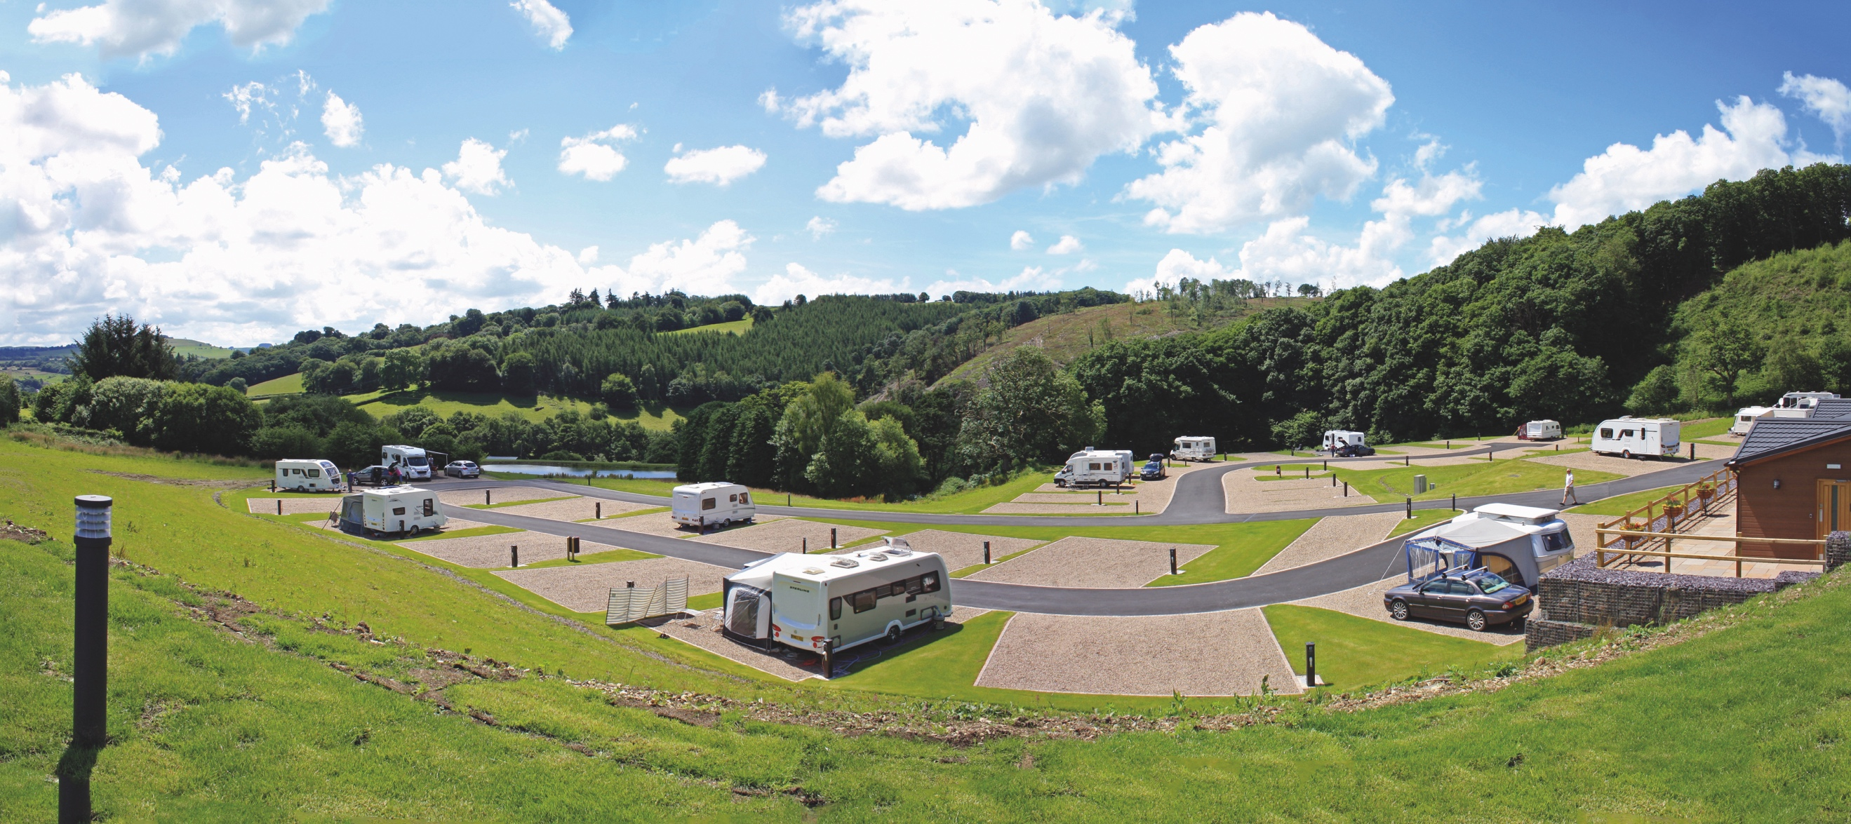
All winners will feature in the 50th Anniversary Edition of the AA Caravanning and Camping Guide. Each of the 800 sites included in the guide have been visited by one of the AA’s experienced Campsite Inspectors, grading sites from one to five Pennants, based on their facilities and hospitality. Only the parks of the very highest standard are awarded the coveted Gold Pennant award. Each entry within the guide includes location, ratings, contact details, directions, prices, opening times, facilities and a description to help select the right site for your needs.
The AA Caravan and Camping Guide 2018 is available from amazon.
The winners of the 2018 AA Caravan and Camping Awards are:
AA CAMPSITE OF THE YEAR 2018
ENGLAND AND OVERALL WINNER: Old Oaks Touring Park, Glastonbury, Somerset
SCOTLAND: Trossachs Holiday Park, Aberfoyle, Stirling
WALES: Red Kite Touring Park, Llanidloes, Powys

AA REGIONAL CAMPSITES OF THE YEAR 2018
SOUTH WEST: Trevalgan Touring Park, St Ives, Cornwall
SOUTH EAST: Whitefield Forest Touring Park, Ryde, Isle of Wight
HEART OF ENGLAND: Cakes & Ale, Leiston, Suffolk
NORTH WEST: Skelwith Fold Caravan Park, Ambleside, Cumbria
NORTH EAST: Herding Hill Farm, Haltwhistle, Northumberland

HOLIDAY CENTRE OF THE YEAR 2018
Woodside Bay Lodge Retreat, Wooton Bridge, Isle of Wight

MOST IMPROVED CAMPSITE OF THE YEAR 2018
Wheathill Touring Park, Wheathill, Shropshire

SMALL CAMPSITE OF THE YEAR
Seal Shore Camping & Touring Site, Kildonan, Isle of Arran

GLAMPING SITE OF THE YEAR
Runach Arainn Glamping, Kilmory, Isle of Arran

***Ends***
For press enquires or more information please contact Chris Webb on 01256 491521 or Chris.Webb@theAA.com

