UNDER EMBARGO UNTIL 00:01AM 15TH NOVEMBER 2017

TREVALGAN TOURING PARK NAMED AA CAMPSITE OF THE YEAR
FOR THE SOUTH WEST

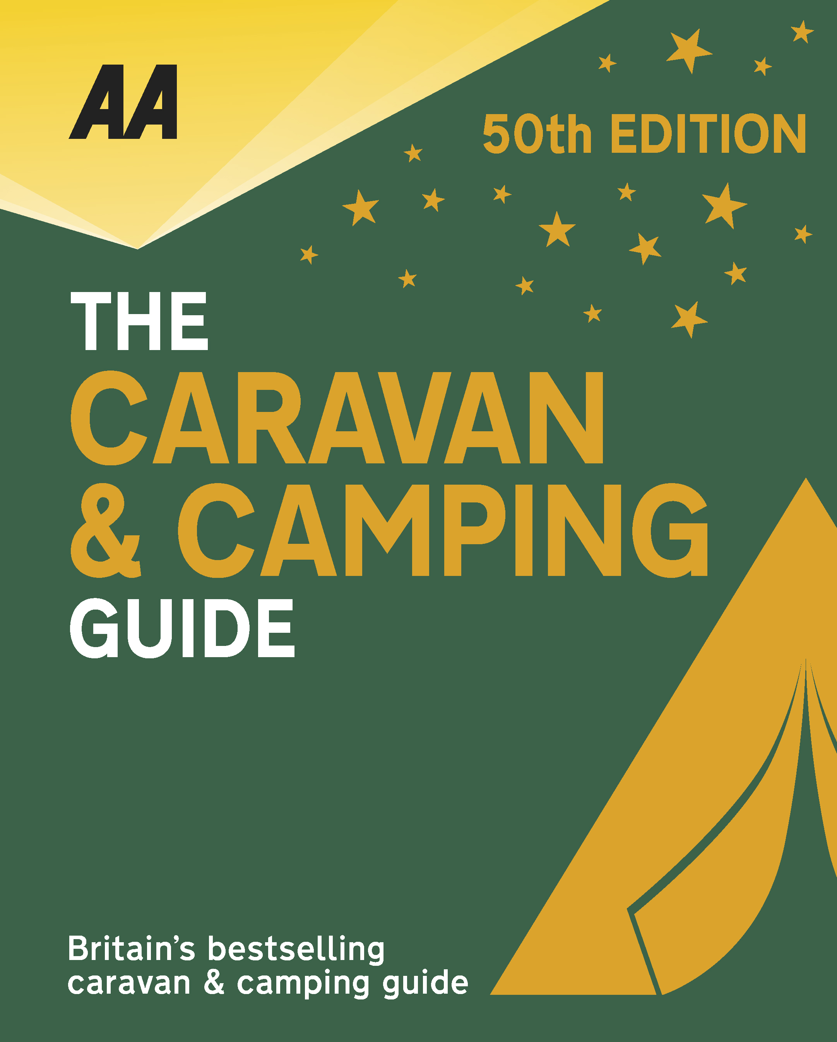
The very best spots for British caravanning and camping have been revealed today as the AA announce the winners of the AA Caravan and Camping Awards 2018. Amongst those celebrating is Trevalgan Touring Park in St Ives, Cornwall, winners of AA Campsite of the Year for the South West 2018.

Brexit and the fall in the value of the pound has helped contribute to the rise of glamping and luxury options available, helping to ensure these camping and caravanning sites remain firm family favourites for holiday destinations. More and more sites now provide the likes of luxury yurts and huts in addition to the more traditional family holiday options.

The 2016 winners of our Most Improved Campsite of the Year award fully deserve this coveted regional accolade. Hands-on owners Annette and Neil Osborne have continued to invest and improve the facilities and standards, totally transforming this popular holiday destination on the Cornish coast over the past four years. Beautifully landscaped and with stunning views across farmland to the sea, it is situated between St Ives and Zennor on the wild and rugged Penwith peninsula and is now one of the best parks in the area. Guests can expect very high levels of customer care, excellent upmarket toilet facilities, replete with family rooms and underfloor heating, spacious pitches offering both privacy and shelter, and a smart wood-clad reception and shop where freshly baked pastries and bread are available each morning. It’s the little details that set Trevalgan apart, for example, the two half-sized baths for toddlers, the unisex/family rooms where you can adjust the water pressure for children, the wet suit wash area for keeping sand out of the facility block, and the charity book exchange. Combined with the fabulous location, this is what makes the park so special and why people return year after year.

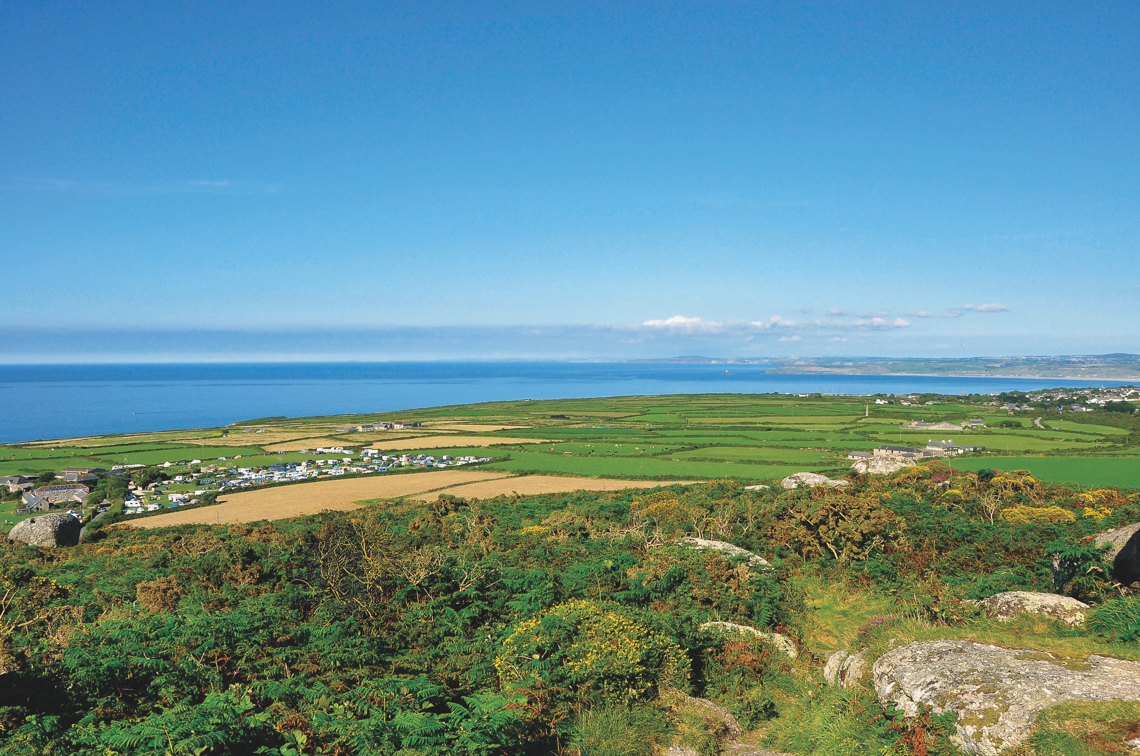
All winners will feature in the 50th Anniversary Edition of the AA Caravanning and Camping Guide. Each of the 800 sites included in the guide have been visited by one of the AA’s experienced Campsite Inspectors, grading sites from one to five Pennants, based on their facilities and hospitality. Only the parks of the very highest standard are awarded the coveted Gold Pennant award. Each entry within the guide includes location, ratings, contact details, directions, prices, opening times, facilities and a description to help select the right site for your needs.
The AA Caravan and Camping Guide 2018 is available from amazon.
The winners of the 2018 AA Caravan and Camping Awards are:
AA CAMPSITE OF THE YEAR 2018
ENGLAND AND OVERALL WINNER: Old Oaks Touring Park, Glastonbury, Somerset
SCOTLAND: Trossachs Holiday Park, Aberfoyle, Stirling
WALES: Red Kite Touring Park, Llanidloes, Powys

AA REGIONAL CAMPSITES OF THE YEAR 2018
SOUTH WEST: Trevalgan Touring Park, St Ives, Cornwall
SOUTH EAST: Whitefield Forest Touring Park, Ryde, Isle of Wight
HEART OF ENGLAND: Cakes & Ale, Leiston, Suffolk
NORTH WEST: Skelwith Fold Caravan Park, Ambleside, Cumbria
NORTH EAST: Herding Hill Farm, Haltwhistle, Northumberland

HOLIDAY CENTRE OF THE YEAR 2018
Woodside Bay Lodge Retreat, Wooton Bridge, Isle of Wight

MOST IMPROVED CAMPSITE OF THE YEAR 2018
Wheathill Touring Park, Wheathill, Shropshire

SMALL CAMPSITE OF THE YEAR
Seal Shore Camping & Touring Site, Kildonan, Isle of Arran

GLAMPING SITE OF THE YEAR
Runach Arainn Glamping, Kilmory, Isle of Arran

***Ends***
For press enquires or more information please contact Chris Webb on 01256 491521 or Chris.Webb@theAA.com

