UNDER EMBARGO UNTIL 00:01AM 15TH NOVEMBER 2017

WHITEFIELD FOREST TOURING PARK NAMED AA CAMPSITE OF THE YEAR FOR THE SOUTH WEST

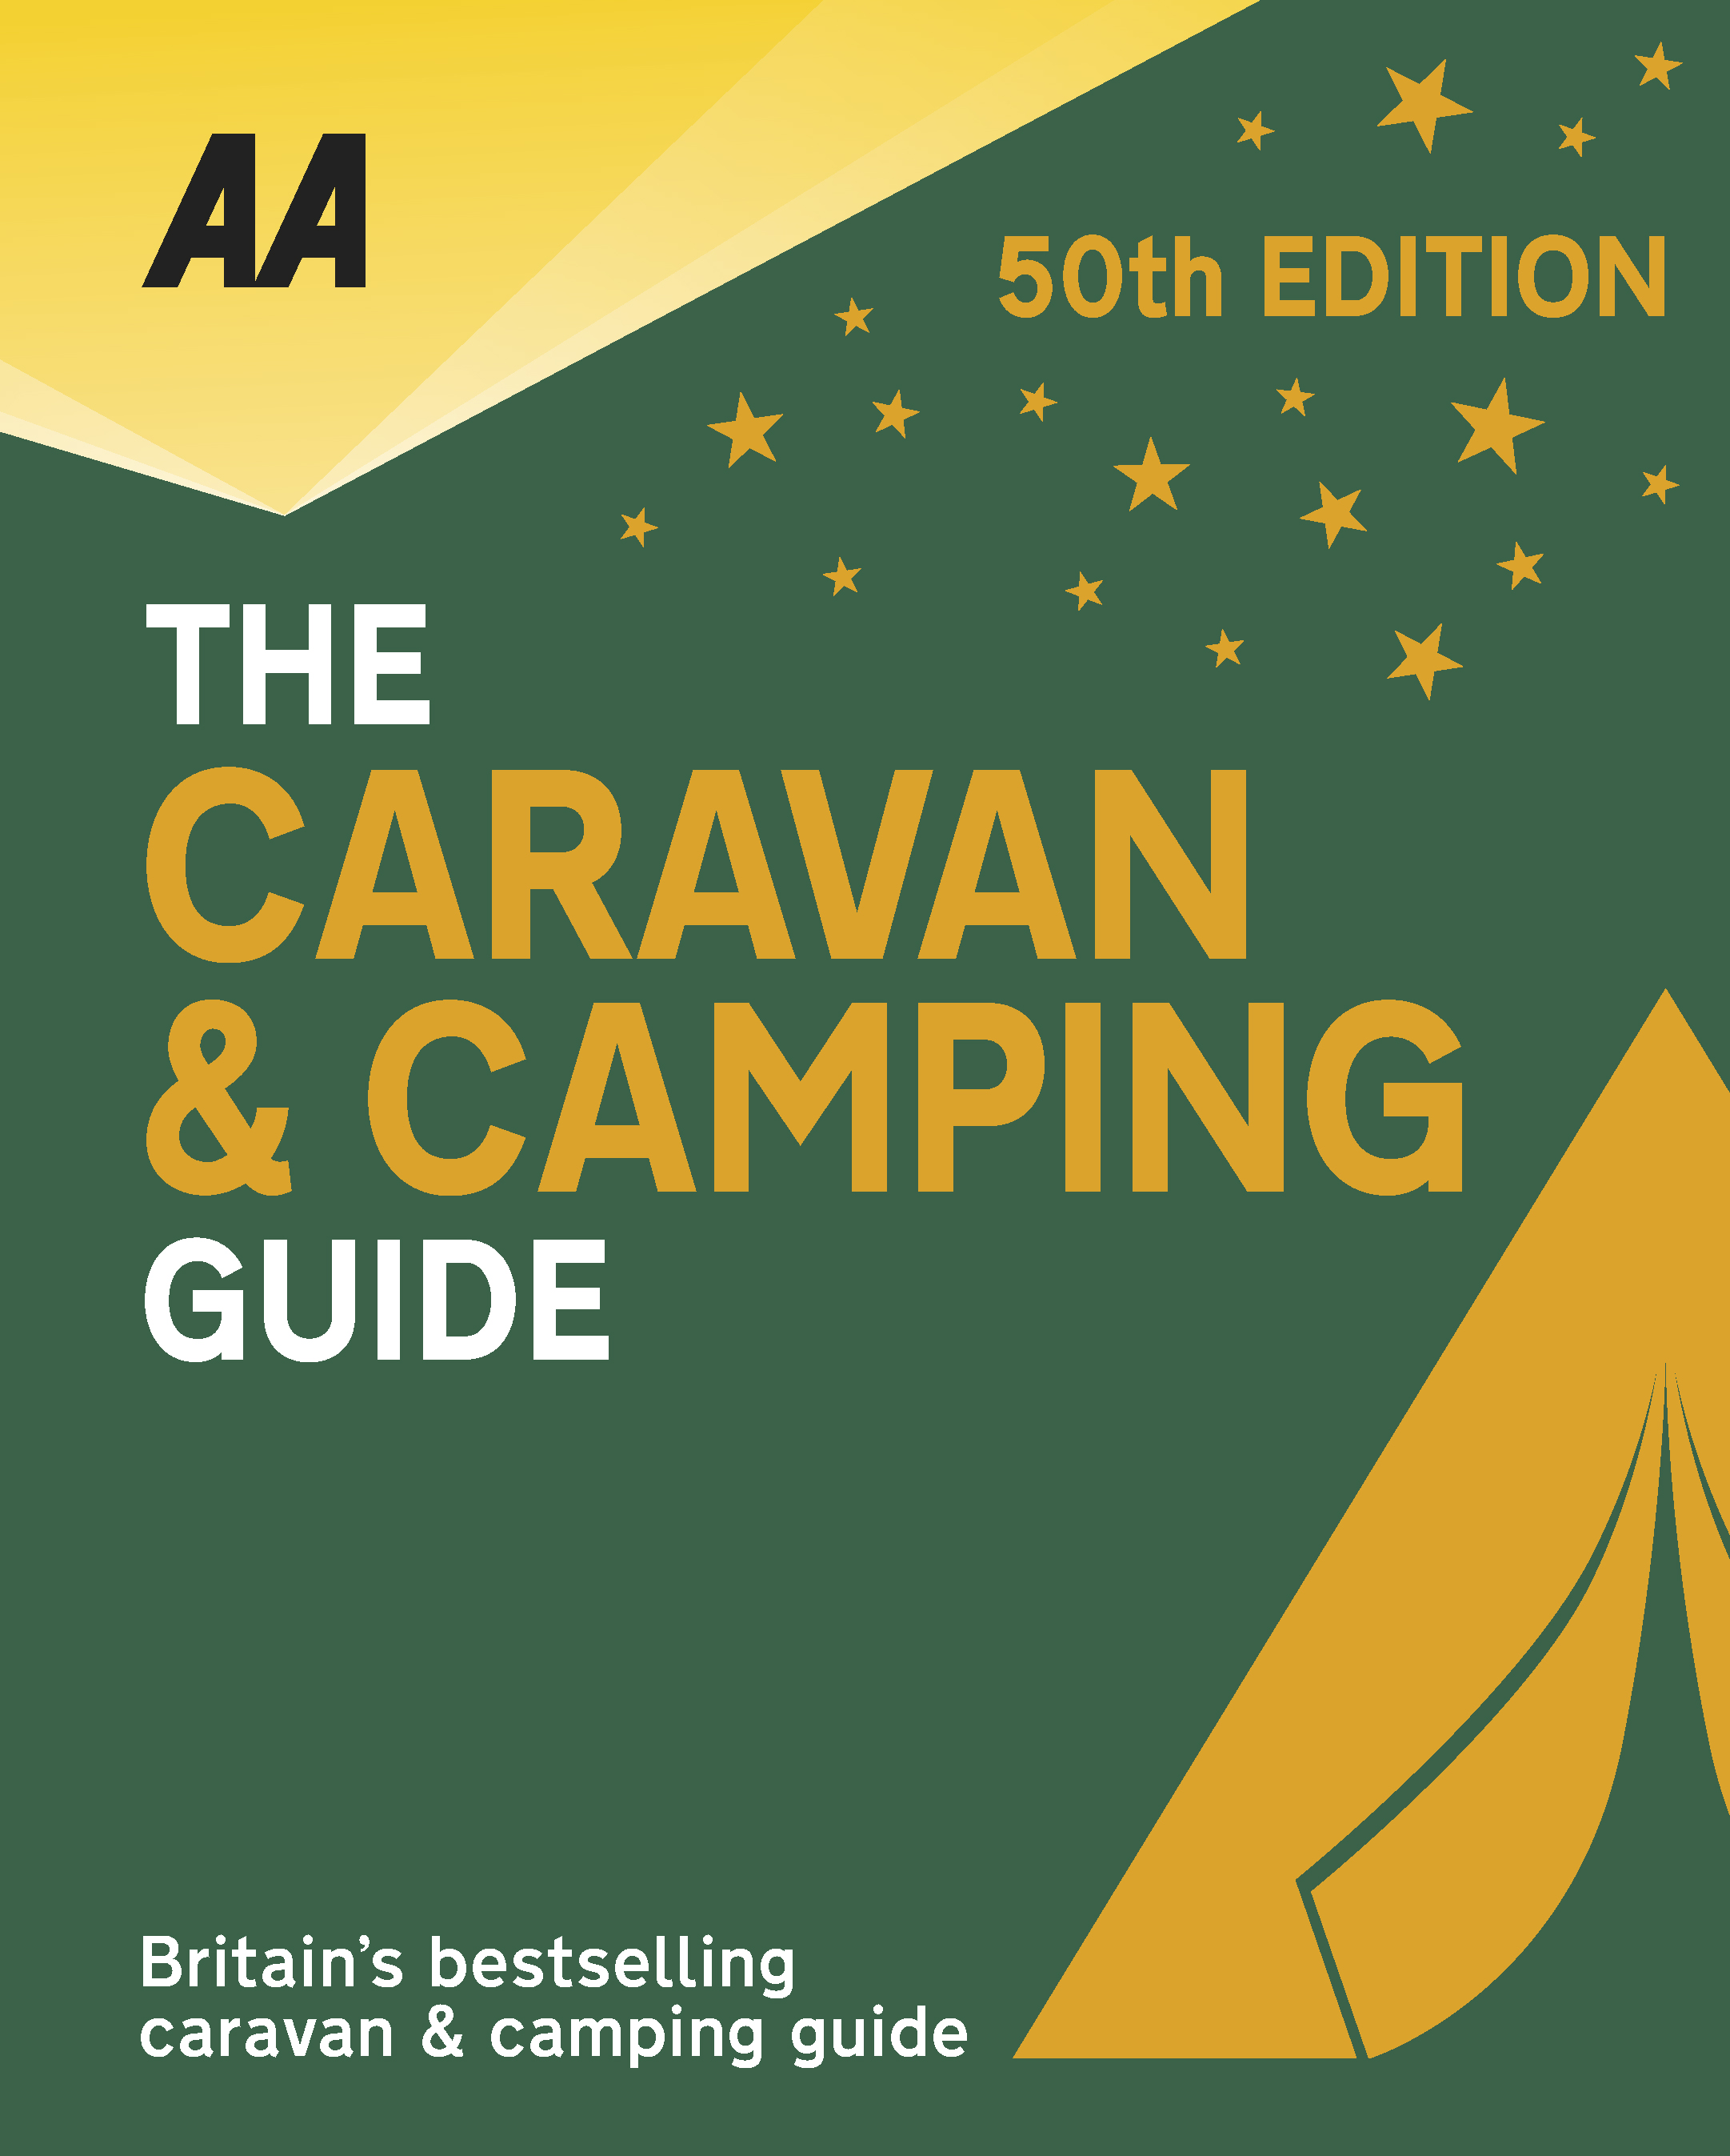
The very best spots for British caravanning and camping have been revealed today as the AA announce the winners of the AA Caravan and Camping Awards 2018. Amongst those celebrating is Whitefield Forest Touring Park in Ryde, Isle of Wight, winners of AA Campsite of the Year for the South East 2018.

Brexit and the fall in the value of the pound has helped contribute to the rise of glamping and luxury options available, helping to ensure these camping and caravanning sites remain firm family favourites for holiday destinations. More and more sites now provide the likes of luxury yurts and huts in addition to the more traditional family holiday options.

Set in a natural forest and beautifully laid out to take full advantage of the undulating forest environment, this top-class park offers a wide variety of spacious pitches, including 26 fully serviced pitches. A new area with huge hardstanding pitches and good privacy was created in 2017 in a secluded section of the park and this spot has proved very popular. The excellent landscaping and the meandering roadway through the forest enable the pitches to be perfectly placed to take full advantage of the natural setting. All buildings are clad in wood and blend in well with the feel of the park. The superb toilet and shower block has been further improved for 2017, with extra family wet rooms and new laundry area, and the general standards of cleanliness are exceptional. There’s a superb nature walk around the park, which includes a hide to watch the wildlife, and red squirrels can be spotted throughout the park. Activities such as foraging, bushcraft and cycle rides for children and adults are also available at certain times of the year. Whitefield Forest is a very tranquil place to stay on the island and you can expect high levels of customer care from hands-on owners Simon and Pat Glover.

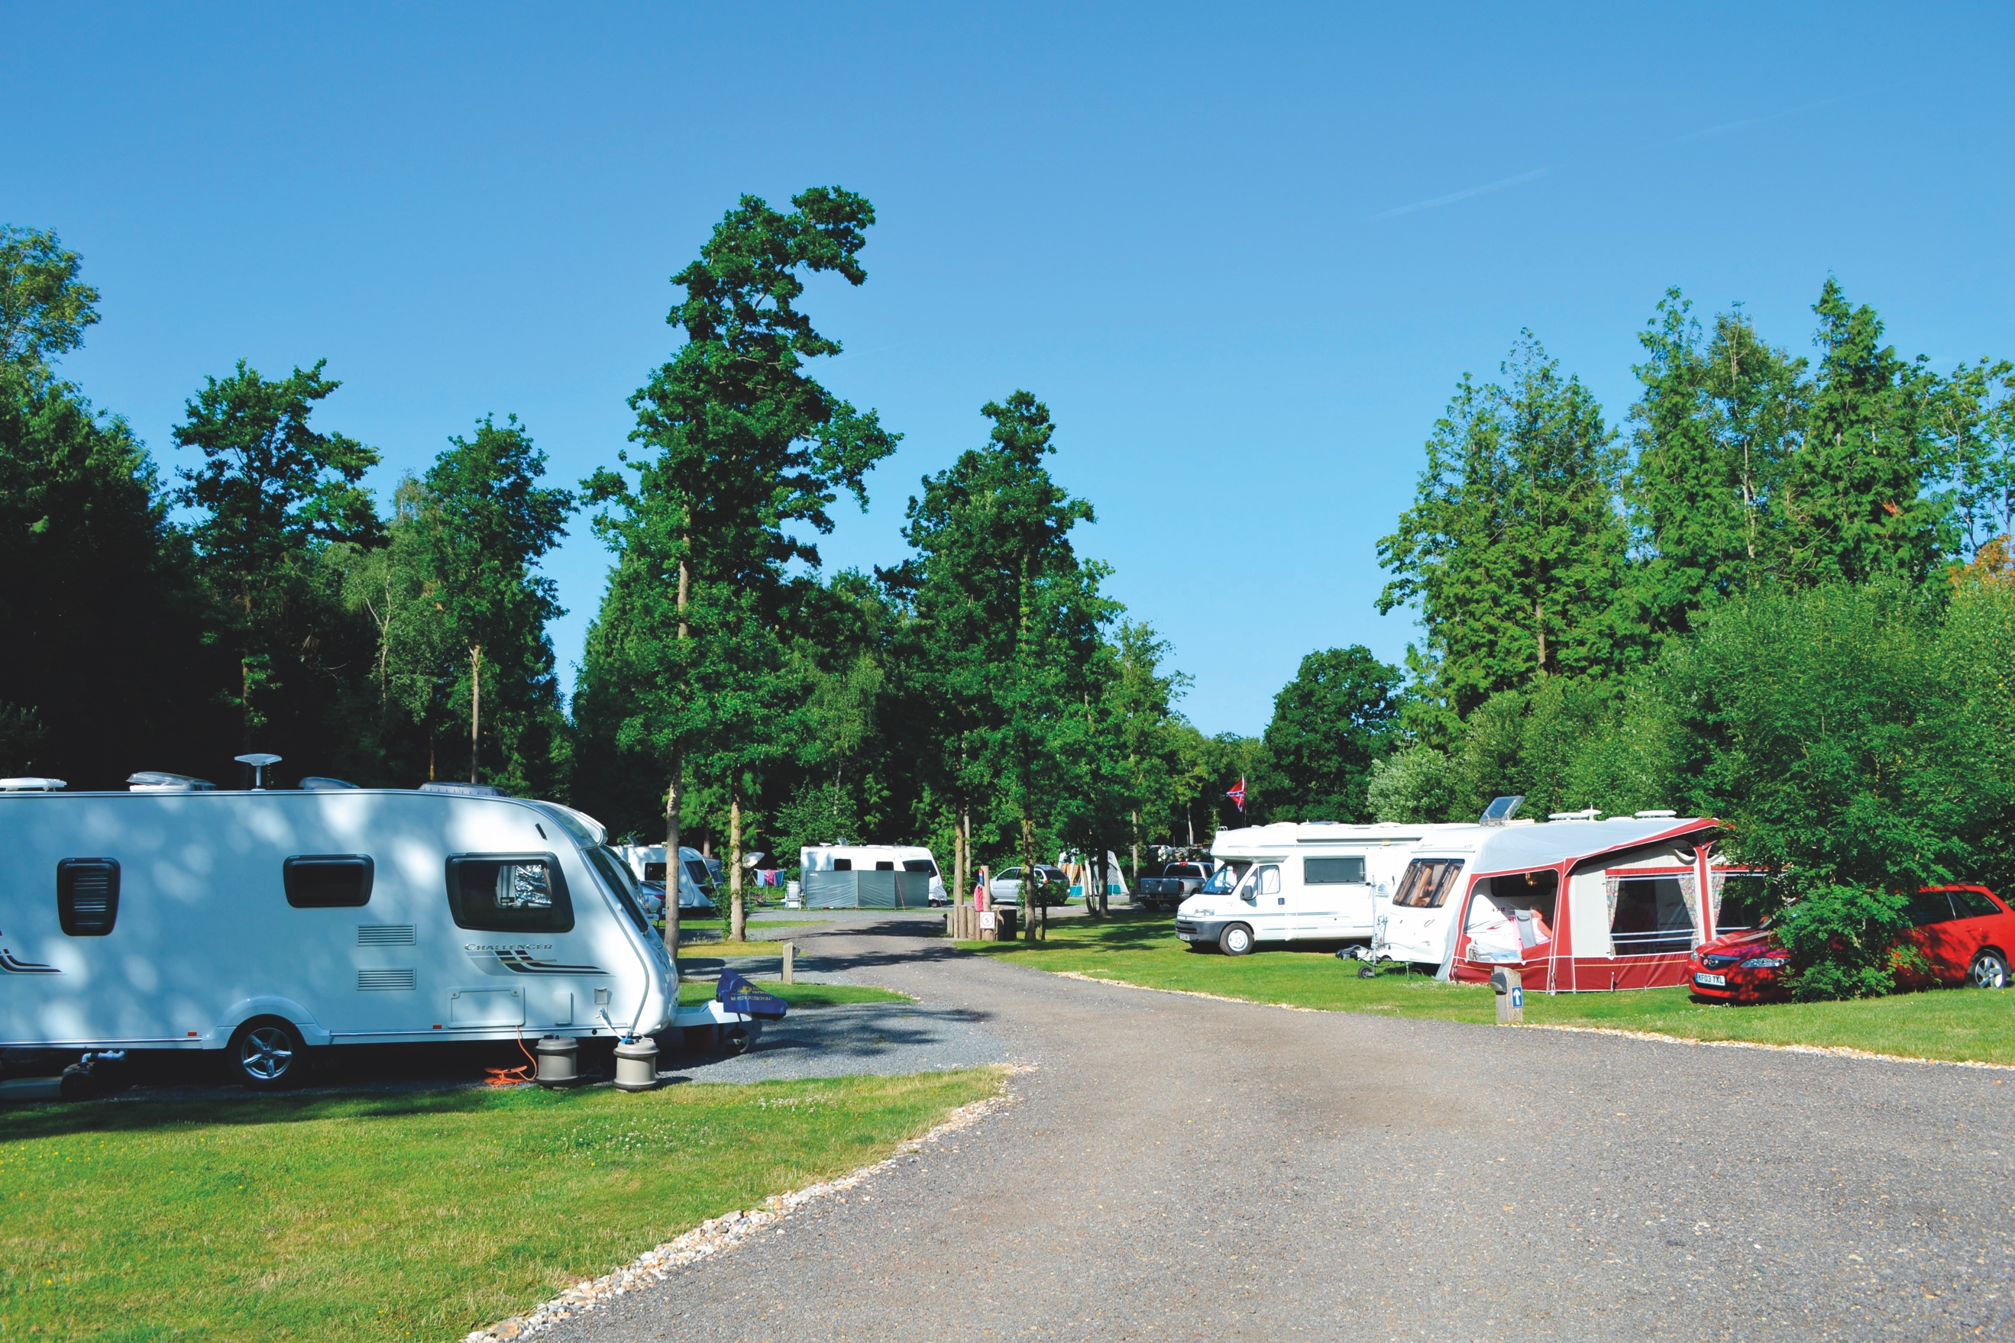
All winners will feature in the 50th Anniversary Edition of the AA Caravanning and Camping Guide. Each of the 800 sites included in the guide have been visited by one of the AA’s experienced Campsite Inspectors, grading sites from one to five Pennants, based on their facilities and hospitality. Only the parks of the very highest standard are awarded the coveted Gold Pennant award. Each entry within the guide includes location, ratings, contact details, directions, prices, opening times, facilities and a description to help select the right site for your needs.
The AA Caravan and Camping Guide 2018 is available from amazon.
The winners of the 2018 AA Caravan and Camping Awards are:
AA CAMPSITE OF THE YEAR 2018
ENGLAND AND OVERALL WINNER: Old Oaks Touring Park, Glastonbury, Somerset
SCOTLAND: Trossachs Holiday Park, Aberfoyle, Stirling
WALES: Red Kite Touring Park, Llanidloes, Powys

AA REGIONAL CAMPSITES OF THE YEAR 2018
SOUTH WEST: Trevalgan Touring Park, St Ives, Cornwall
SOUTH EAST: Whitefield Forest Touring Park, Ryde, Isle of Wight
HEART OF ENGLAND: Cakes & Ale, Leiston, Suffolk
NORTH WEST: Skelwith Fold Caravan Park, Ambleside, Cumbria
NORTH EAST: Herding Hill Farm, Haltwhistle, Northumberland

HOLIDAY CENTRE OF THE YEAR 2018
Woodside Bay Lodge Retreat, Wooton Bridge, Isle of Wight

MOST IMPROVED CAMPSITE OF THE YEAR 2018
Wheathill Touring Park, Wheathill, Shropshire

SMALL CAMPSITE OF THE YEAR
Seal Shore Camping & Touring Site, Kildonan, Isle of Arran

GLAMPING SITE OF THE YEAR
Runach Arainn Glamping, Kilmory, Isle of Arran

***Ends***
For press enquires or more information please contact Chris Webb on 01256 491521 or Chris.Webb@theAA.com

