UNDER EMBARGO UNTIL 00:01AM 15TH NOVEMBER 2017

SEAL SHORE CAMPING & TOURING SITE NAMED AA SMALL CAMPSITE OF THE YEAR

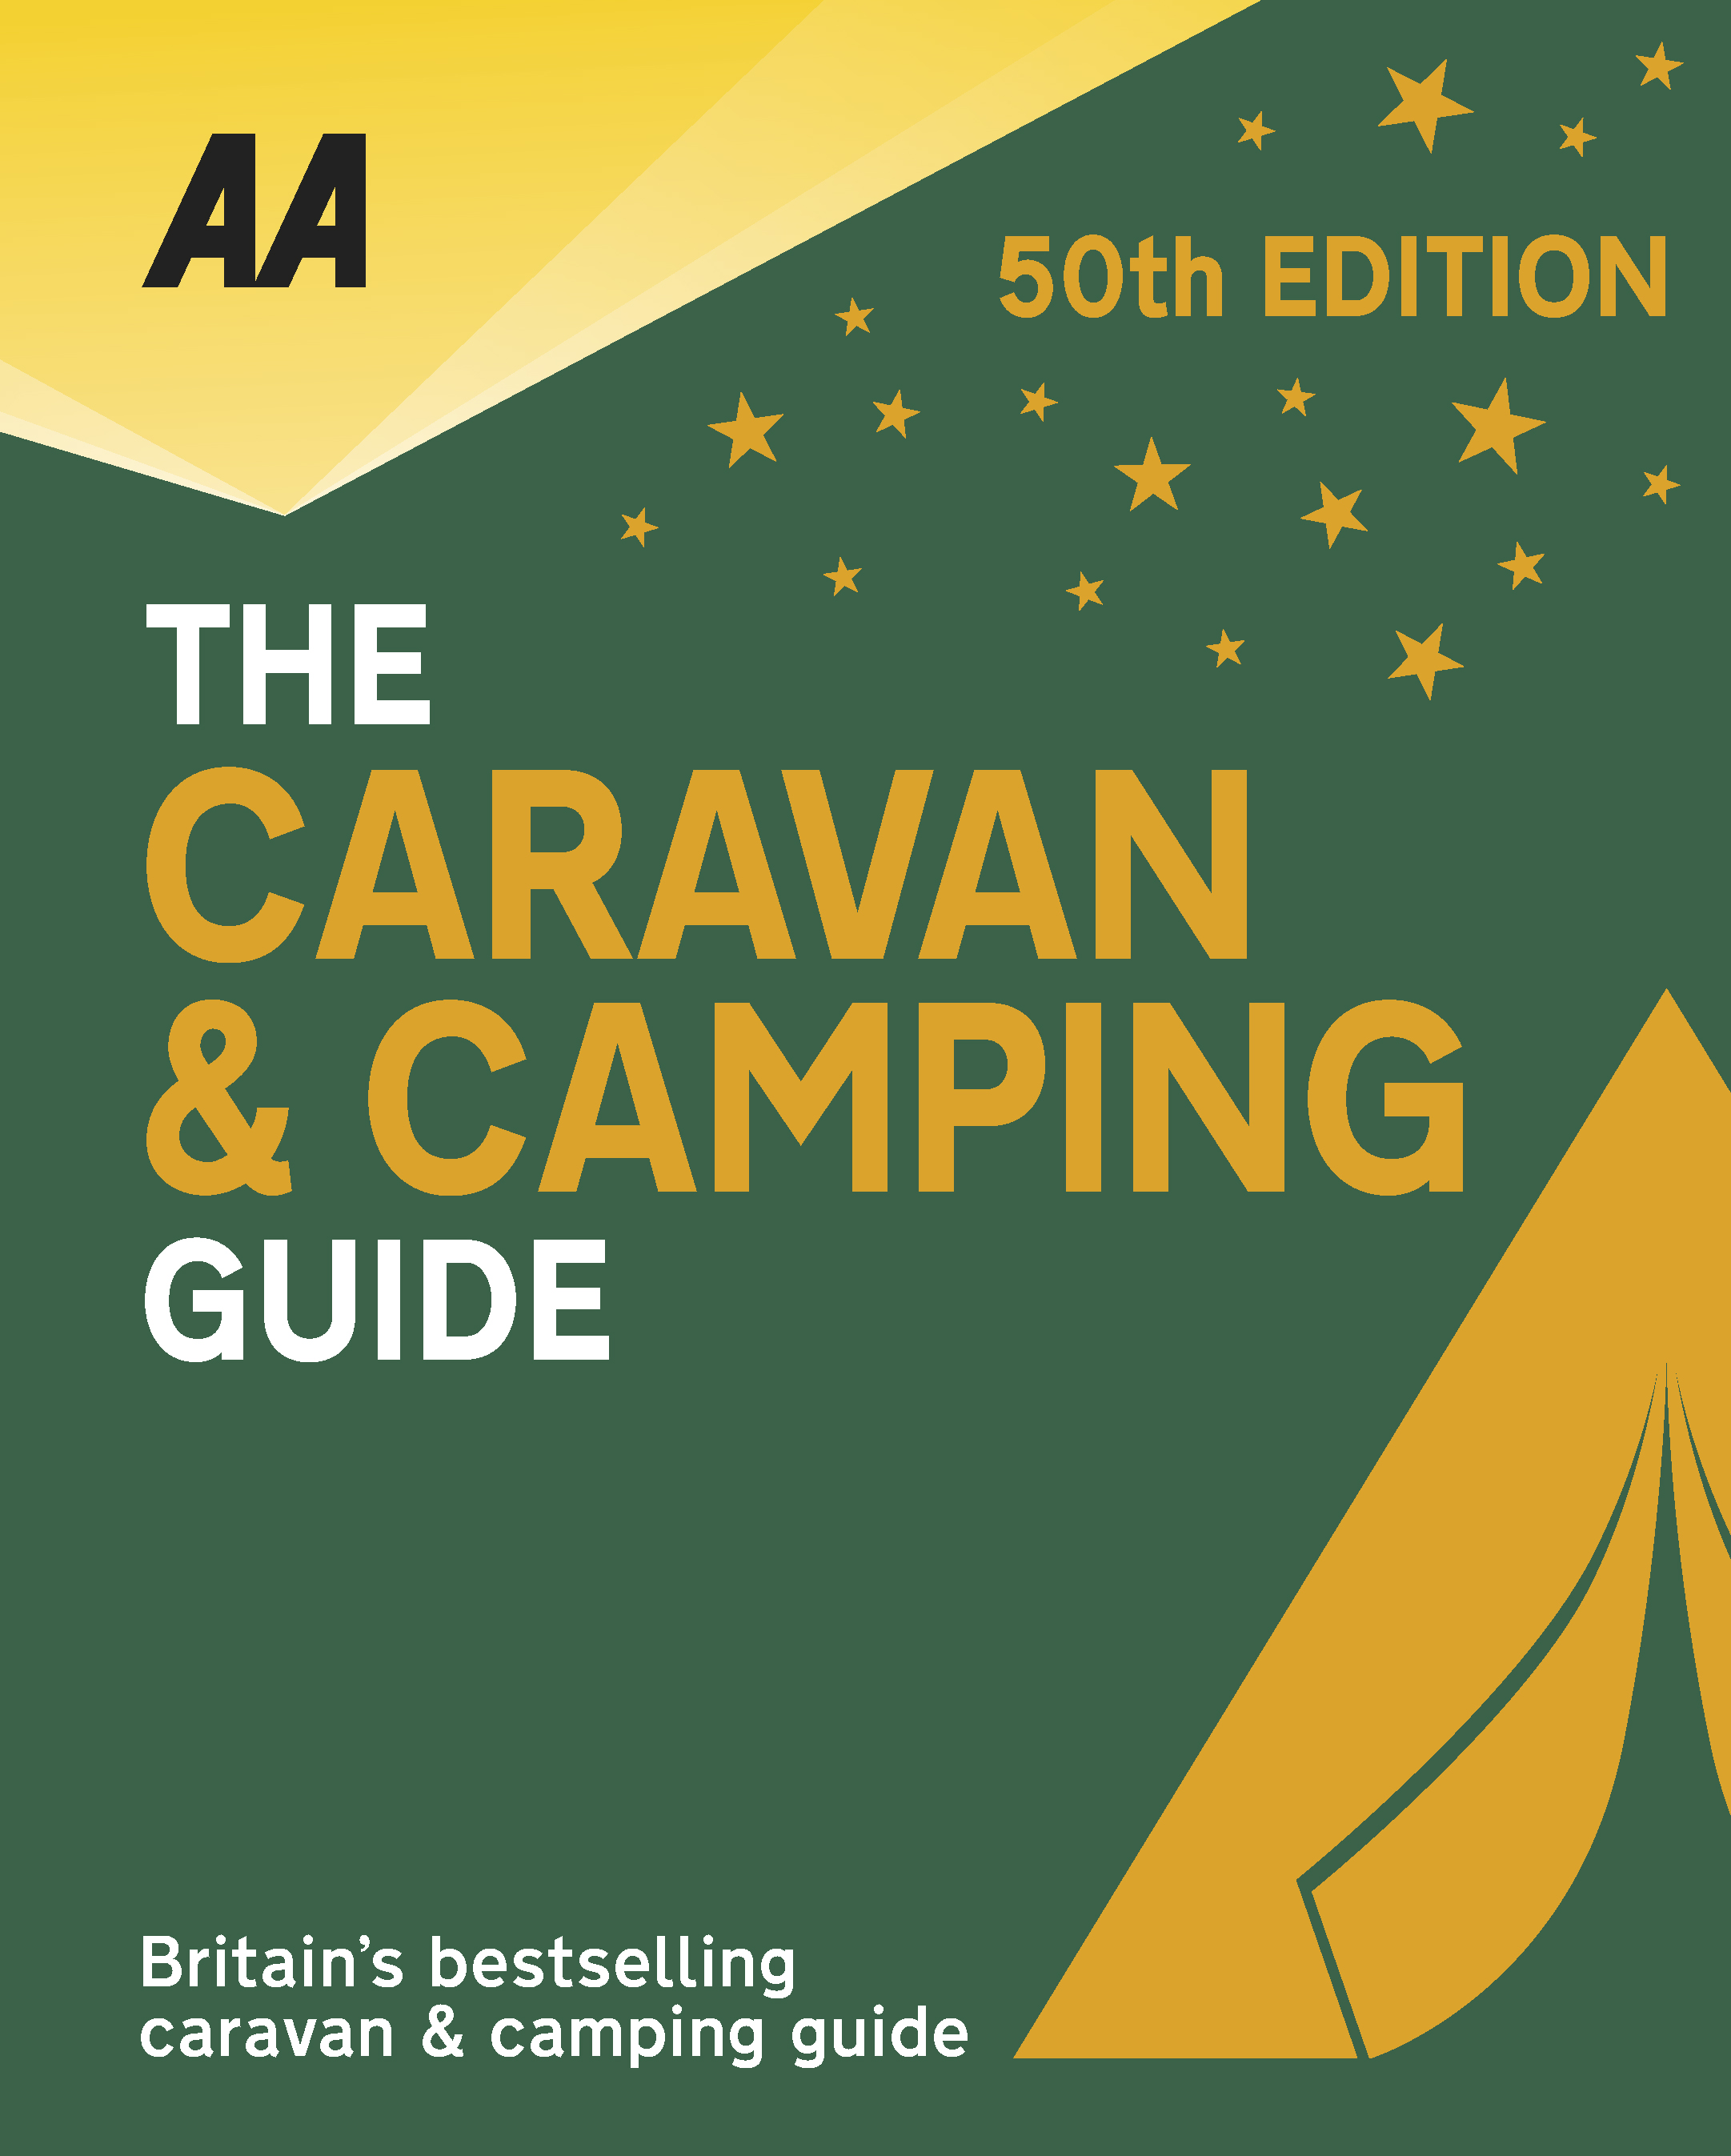
The very best spots for British caravanning and camping have been revealed today as the AA announce the winners of the AA Caravan and Camping Awards 2018. Amongst those celebrating is Seal Shore Camping and Touring Site in Kildonan, Isle of Arran, winners of AA Small Campsite of the Year 2018.

Brexit and the fall in the value of the pound has helped contribute to the rise of glamping and luxury options available, helping to ensure these camping and caravanning sites remain firm family favourites for holiday destinations. More and more sites now provide the likes of luxury yurts and huts in addition to the more traditional family holiday options.

On the south coast of Arran and only 12 miles from the ferry at Brodick, this is a peaceful, family-run site with direct access to a sandy beach. There are fabulous views across the water to Pladda Island and Ailsa Craig. There’s an abundance of wildlife too. Our inspector enjoyed watching seals by the shore when he arrived and otters with their young during his stay – all can easily be seen from the pitches. This beautiful get-away-from-it-all location, understandably, is exceptionally popular, with many returning customers – it’s essential to book to secure one of the 40 pitches. Motorhomes and caravans share the centre of the park, tents are pitched on the periphery and campervans have prime shorefront pitches looking directly towards the Ayrshire coast. The resident owner, also a registered fisherman, sells fresh lobsters and crabs, and on request will give fishing lessons on a small, privately owned lochan. There is an undercover barbecue, campers’ kitchen, a day room with TV, and an excellent toilet block, plus two wooden pods, two gypsy caravans and a lovely shepherd’s hut for hire. Maurice and Teresa Deighton have created a very special small campsite in a stunning location.
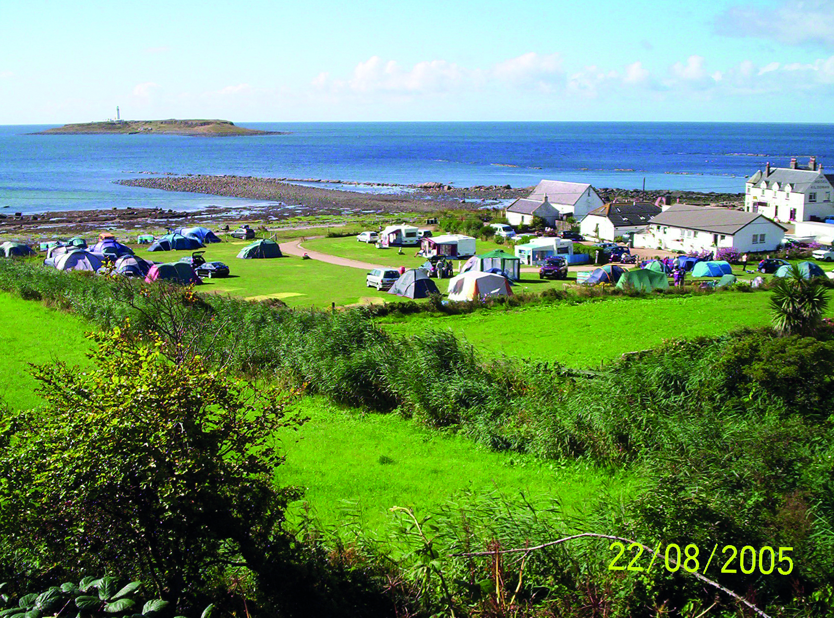
All winners will feature in the 50th Anniversary Edition of the AA Caravanning and Camping Guide. Each of the 800 sites included in the guide have been visited by one of the AA’s experienced Campsite Inspectors, grading sites from one to five Pennants, based on their facilities and hospitality. Only the parks of the very highest standard are awarded the coveted Gold Pennant award. Each entry within the guide includes location, ratings, contact details, directions, prices, opening times, facilities and a description to help select the right site for your needs.
The AA Caravan and Camping Guide 2018 is available from amazon.
The winners of the 2018 AA Caravan and Camping Awards are:
AA CAMPSITE OF THE YEAR 2018
ENGLAND AND OVERALL WINNER: Old Oaks Touring Park, Glastonbury, Somerset
SCOTLAND: Trossachs Holiday Park, Aberfoyle, Stirling
WALES: Red Kite Touring Park, Llanidloes, Powys

AA REGIONAL CAMPSITES OF THE YEAR 2018
SOUTH WEST: Trevalgan Touring Park, St Ives, Cornwall
SOUTH EAST: Whitefield Forest Touring Park, Ryde, Isle of Wight
HEART OF ENGLAND: Cakes & Ale, Leiston, Suffolk
NORTH WEST: Skelwith Fold Caravan Park, Ambleside, Cumbria
NORTH EAST: Herding Hill Farm, Haltwhistle, Northumberland

HOLIDAY CENTRE OF THE YEAR 2018
Woodside Bay Lodge Retreat, Wooton Bridge, Isle of Wight

MOST IMPROVED CAMPSITE OF THE YEAR 2018
Wheathill Touring Park, Wheathill, Shropshire

SMALL CAMPSITE OF THE YEAR
Seal Shore Camping & Touring Site, Kildonan, Isle of Arran

GLAMPING SITE OF THE YEAR
Runach Arainn Glamping, Kilmory, Isle of Arran

***Ends***
For press enquires or more information please contact Chris Webb on 01256 491521 or Chris.Webb@theAA.com

