UNDER EMBARGO UNTIL 00:01AM 15TH NOVEMBER 2017

TROSSACHS HOLIDAY PARK NAMED AA CAMPSITE OF THE YEAR
FOR SCOTLAND

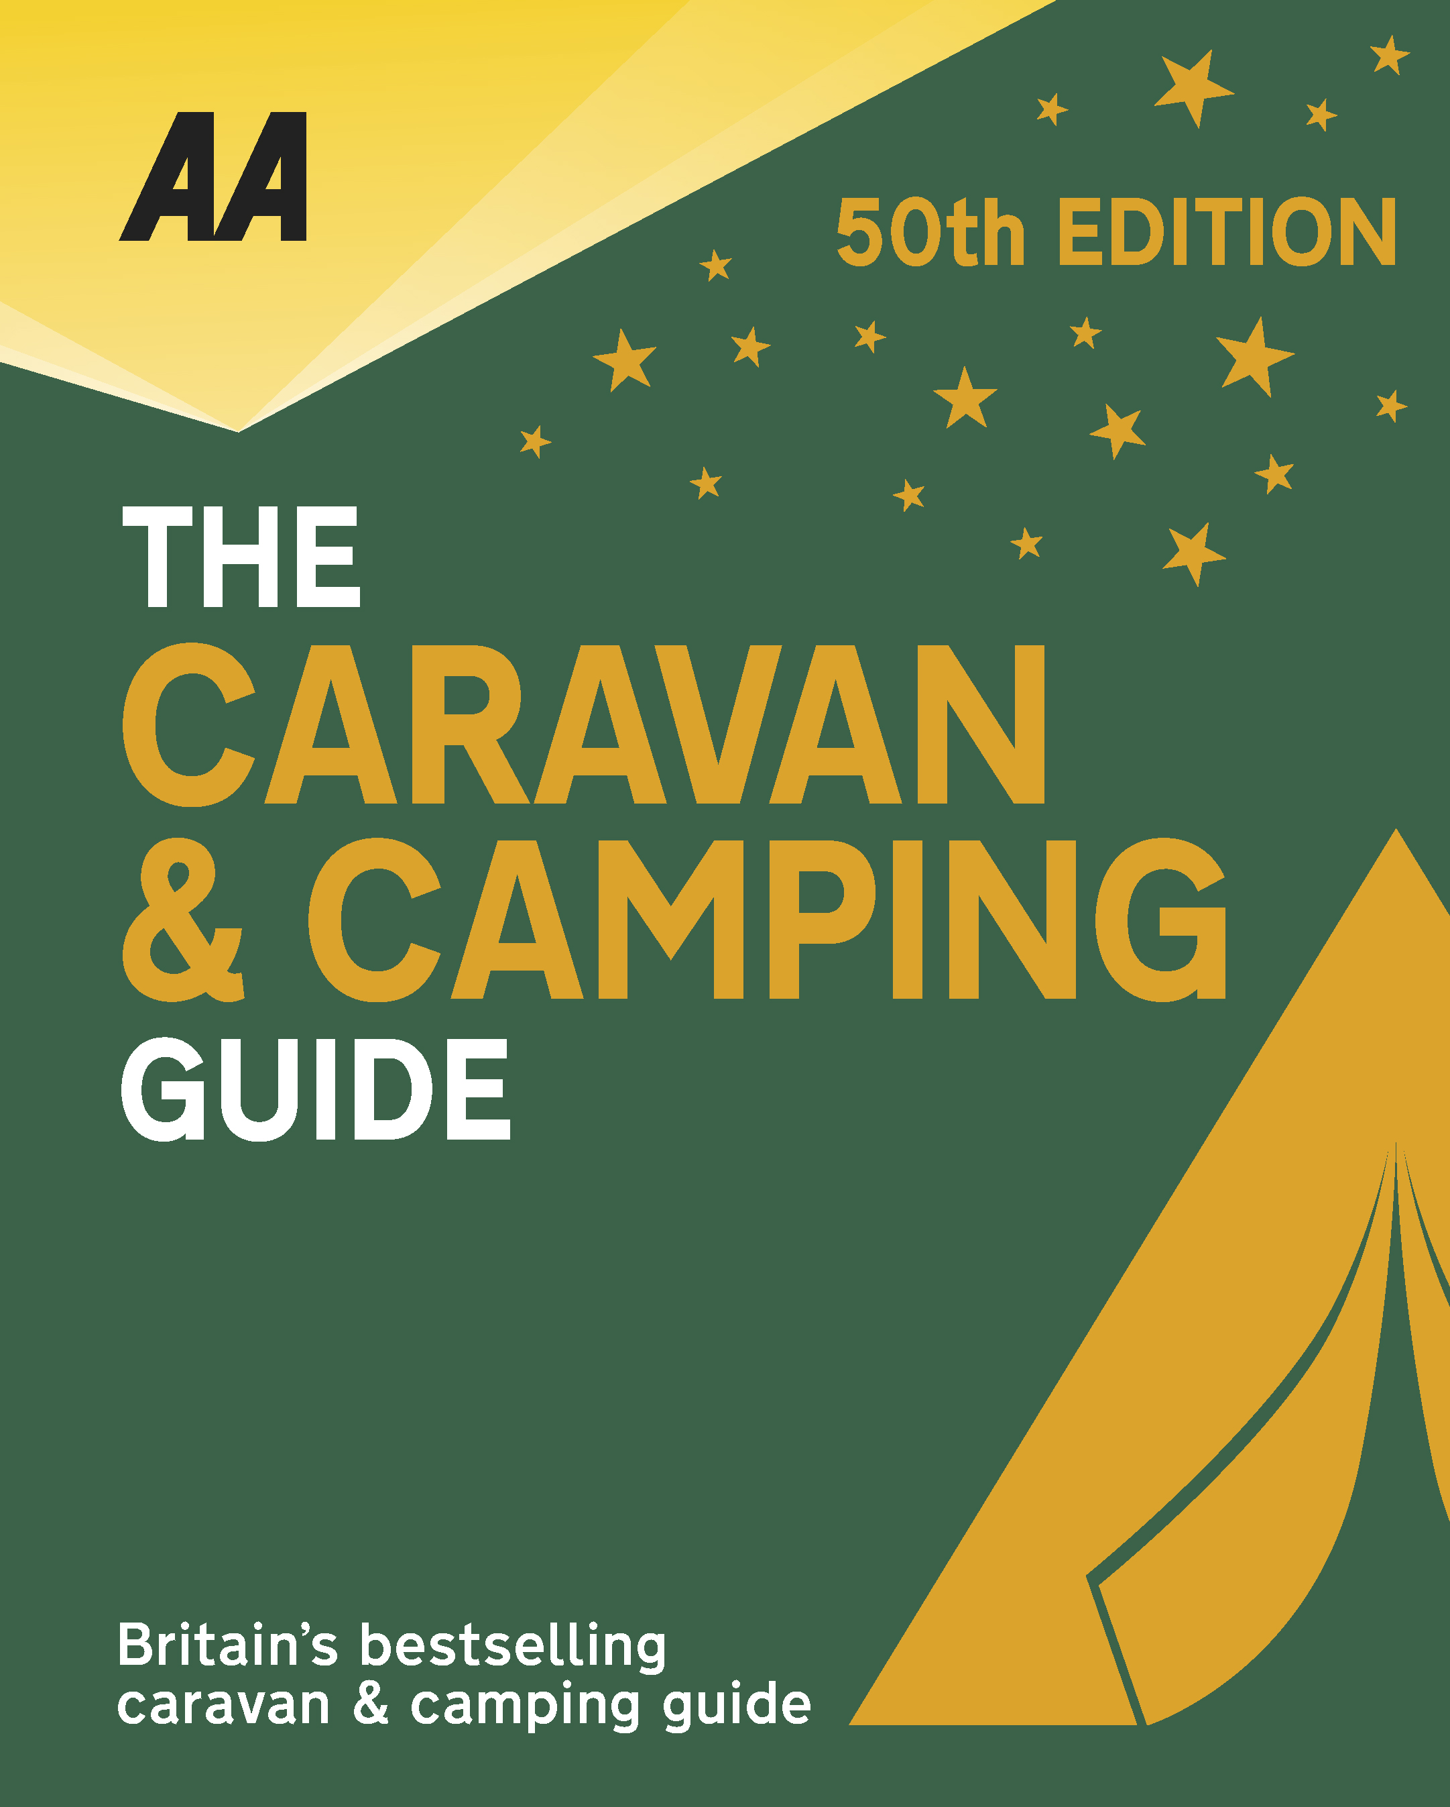
The very best spots for British caravanning and camping have been revealed today as the AA announce the winners of the AA Caravan and Camping Awards 2018. Amongst those celebrating is Trossachs Holiday Park in Aberfoyle, Stirling, winners of AA Campsite of the Year for Scotland 2018.

Brexit and the fall in the value of the pound has helped contribute to the rise of glamping and luxury options available, helping to ensure these camping and caravanning sites remain firm family favourites for holiday destinations. More and more sites now provide the likes of luxury yurts and huts in addition to the more traditional family holiday options.

Set on the edge of the Loch Lomond National Park, Trossachs Holiday Park is an attractively landscaped site, set on terraces with pitches having breathtaking views across the Carse of Stirling towards the Fintry Hills and the Munro of Ben Lomond. The location is perfect, being close to many boating, walking and cycling opportunities, and beautiful drives over the Dukes Pass and through the Trossachs. The tranquillity at this site is only broken by birdsong, and the grounds with their hanging baskets, beautiful flower tubs, lovely woodland and a large attractive pond are a pleasure to walk around. The park was awarded the gold pennants and a quality score of 91% in 2016, and hands-on management team continues to achieve high standards in all areas throughout the park, from the excellent updated toilet and shower facilities, housed in a cabin-style building, and the well-tended pitches, which offer space and privacy, to the first-class customer care and the superb overall appearance of the park. Friendly, helpful staff, who know the area well, will help you get the most out of your visit. However, if you wish to do your own research, there’s a popular internet café where home-baked cakes and local produce are available.

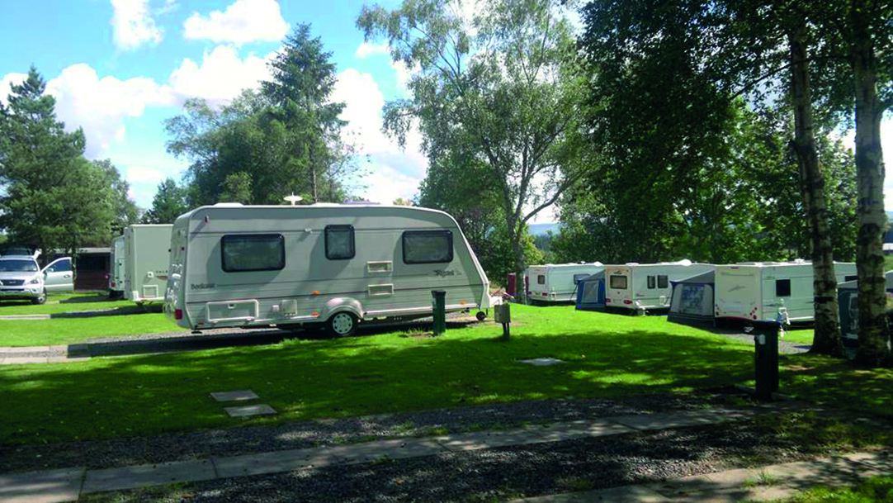
All winners will feature in the 50th Anniversary Edition of the AA Caravanning and Camping Guide. Each of the 800 sites included in the guide have been visited by one of the AA’s experienced Campsite Inspectors, grading sites from one to five Pennants, based on their facilities and hospitality. Only the parks of the very highest standard are awarded the coveted Gold Pennant award. Each entry within the guide includes location, ratings, contact details, directions, prices, opening times, facilities and a description to help select the right site for your needs.
The AA Caravan and Camping Guide 2018 is available from amazon.
The winners of the 2018 AA Caravan and Camping Awards are:
AA CAMPSITE OF THE YEAR 2018
ENGLAND AND OVERALL WINNER: Old Oaks Touring Park, Glastonbury, Somerset
SCOTLAND: Trossachs Holiday Park, Aberfoyle, Stirling
WALES: Red Kite Touring Park, Llanidloes, Powys

AA REGIONAL CAMPSITES OF THE YEAR 2018
SOUTH WEST: Trevalgan Touring Park, St Ives, Cornwall
SOUTH EAST: Whitefield Forest Touring Park, Ryde, Isle of Wight
HEART OF ENGLAND: Cakes & Ale, Leiston, Suffolk
NORTH WEST: Skelwith Fold Caravan Park, Ambleside, Cumbria
NORTH EAST: Herding Hill Farm, Haltwhistle, Northumberland

HOLIDAY CENTRE OF THE YEAR 2018
Woodside Bay Lodge Retreat, Wooton Bridge, Isle of Wight

MOST IMPROVED CAMPSITE OF THE YEAR 2018
Wheathill Touring Park, Wheathill, Shropshire

SMALL CAMPSITE OF THE YEAR
Seal Shore Camping & Touring Site, Kildonan, Isle of Arran

GLAMPING SITE OF THE YEAR
Runach Arainn Glamping, Kilmory, Isle of Arran

***Ends***
For press enquires or more information please contact Chris Webb on 01256 491521 or Chris.Webb@theAA.com

