UNDER EMBARGO UNTIL 00:01AM 15TH NOVEMBER 2017

HERDING HILL FARM NAMED AA CAMPSITE OF THE YEAR FOR THE NORTH EAST

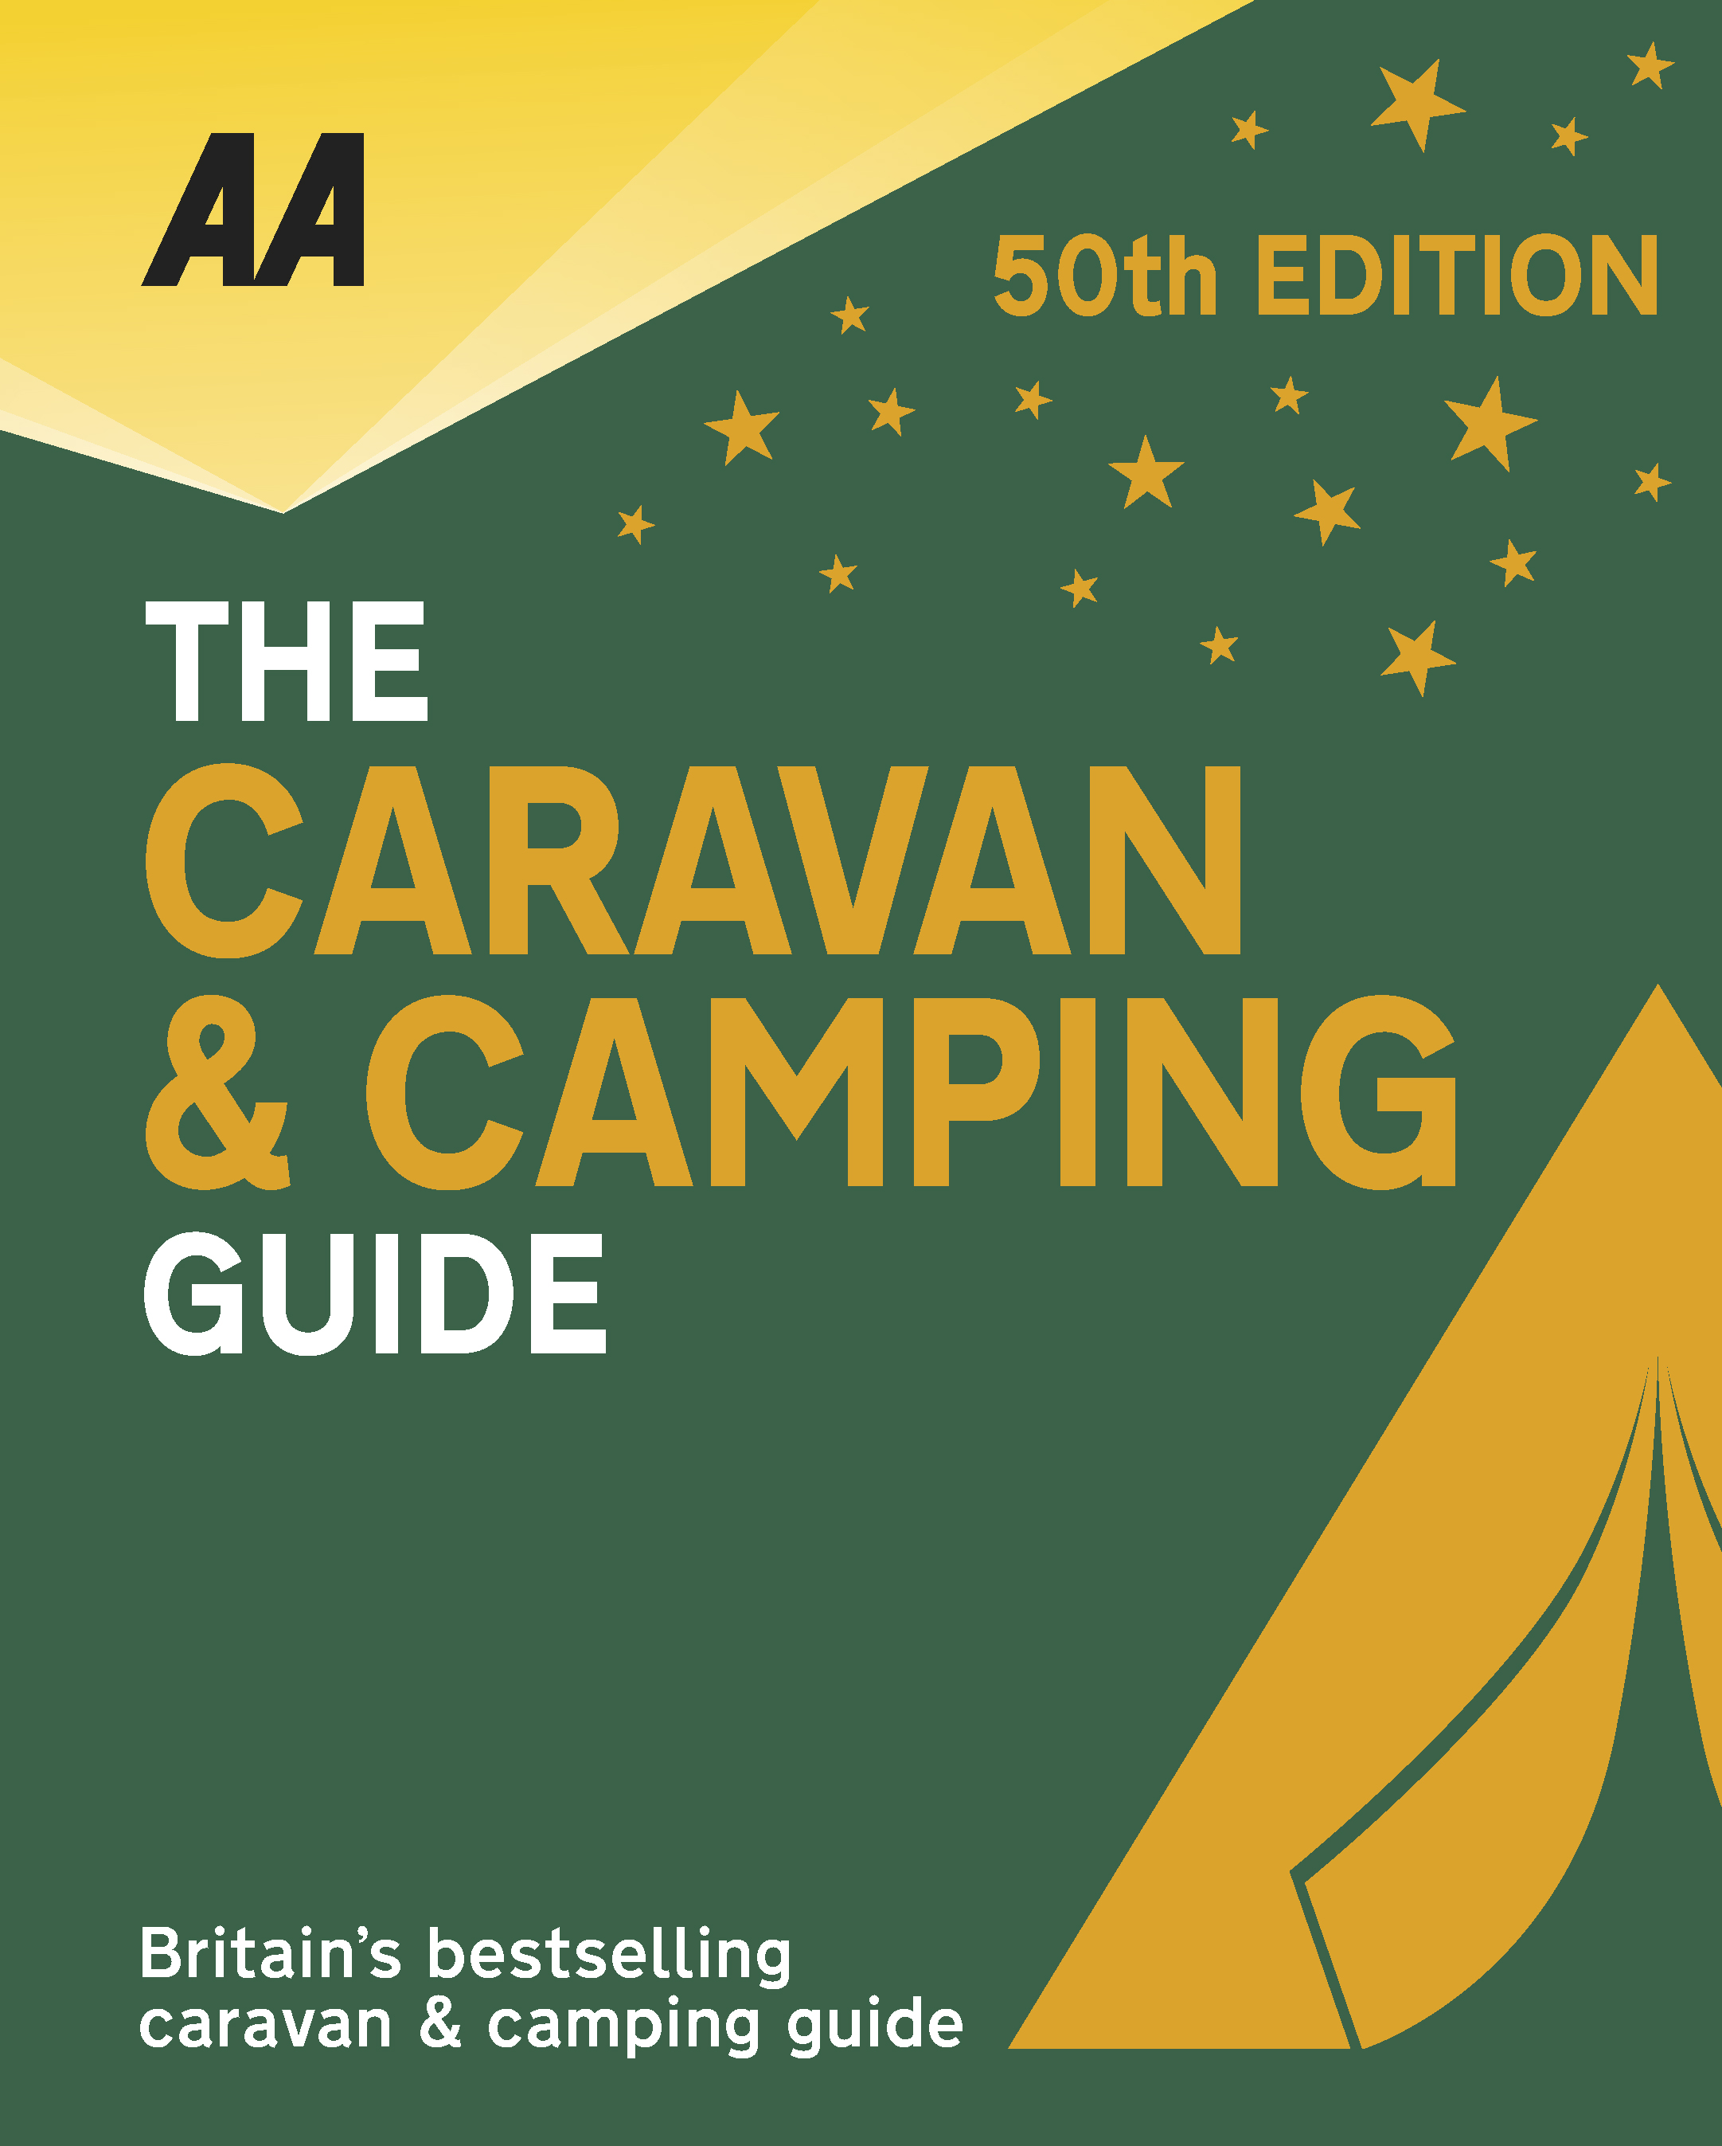
The very best spots for British caravanning and camping have been revealed today as the AA announce the winners of the AA Caravan and Camping Awards 2018. Amongst those celebrating is Herding Hill Farm in Haltwhistle, Northumberland, winners of AA Campsite of the Year for the North East 2018.

Brexit and the fall in the value of the pound has helped contribute to the rise of glamping and luxury options available, helping to ensure these camping and caravanning sites remain firm family favourites for holiday destinations. More and more sites now provide the likes of luxury yurts and huts in addition to the more traditional family holiday options.

In an idyllic moorland location above Haltwhistle, this beautifully developed working farm site is geared to families and offers a mix of accommodation − excellent tent pitches, quality hardstandings, a bunkhouse sleeping 28, a 6-berth lodge, and a glamping area. The upmarket amenity block is ultra-modern − the internal red and grey partitioning really sets off the very high standard of fixtures and fittings, and the underfloor heating is very welcoming. A drying room, barbecues and fire baskets, a playground and petting farm, an excellent shop and café, and activities such as star-gazing, Geocaching, and excellent walking and cycling opportunities complete the package. In fact, the site that has it all, an ideal mix of high quality pitches and an innovative glamping area with excellent facilities, plus it has the substantial parts of Hadrian’s Wall on its doorstep plus all the best visitor hotspots. Over a very short period the hands-on owners have converted farmland into a justifiable gold standard, award-winning campsite where every aspect is exceptional and without weaknesses. Customer care is at the forefront and it is obvious that the owners have applied their personal experience of touring with children in the development of this site.

All winners will feature in the 50th Anniversary Edition of the AA Caravanning and Camping Guide. Each of the 800 sites included in the guide have been visited by one of the AA’s experienced Campsite Inspectors, grading sites from one to five Pennants, based on their facilities and hospitality. Only the parks of the very highest standard are awarded the coveted Gold Pennant award. Each entry within the guide includes location, ratings, contact details, directions, prices, opening times, facilities and a description to help select the right site for your needs.
The AA Caravan and Camping Guide 2018 is available from amazon.
The winners of the 2018 AA Caravan and Camping Awards are:
AA CAMPSITE OF THE YEAR 2018
ENGLAND AND OVERALL WINNER: Old Oaks Touring Park, Glastonbury, Somerset
SCOTLAND: Trossachs Holiday Park, Aberfoyle, Stirling
WALES: Red Kite Touring Park, Llanidloes, Powys

AA REGIONAL CAMPSITES OF THE YEAR 2018
SOUTH WEST: Trevalgan Touring Park, St Ives, Cornwall
SOUTH EAST: Whitefield Forest Touring Park, Ryde, Isle of Wight
HEART OF ENGLAND: Cakes & Ale, Leiston, Suffolk
NORTH WEST: Skelwith Fold Caravan Park, Ambleside, Cumbria
NORTH EAST: Herding Hill Farm, Haltwhistle, Northumberland

HOLIDAY CENTRE OF THE YEAR 2018
Woodside Bay Lodge Retreat, Wooton Bridge, Isle of Wight

MOST IMPROVED CAMPSITE OF THE YEAR 2018
Wheathill Touring Park, Wheathill, Shropshire

SMALL CAMPSITE OF THE YEAR
Seal Shore Camping & Touring Site, Kildonan, Isle of Arran

GLAMPING SITE OF THE YEAR
Runach Arainn Glamping, Kilmory, Isle of Arran

***Ends***
For press enquires or more information please contact Chris Webb on 01256 491521 or Chris.Webb@theAA.com

