UNDER EMBARGO UNTIL 00:01AM 15TH NOVEMBER 2017

WHEATHILL TOURING PARK NAMED AA MOST IMPROVED CAMPSITE OF THE YEAR

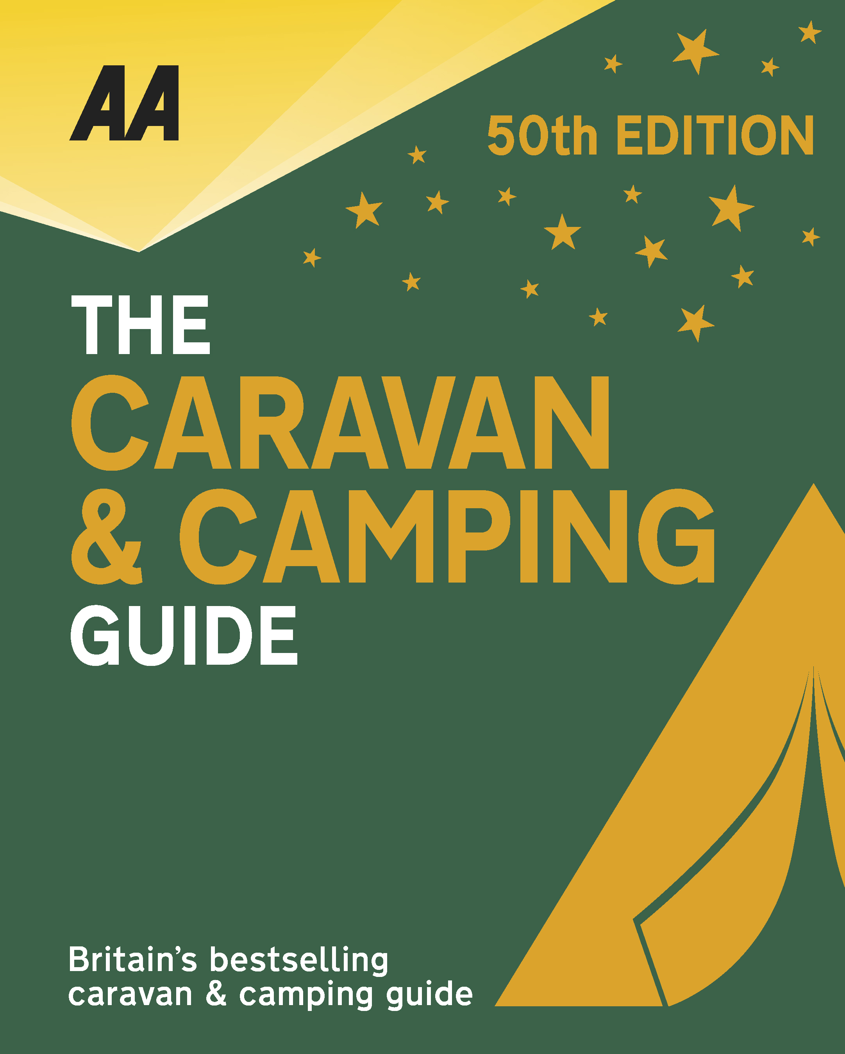
The very best spots for British caravanning and camping have been revealed today as the AA announce the winners of the AA Caravan and Camping Awards 2018. Amongst those celebrating is Wheathill Touring Park in Wheathill, Shropshire, winners of AA Most Improved Campsite of the Year 2018.

Brexit and the fall in the value of the pound has helped contribute to the rise of glamping and luxury options available, helping to ensure these camping and caravanning sites remain firm family favourites for holiday destinations. More and more sites now provide the likes of luxury yurts and huts in addition to the more traditional family holiday options.

Situated on a gently sloping hillside from which the stunning country views are notable, this adults-only touring park opened in 2013, and owners Lee and Sue Partridge have continued to invest year on year to enhance the customer experience. All the fully serviced pitches are level, well-spaced extra-large hardstandings and mature planting ensures optimum privacy. Between 2014 and 2016, existing pitches were further improved and a superb dog wash was installed at the side of the stylish amenities block. The block itself benefits from excellent fixtures and fittings and good privacy options. In 2017 the park was extended following the redevelopment of an adjoining field which added 15 further excellent fully serviced pitches and an additional top-notch amenities block. All inner roadways were then resurfaced to an excellent standard to ensure good access and ease of use, and a major planting programme was also undertaken introducing a wide variety of indigenous species; this is not only visually pleasing but also acts as a magnet for wildlife. Secure caravan and motorhome storage has also been created. The adjacent Three Horseshoes country pub, under the same ownership, serves locally sourced food and a good selection of ales and wine.
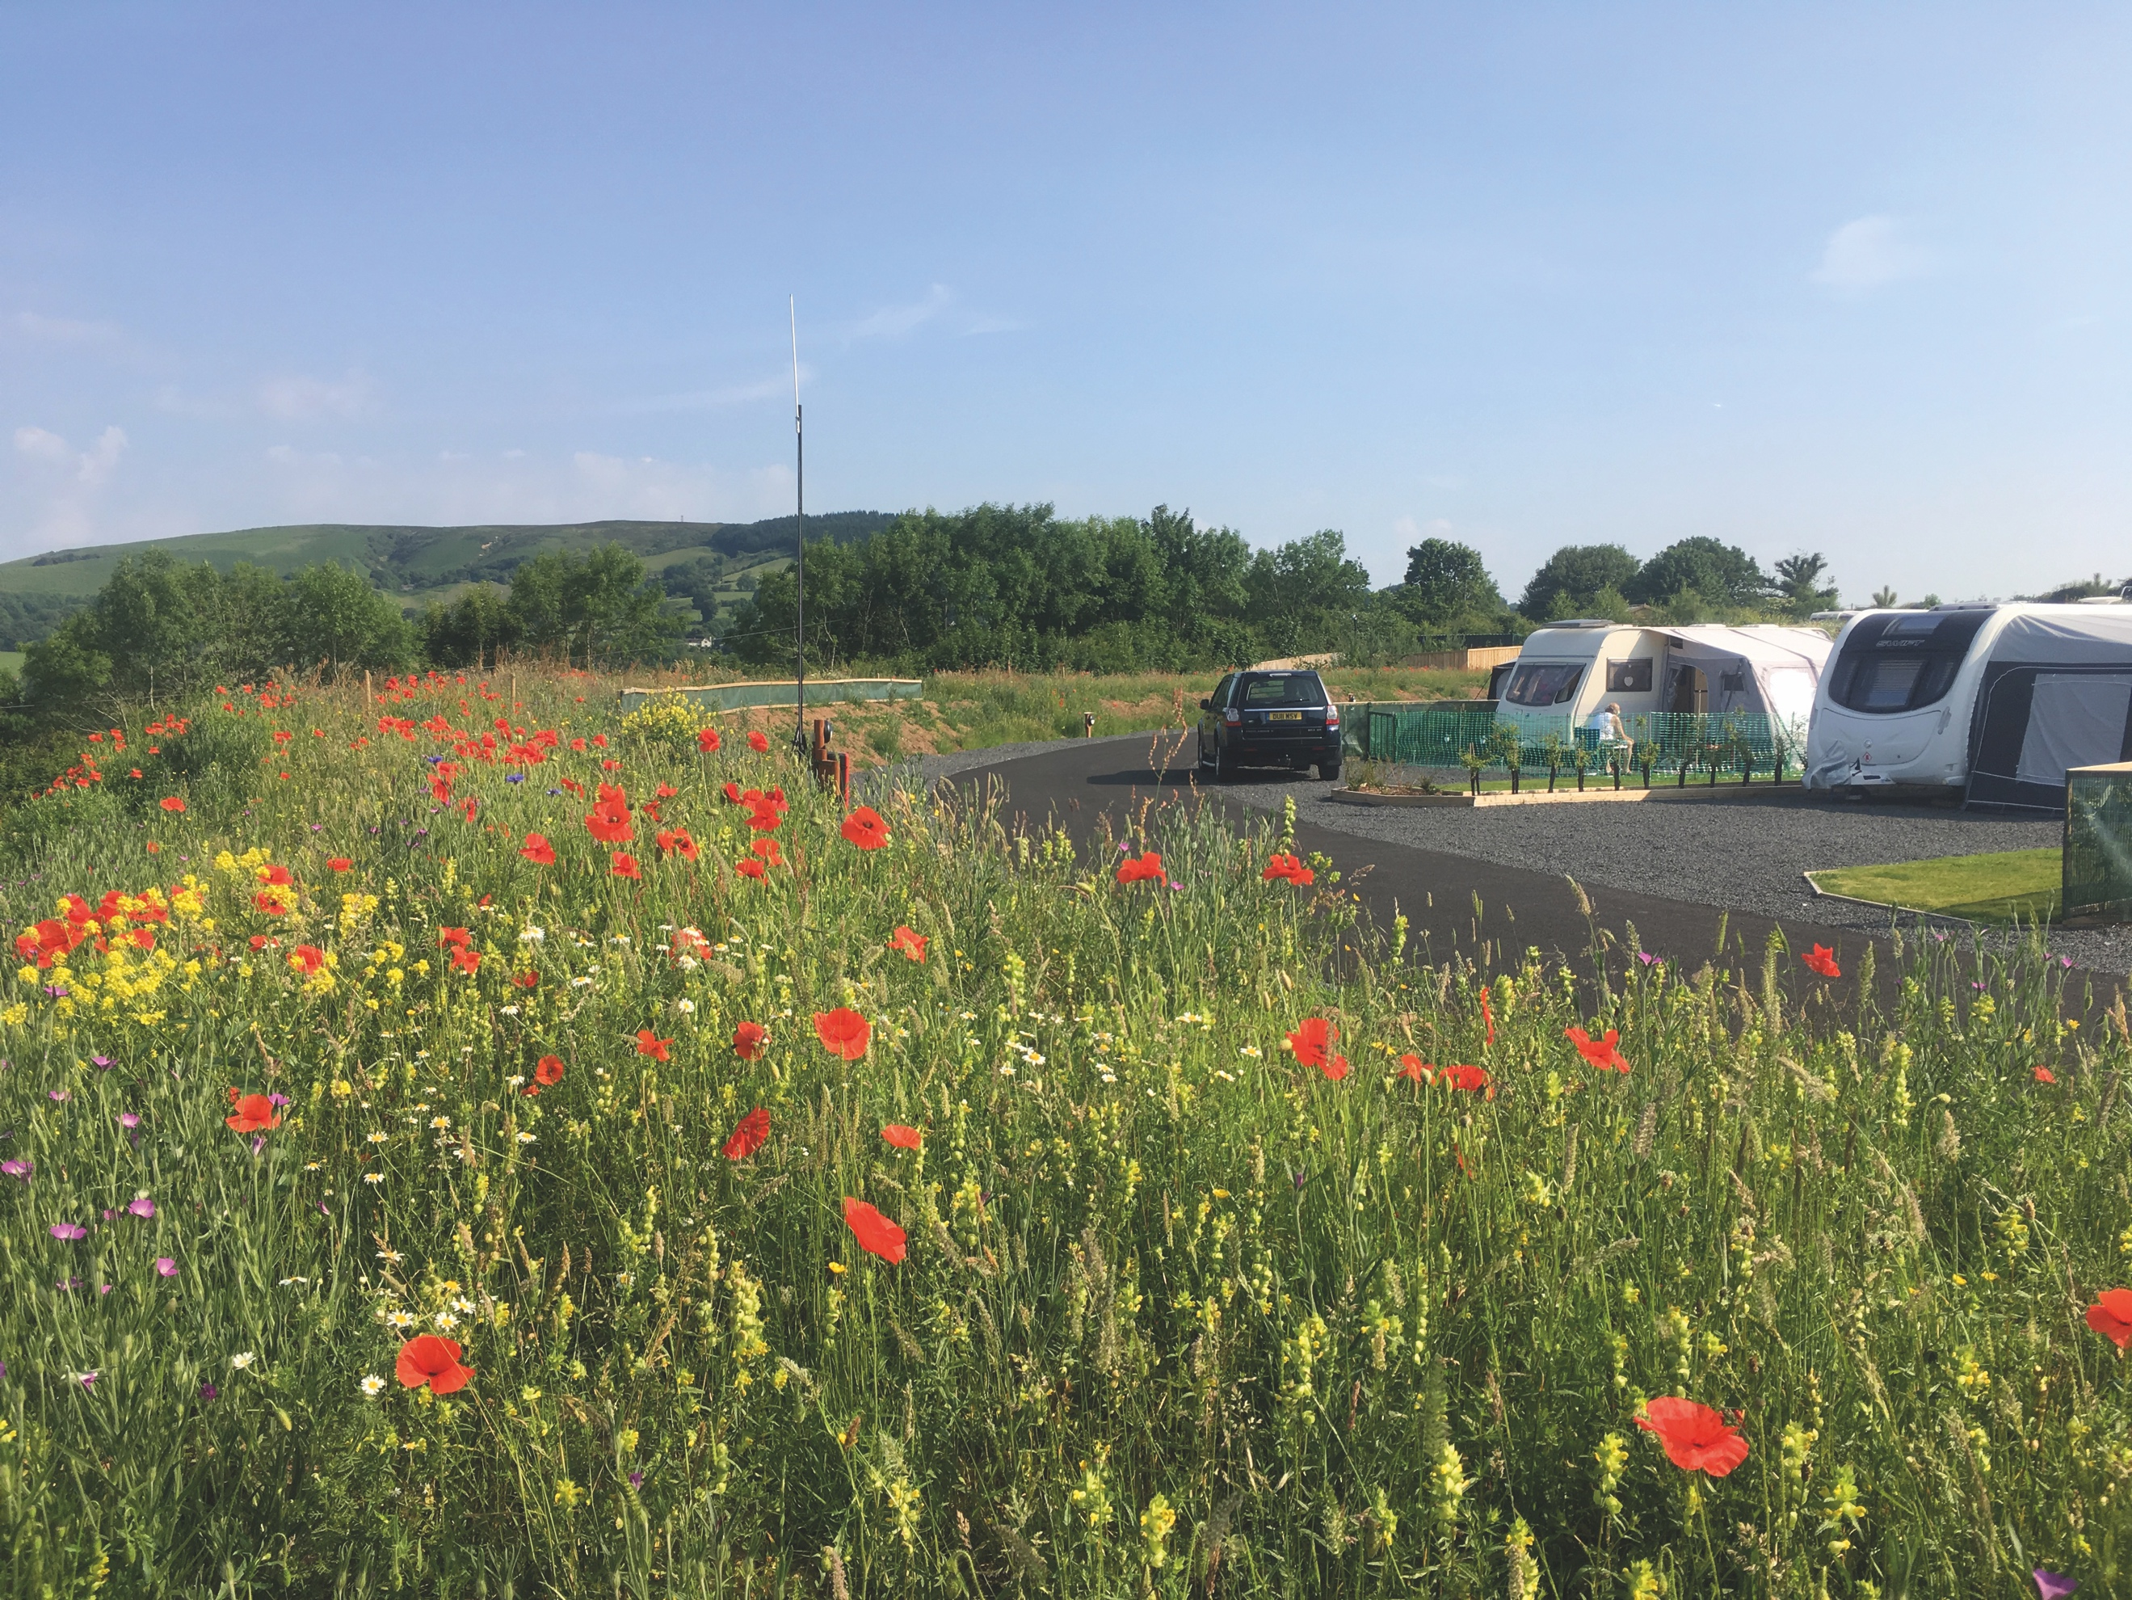
All winners will feature in the 50th Anniversary Edition of the AA Caravanning and Camping Guide. Each of the 800 sites included in the guide have been visited by one of the AA’s experienced Campsite Inspectors, grading sites from one to five Pennants, based on their facilities and hospitality. Only the parks of the very highest standard are awarded the coveted Gold Pennant award. Each entry within the guide includes location, ratings, contact details, directions, prices, opening times, facilities and a description to help select the right site for your needs.
The AA Caravan and Camping Guide 2018 is available from amazon.
The winners of the 2018 AA Caravan and Camping Awards are:
AA CAMPSITE OF THE YEAR 2018
ENGLAND AND OVERALL WINNER: Old Oaks Touring Park, Glastonbury, Somerset
SCOTLAND: Trossachs Holiday Park, Aberfoyle, Stirling
WALES: Red Kite Touring Park, Llanidloes, Powys

AA REGIONAL CAMPSITES OF THE YEAR 2018
SOUTH WEST: Trevalgan Touring Park, St Ives, Cornwall
SOUTH EAST: Whitefield Forest Touring Park, Ryde, Isle of Wight
HEART OF ENGLAND: Cakes & Ale, Leiston, Suffolk
NORTH WEST: Skelwith Fold Caravan Park, Ambleside, Cumbria
NORTH EAST: Herding Hill Farm, Haltwhistle, Northumberland

HOLIDAY CENTRE OF THE YEAR 2018
Woodside Bay Lodge Retreat, Wooton Bridge, Isle of Wight

MOST IMPROVED CAMPSITE OF THE YEAR 2018
Wheathill Touring Park, Wheathill, Shropshire

SMALL CAMPSITE OF THE YEAR
Seal Shore Camping & Touring Site, Kildonan, Isle of Arran

GLAMPING SITE OF THE YEAR
Runach Arainn Glamping, Kilmory, Isle of Arran

***Ends***
For press enquires or more information please contact Chris Webb on 01256 491521 or Chris.Webb@theAA.com

