UNDER EMBARGO UNTIL 00:01AM 15TH NOVEMBER 2017

WOODSIDE BAY LODGE RETREAT NAMED AA HOLIDAY CENTRE
OF THE YEAR

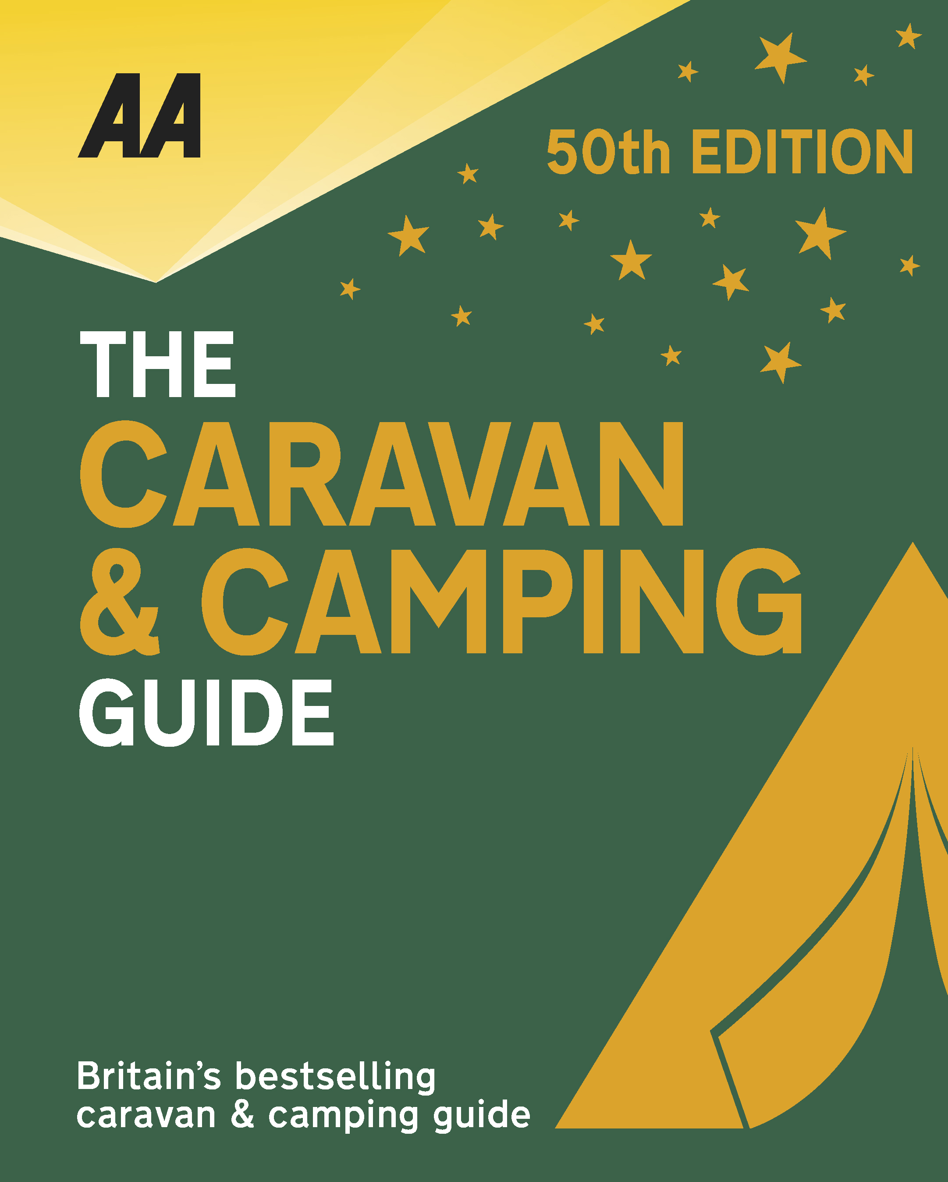
The very best spots for British caravanning and camping have been revealed today as the AA announce the winners of the AA Caravan and Camping Awards 2018. Amongst those celebrating is Woodside Bay Lodge Retreat in Wooton Bridge, Isle of Wight, winners of AA Holiday Centre of the Year 2018.

Brexit and the fall in the value of the pound has helped contribute to the rise of glamping and luxury options available, helping to ensure these camping and caravanning sites remain firm family favourites for holiday destinations. More and more sites now provide the likes of luxury yurts and huts in addition to the more traditional family holiday options.

Whether it’s homes or holidays, it’s all about location, and the site of Darwin Escapes’ fabulous new lodge park, Woodside Bay Lodge Retreat, is absolutely stunning. The company has raised the standards of holiday home and lodge parks to a new level in recent years, with serious investment in high quality lodge accommodation, superb landscaping and top-notch leisure facilities. This newly developed park on the Isle of Wight is a shining example of their vision for luxury holiday destinations. However, what sets Woodside Bay apart in their collection is the unique setting on the northeast shore of the island. The landscaping uses the natural slope of the land to achieve an outstanding effect, from the reception, bar, lounge and restaurant area situated at the top of the site, which is further enhanced by its curved layout, leading down to the alfresco eating area, The Braai, and then to the luxury lodge accommodation. Wherever you are on the park you have outstanding views over the Solent. In addition, there is a spa and gym and two spectacular tree houses (sleeping two) for those looking for something different. The high standards and the exceptional customer care make Woodside Bay Lodge Retreat a worthy winner of this award.
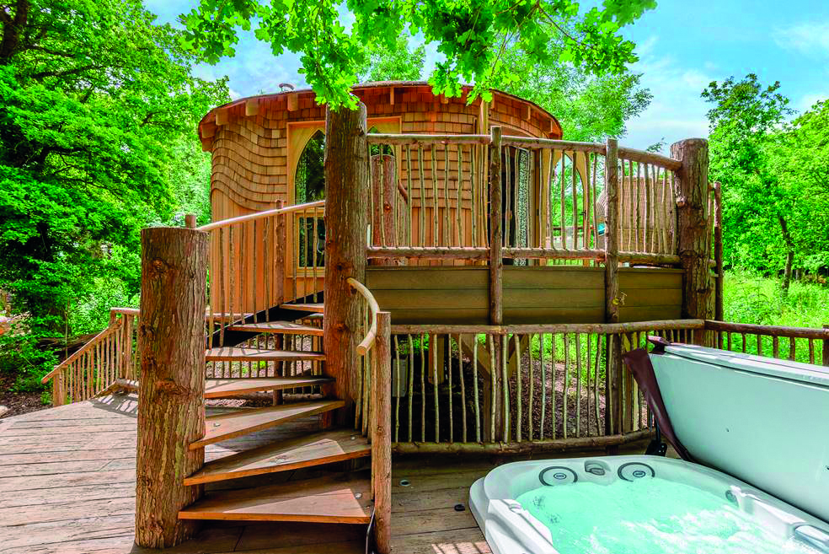
All winners will feature in the 50th Anniversary Edition of the AA Caravanning and Camping Guide. Each of the 800 sites included in the guide have been visited by one of the AA’s experienced Campsite Inspectors, grading sites from one to five Pennants, based on their facilities and hospitality. Only the parks of the very highest standard are awarded the coveted Gold Pennant award. Each entry within the guide includes location, ratings, contact details, directions, prices, opening times, facilities and a description to help select the right site for your needs.
The AA Caravan and Camping Guide 2018 is available from amazon.
The winners of the 2018 AA Caravan and Camping Awards are:
AA CAMPSITE OF THE YEAR 2018
ENGLAND AND OVERALL WINNER: Old Oaks Touring Park, Glastonbury, Somerset
SCOTLAND: Trossachs Holiday Park, Aberfoyle, Stirling
WALES: Red Kite Touring Park, Llanidloes, Powys

AA REGIONAL CAMPSITES OF THE YEAR 2018
SOUTH WEST: Trevalgan Touring Park, St Ives, Cornwall
SOUTH EAST: Whitefield Forest Touring Park, Ryde, Isle of Wight
HEART OF ENGLAND: Cakes & Ale, Leiston, Suffolk
NORTH WEST: Skelwith Fold Caravan Park, Ambleside, Cumbria
NORTH EAST: Herding Hill Farm, Haltwhistle, Northumberland

HOLIDAY CENTRE OF THE YEAR 2018
Woodside Bay Lodge Retreat, Wooton Bridge, Isle of Wight

MOST IMPROVED CAMPSITE OF THE YEAR 2018
Wheathill Touring Park, Wheathill, Shropshire

SMALL CAMPSITE OF THE YEAR
Seal Shore Camping & Touring Site, Kildonan, Isle of Arran

GLAMPING SITE OF THE YEAR
Runach Arainn Glamping, Kilmory, Isle of Arran

***Ends***
For press enquires or more information please contact Chris Webb on 01256 491521 or Chris.Webb@theAA.com

