UNDER EMBARGO UNTIL 00:01AM 15TH NOVEMBER 2017

CAKES & ALE NAMED AA CAMPSITE OF THE YEAR FOR
THE HEART OF ENGLAND

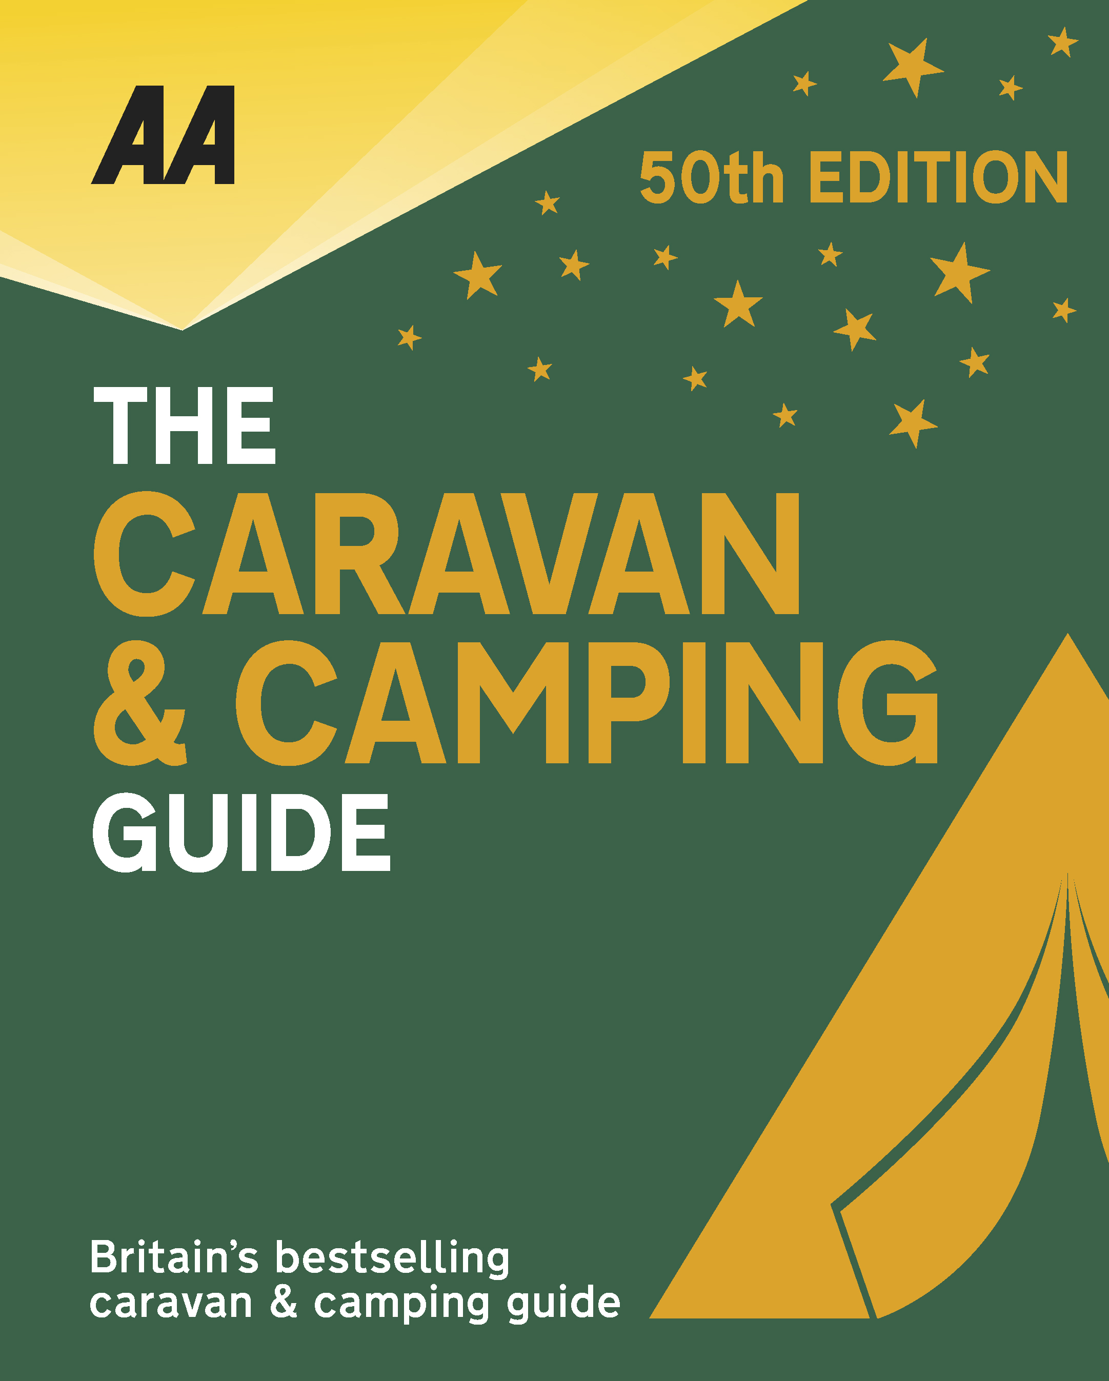
The very best spots for British caravanning and camping have been revealed today as the AA announce the winners of the AA Caravan and Camping Awards 2018. Amongst those celebrating is Cakes & Ale in Leiston, Suffolk, winners of AA Campsite of the Year for the Heart of England 2018.

Brexit and the fall in the value of the pound has helped contribute to the rise of glamping and luxury options available, helping to ensure these camping and caravanning sites remain firm family favourites for holiday destinations. More and more sites now provide the likes of luxury yurts and huts in addition to the more traditional family holiday options.

Located on the site of a World War II American air base, this superbly developed park offers very spacious, fully serviced grass and hardstanding pitches – all are well spaced to ensure privacy. A major, well-designed landscaping programme has introduced in a wide range of colourful trees, hedges, shrubs and pretty seasonal flowers to the park; they combine to create a peaceful environment so the only distraction is the welcome one of birdsong. The large, stylish and very well-equipped solar-powered amenity building provides underfloor heating, quality fixtures and fittings and excellent privacy options. Recreation facilities at the park include a golf practice range, tennis courts, boules pitch and, for the children, a playground and football pitch. The Yoxford Boys Bar with its unique interior and alfresco area is open between April and October, serving real ales and a good wine selection. There are two holiday homes for hire and families are especially welcome, although an adults-only touring area is also provided. A well-stocked shop sells essentials and a large dedicated resident team ensures safety and security for all. Owners of holiday homes, tourers and campers all receive the same excellent customer service.
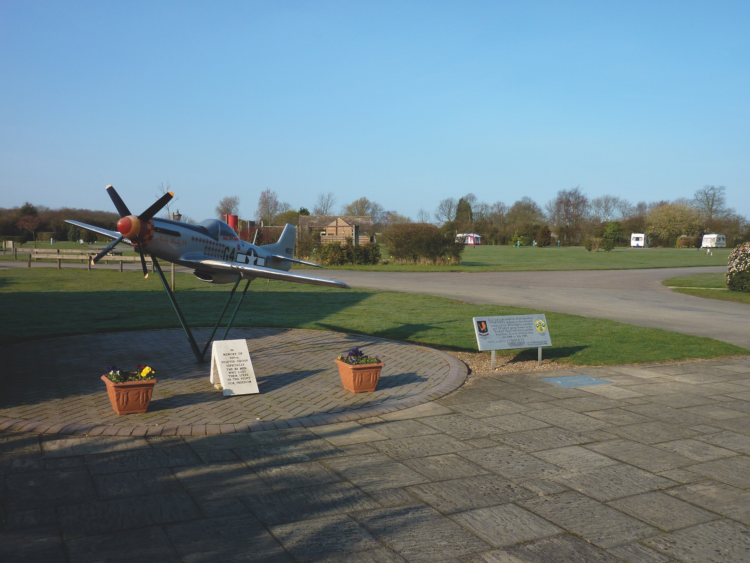
All winners will feature in the 50th Anniversary Edition of the AA Caravanning and Camping Guide. Each of the 800 sites included in the guide have been visited by one of the AA’s experienced Campsite Inspectors, grading sites from one to five Pennants, based on their facilities and hospitality. Only the parks of the very highest standard are awarded the coveted Gold Pennant award. Each entry within the guide includes location, ratings, contact details, directions, prices, opening times, facilities and a description to help select the right site for your needs.
The AA Caravan and Camping Guide 2018 is available from amazon.
The winners of the 2018 AA Caravan and Camping Awards are:
AA CAMPSITE OF THE YEAR 2018
ENGLAND AND OVERALL WINNER: Old Oaks Touring Park, Glastonbury, Somerset
SCOTLAND: Trossachs Holiday Park, Aberfoyle, Stirling
WALES: Red Kite Touring Park, Llanidloes, Powys

AA REGIONAL CAMPSITES OF THE YEAR 2018
SOUTH WEST: Trevalgan Touring Park, St Ives, Cornwall
SOUTH EAST: Whitefield Forest Touring Park, Ryde, Isle of Wight
HEART OF ENGLAND: Cakes & Ale, Leiston, Suffolk
NORTH WEST: Skelwith Fold Caravan Park, Ambleside, Cumbria
NORTH EAST: Herding Hill Farm, Haltwhistle, Northumberland

HOLIDAY CENTRE OF THE YEAR 2018
Woodside Bay Lodge Retreat, Wooton Bridge, Isle of Wight

MOST IMPROVED CAMPSITE OF THE YEAR 2018
Wheathill Touring Park, Wheathill, Shropshire

SMALL CAMPSITE OF THE YEAR
Seal Shore Camping & Touring Site, Kildonan, Isle of Arran

GLAMPING SITE OF THE YEAR
Runach Arainn Glamping, Kilmory, Isle of Arran

***Ends***
For press enquires or more information please contact Chris Webb on 01256 491521 or Chris.Webb@theAA.com

