UNDER EMBARGO UNTIL 00:01AM 15TH NOVEMBER 2017

THE OLD OAKS TOURING PARK NAMED AA CAMPSITE OF THE YEAR FOR ENGLAND AND OVERALL WINNER

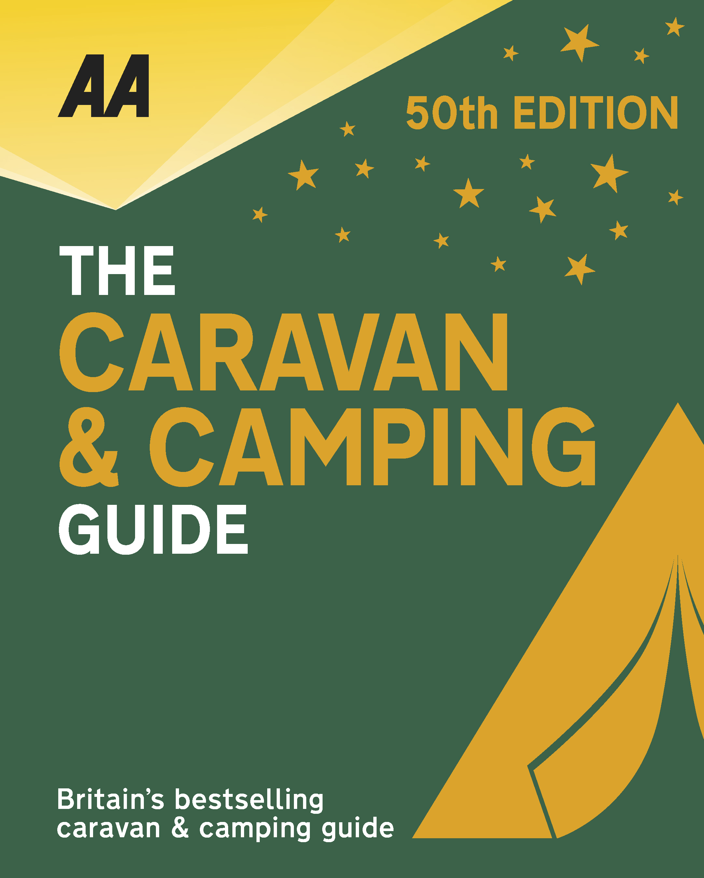
The very best spots for British caravanning and camping have been revealed today as the AA announce the winners of the AA Caravan and Camping Awards 2018. Amongst those celebrating is The Old Oaks Touring Park in Glastonbury, Somerset, winners of AA Campsite of the Year for England 2018 and Overall winner.

Brexit and the fall in the value of the pound has helped contribute to the rise of glamping and luxury options available, helping to ensure these camping and caravanning sites remain firm family favourites for holiday destinations. More and more sites now provide the likes of luxury yurts and huts in addition to the more traditional family holiday options.

A two-time winner of this coveted award, Old Oaks Touring Park has developed to an exceptional level in this year by hands-on owners James and Tara White, who continue to invest and innovate across the park, and this year our inspector thought the park was ‘absolutely stunning’. The vision and effort put in by James and Tara is outstanding and makes Old Oaks one of the best camping parks in Britain. All pitches are very spacious and level – some beautifully terraced to make the most of the views across the surrounding countryside, and the huge premier pitches are fully serviced and include HD TV. 2017 saw the inspired development of the Orchard Field and the embracement of the glamping trend. The result is four fabulous mini-lodges, all situated on carefully landscaped areas with outstanding views of the Mendip Hills and space for outside living and relaxation – there’s even a fire pit to make evenings even more special. The lodges ooze quality being fully furnished and equipped to a very high standard. The area is also home to two new shepherd’s huts, one of which has its own hot tub. The attention to detail throughout the park is first class – everything that James and Tara undertake is to the highest level possible.

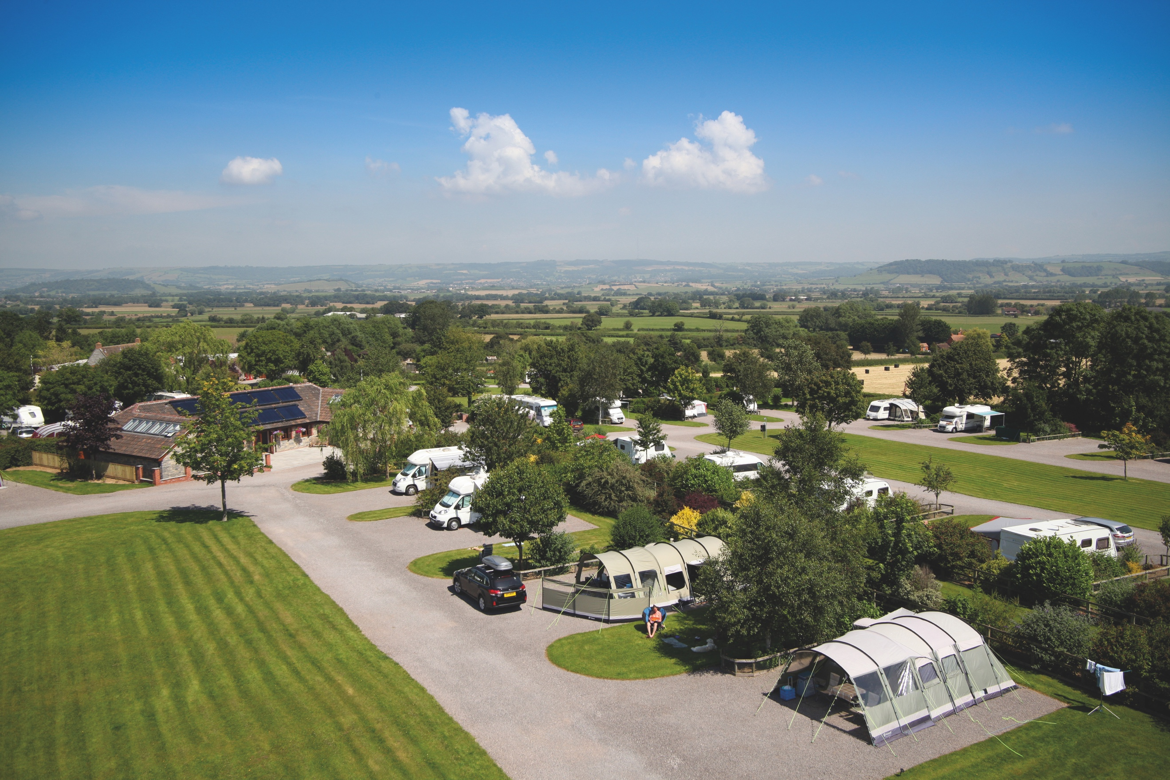
All winners will feature in the 50th Anniversary Edition of the AA Caravanning and Camping Guide. Each of the 800 sites included in the guide have been visited by one of the AA’s experienced Campsite Inspectors, grading sites from one to five Pennants, based on their facilities and hospitality. Only the parks of the very highest standard are awarded the coveted Gold Pennant award. Each entry within the guide includes location, ratings, contact details, directions, prices, opening times, facilities and a description to help select the right site for your needs.
The AA Caravan and Camping Guide 2018 is available from amazon.
The winners of the 2018 AA Caravan and Camping Awards are:
AA CAMPSITE OF THE YEAR 2018
ENGLAND AND OVERALL WINNER: Old Oaks Touring Park, Glastonbury, Somerset
SCOTLAND: Trossachs Holiday Park, Aberfoyle, Stirling
WALES: Red Kite Touring Park, Llanidloes, Powys

AA REGIONAL CAMPSITES OF THE YEAR 2018
SOUTH WEST: Trevalgan Touring Park, St Ives, Cornwall
SOUTH EAST: Whitefield Forest Touring Park, Ryde, Isle of Wight
HEART OF ENGLAND: Cakes & Ale, Leiston, Suffolk
NORTH WEST: Skelwith Fold Caravan Park, Ambleside, Cumbria
NORTH EAST: Herding Hill Farm, Haltwhistle, Northumberland

HOLIDAY CENTRE OF THE YEAR 2018
Woodside Bay Lodge Retreat, Wooton Bridge, Isle of Wight

MOST IMPROVED CAMPSITE OF THE YEAR 2018
Wheathill Touring Park, Wheathill, Shropshire

SMALL CAMPSITE OF THE YEAR
Seal Shore Camping & Touring Site, Kildonan, Isle of Arran

GLAMPING SITE OF THE YEAR
Runach Arainn Glamping, Kilmory, Isle of Arran

***Ends***
For press enquires or more information please contact Chris Webb on 01256 491521 or Chris.Webb@theAA.com

