PRESS RELEASE
Strictly embargoed until 26 September 2017 at 00:01

THE TWR Y FELIN CROWNED
AA HOTEL OF THE YEAR WALES 2017
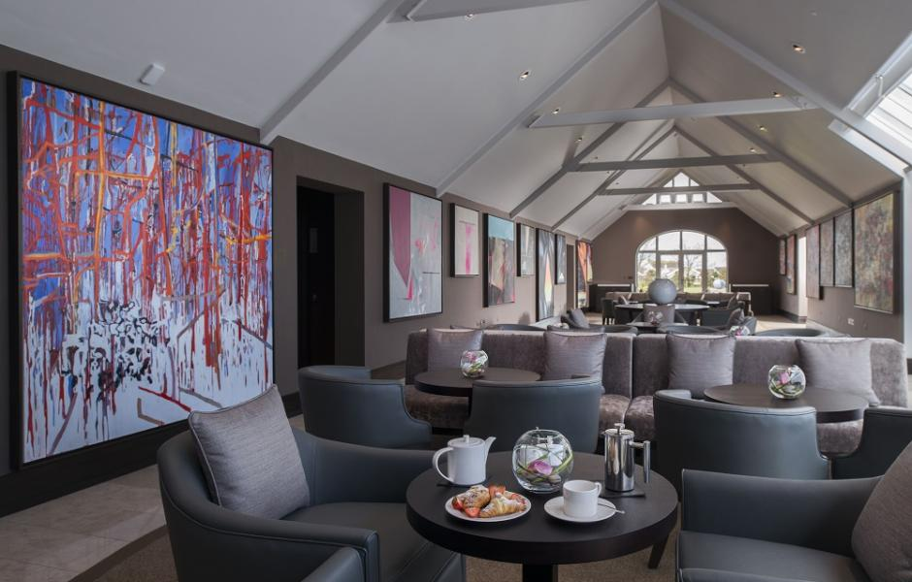
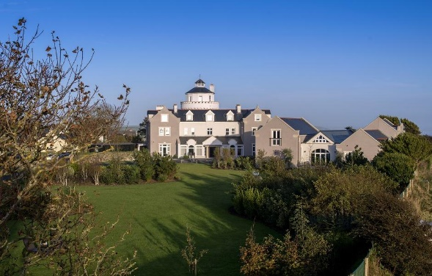

Twr Y Felin was last night (September 25) named the Hotel of the Year – Wales 2017 at the AA Hospitality Awards.

Now in its 20th year, the glittering awards ceremony at the Grosvenor House Hotel celebrates the UK’s top hotels, restaurants, and pubs and the people behind them. It also marks the release of the 2018 editions of the AA’s range of lifestyle guides; the AA Hotel Guide and AA Best Restaurants Guide. .

The AA Hotel of the Year Award, introduced in 1992, is the AA’s ultimate accolade for hotels in the UK. It is awarded to hotels that are recognised as being outstanding examples in their particular market. From the small family-run hotel to the most ambitious commercial ventures, hotels of every size and style are potential winners.

Paula Ellis, Group General Manager of Twr Y Felin, said:

“I am so proud of my team and their outstanding achievement in such a short time since opening. This award will not only establish our reputation as Wales’ leading luxury boutique hotel, but hopefully will also lead the way for other luxury hotels to follow suit to help establish Wales as a truly international luxury destination.”

An AA Hotel Inspector said of Twr Y Felin:

“Excellent design and presentation, with noteworthy attention to detail.”

…Ends…

For press enquiries including images and interview availability, please contact:

020 7361 7860
liz.mallett@midaspr.co.uk / zekra.rahman@midaspr.co.uk

Note to Editors

About Twr Y Felin
The original windmill was built in 1806, becoming the tallest structure in the St Davids Peninsula. During the first century of its’ life the mill passed through many owners and ground corn right through to 1904, when the sails were dismantled.

In 1907, the height of the tower was raised and new buildings erected alongside to create a hotel called Twr y Felin, Welsh for ‘mill tower’, operating successfully and as a well-known temperance hotel until it was requisitioned by the Government for the war effort in 1939. Evacuees from the London Blitz stayed there in 1940, following which, the Admiralty stationed the Women’s Royal Naval Service, “Wrens”, in the building until 1945.

Following extensive repairs after the War, the hotel was returned to its owner and continued its life as a temperance hotel until 1986, when it was purchased by Andrew Middleton, who then converted Twr y Felin into an Eco-Lodge and an Outdoor Pursuits Centre. In 2009, Keith Griffiths identified the property as a worthy addition to the Griffiths Roch Foundation; and after five years of planning, design and construction, Twr y Felin opened in its current form in December 2015 as a contemporary art hotel offering luxury accommodation and fine dining.

Set in its own private grounds Twr y Felin Hotel is close to world renowned beaches, just a ten-minute walk to Caerfai Bay and the historic St Davids Cathedral and is located opposite Oriel y Parc National Park Visitor Centre and National Museum Wales Gallery.
Twr Y Felin Hotel, Ffordd Caerfai, St Davids SA62 6QT

