PRESS RELEASE
Strictly embargoed until 26 September 2017 at 00:01

THE BOW BAR CROWNED
AA PUB OF THE YEAR SCOTLAND 2017
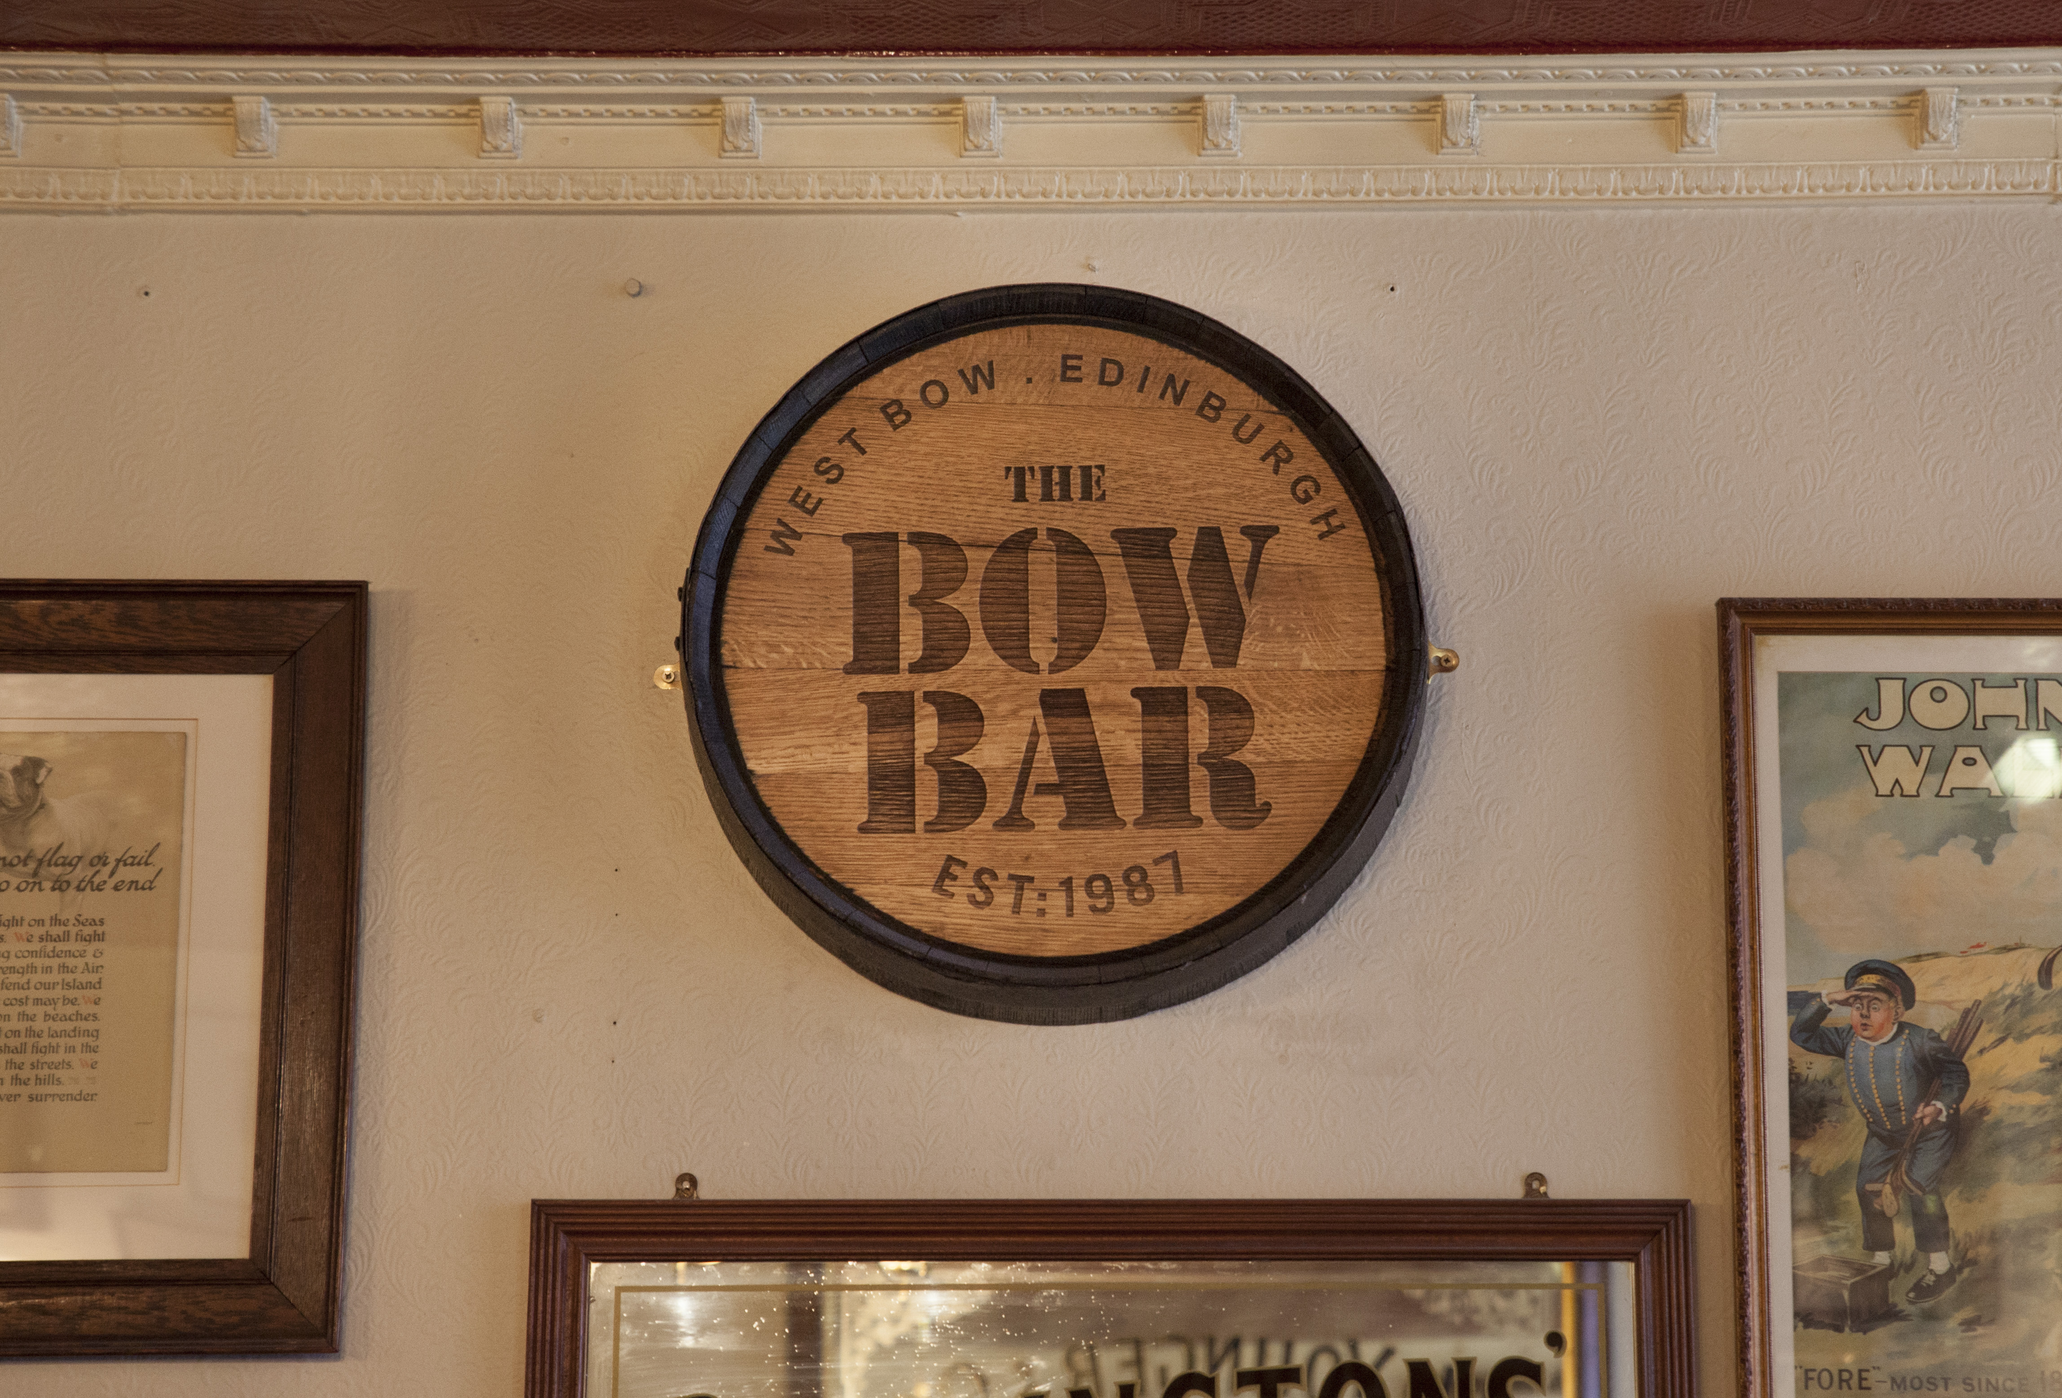
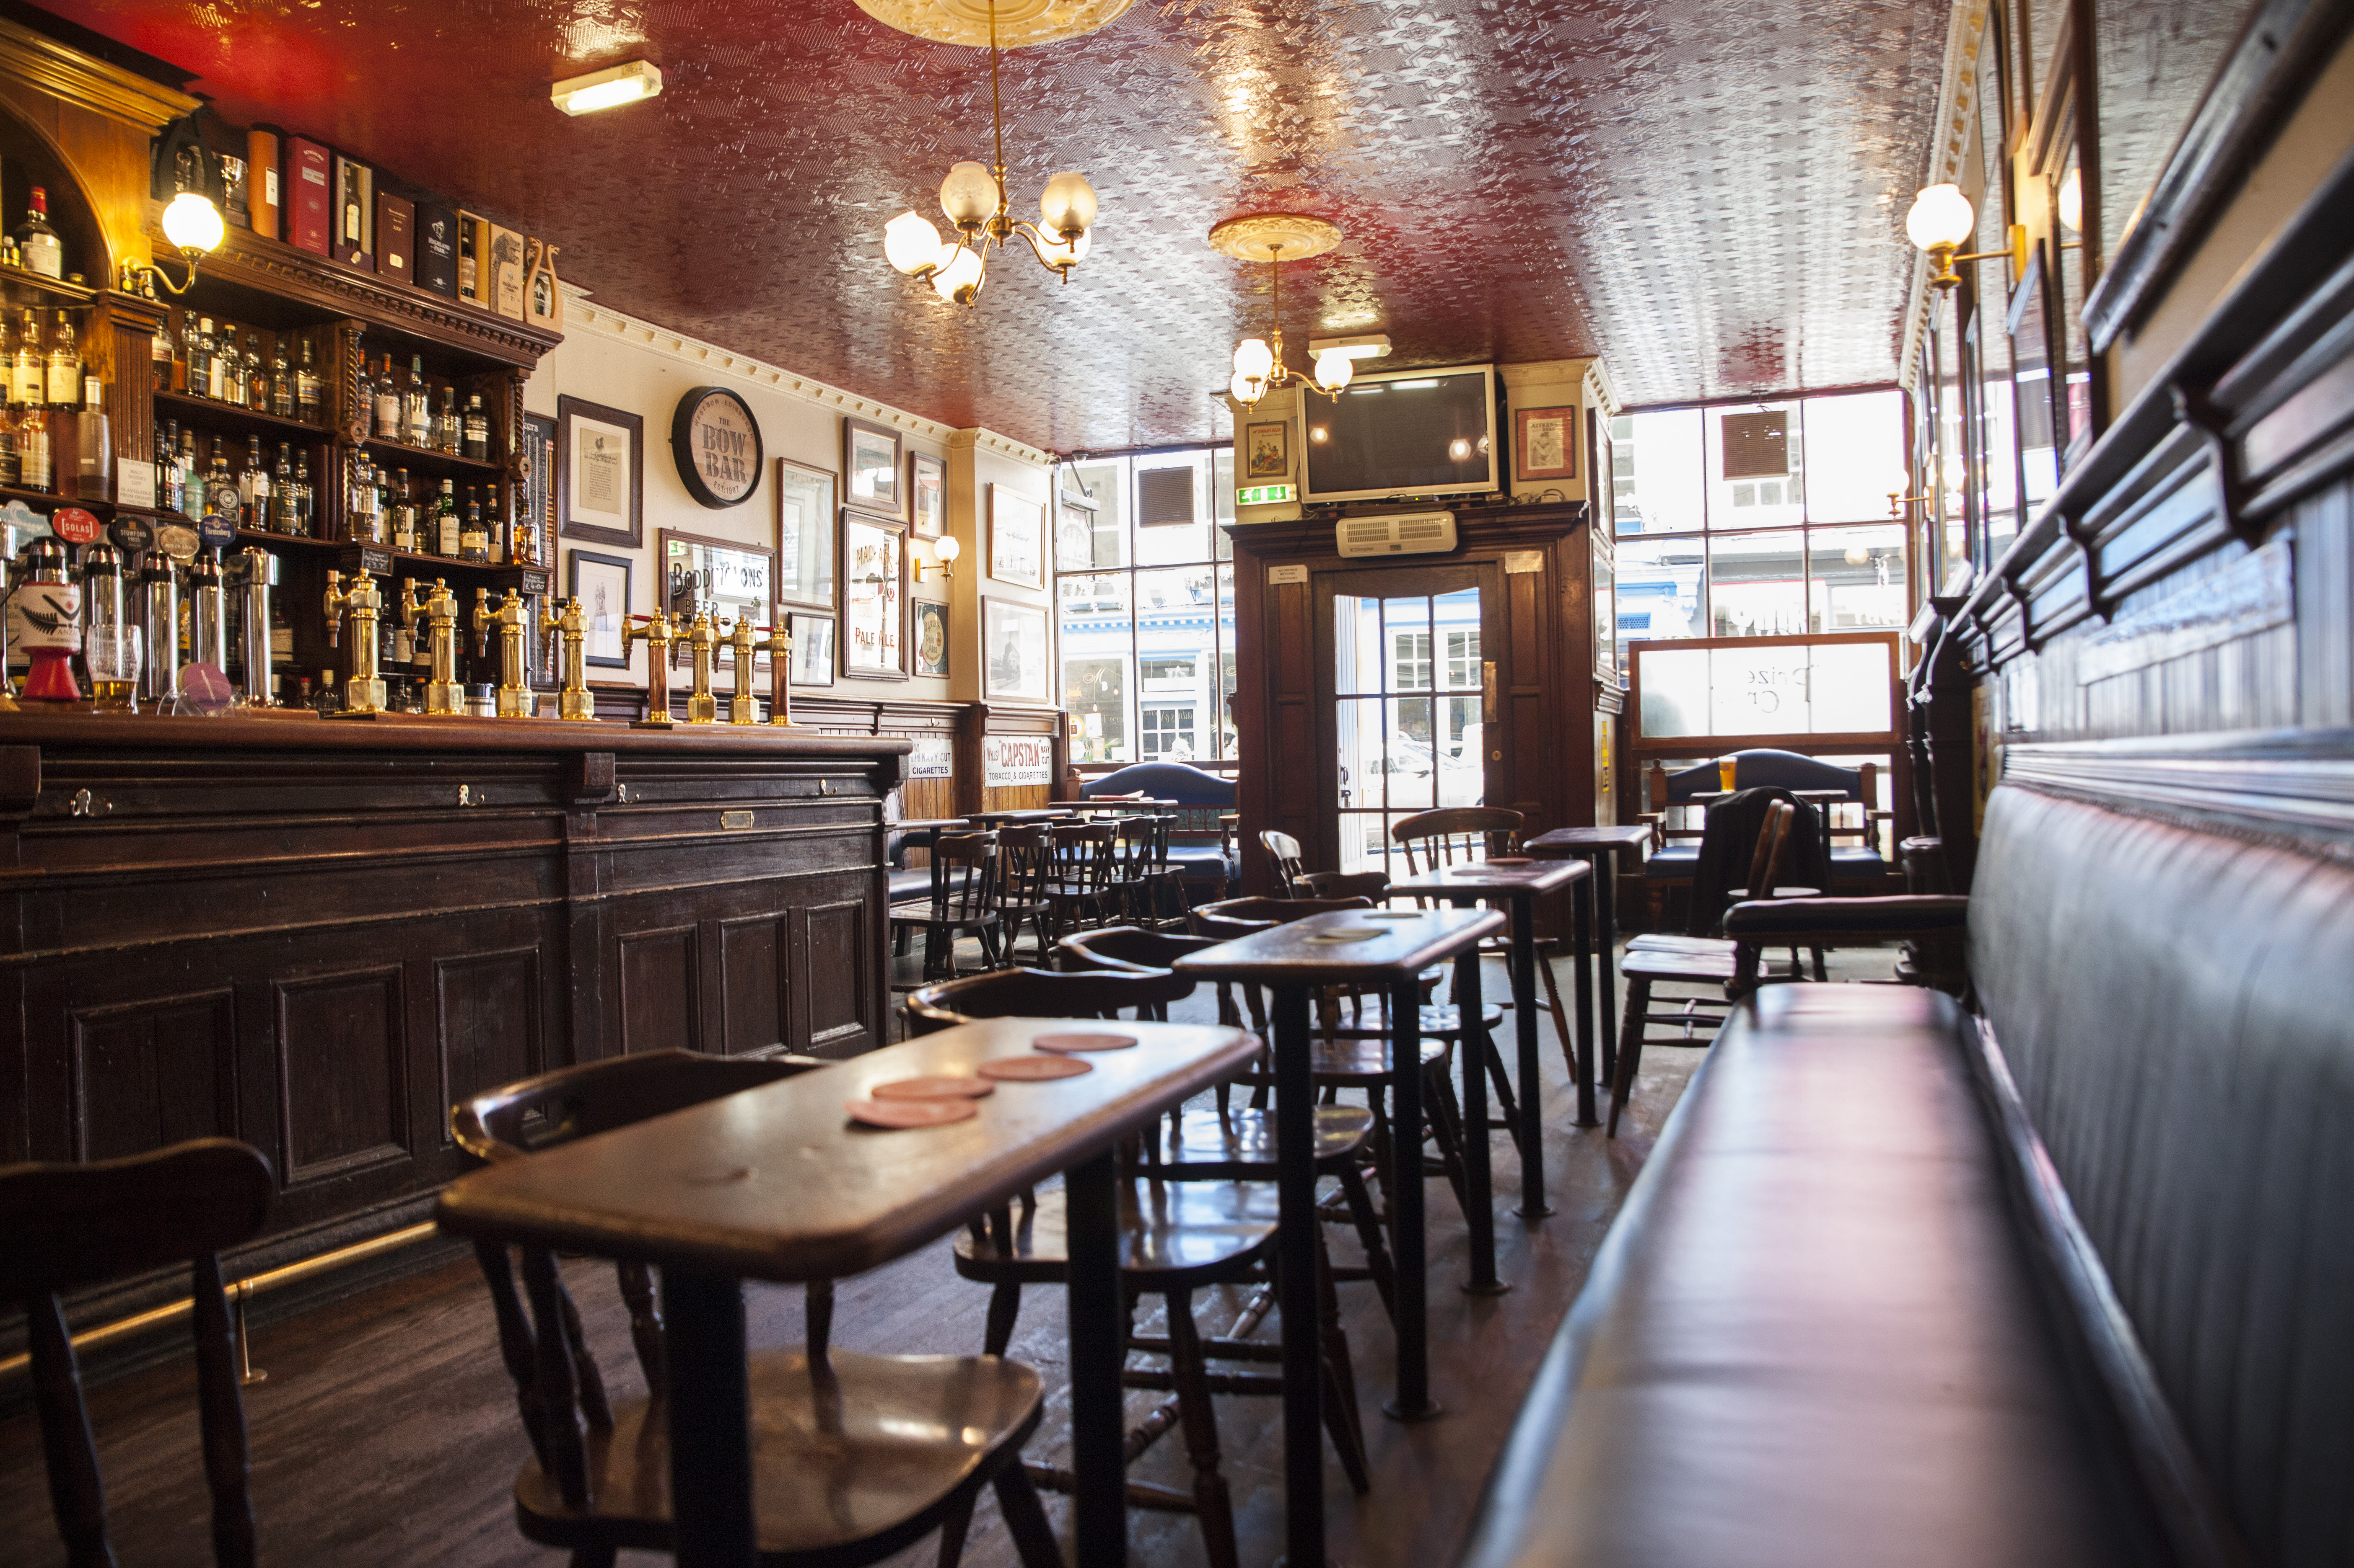

The Bow Bar was last night (September 25) named the Pub of the Year – Scotland 2017 at the AA Hospitality Awards.

Now in its 20th year, the glittering awards ceremony at the Grosvenor House Hotel celebrates the UK’s top hotels, restaurants, and pubs and the people behind them. It also marks the release of the 2018 editions of the AA’s range of lifestyle guides; the AA Hotel Guide and AA Best Restaurants Guide.

The AA Pub of the Year Award, introduced in 2001, is the AA’s ultimate accolade for pubs in the UK. Winners of this prestigious award stand out as truly excellent all-round pubs or inns. They successfully combine the provision of enjoyable food, a great pub atmosphere and a warm welcome with a high standard of management.

Mike Smith, Manager of the Bow Bar, said:
“Managing an independent bar allows for a lot more creativity, so we put a lot of energy into making a simple formula a success. To be recognised for these efforts is a real honour, and we are grateful to be named the ‘Best Pub in Scotland’.”

An AA Hotel Inspector said of the Bow Bar:
“For any whisky or beer connoisseur, the Bow Bar is an absolute delight”.

…Ends…

For press enquiries including images and interview availability, please contact:

020 7361 7860
liz.mallett@midaspr.co.uk / zekra.rahman@midaspr.co.uk

Note to Editors

About Bow Bar
Opened in 1987, the Bow Bar is now in its 30th year. Recreating a traditional Scottish, single room bar, the Bow Bar has lead the local drinking scene by focusing on just Whiskey and Beer. With no flashing machines, music or TVs (exception of 6 Nations and Wimbledon), the bar encourages the art of conversation.

80 W Bow, Edinburgh EH1

