UNDER EMBARGO UNTIL 00:01AM 15TH NOVEMBER 2017

RUNACH ARAINN NAMED AA GLAMPING SITE
OF THE YEAR

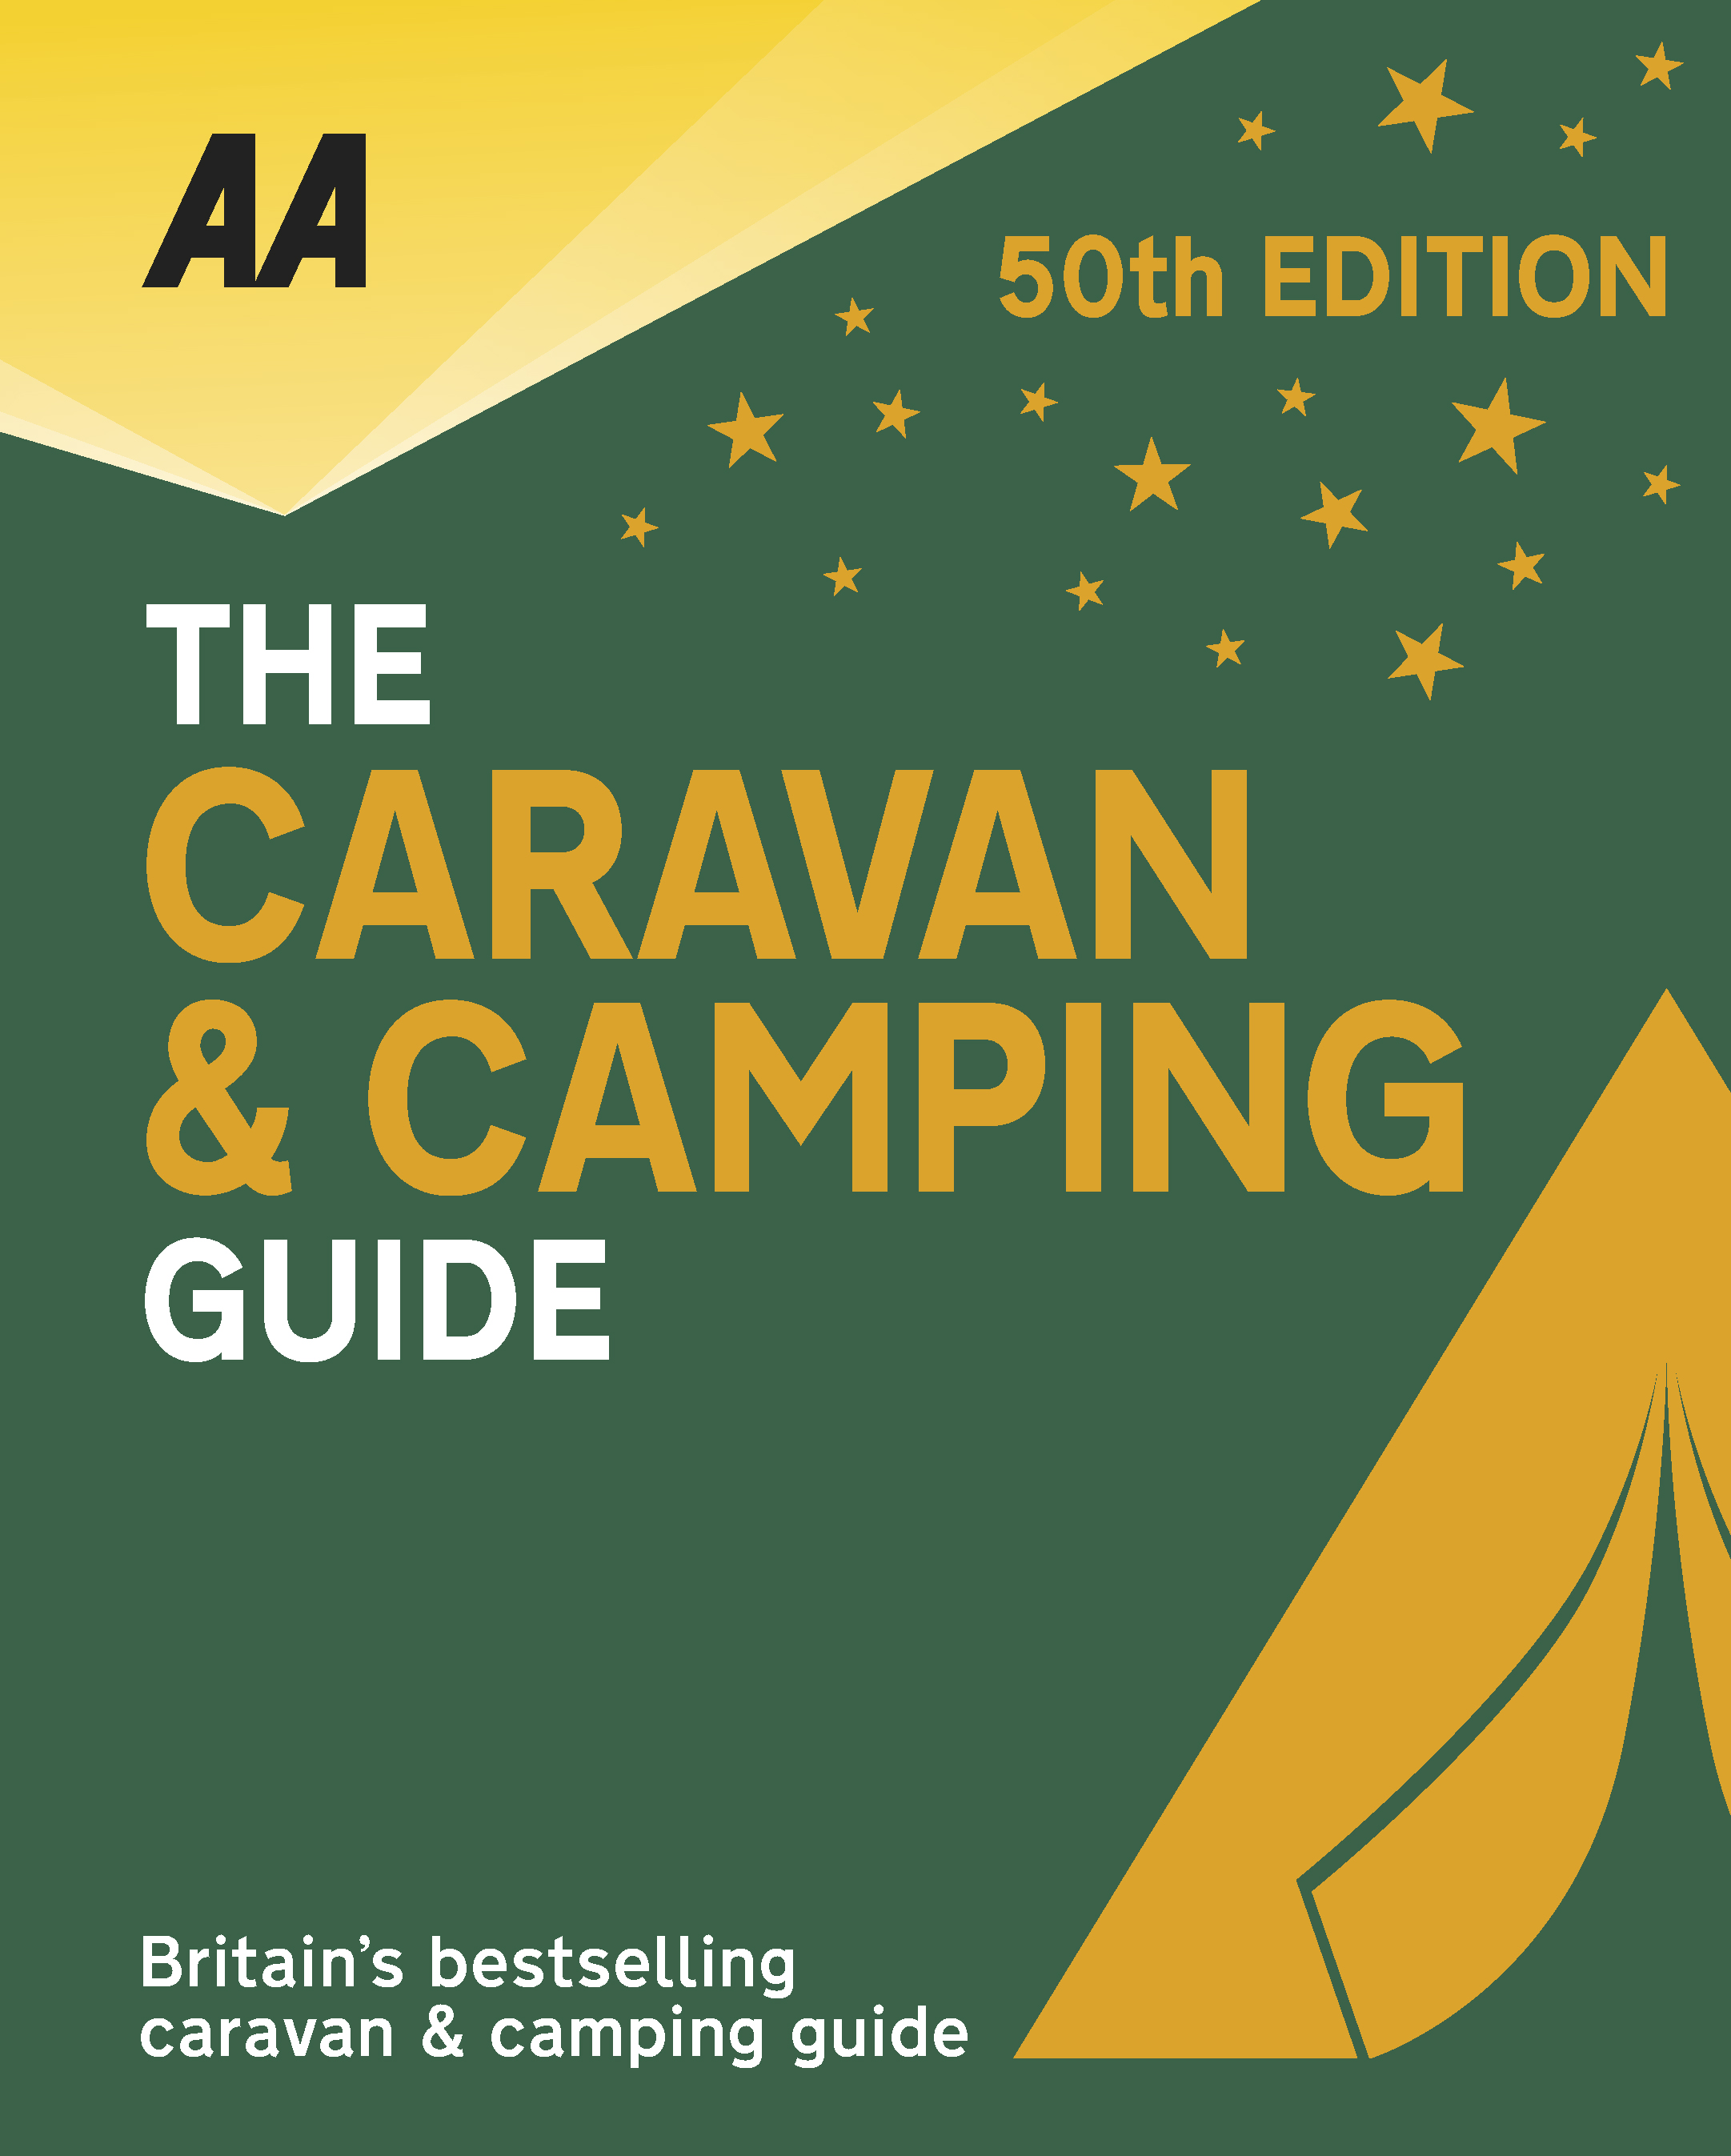
The very best spots for British caravanning and camping have been revealed today as the AA announce the winners of the AA Caravan and Camping Awards 2018. Amongst those celebrating is Runach Arainn in Kilmory, Isle of Arran, winners of AA Glamping Site of the Year 2018.

Brexit and the fall in the value of the pound has helped contribute to the rise of glamping and luxury options available, helping to ensure these camping and caravanning sites remain firm family favourites for holiday destinations. More and more sites now provide the likes of luxury yurts and huts in addition to the more traditional family holiday options.

Runach Arainn, Gaelic for ‘Secret Arran’, lives up to its name – three superb Scottish-made, 20ft-diameter yurts hidden away in a quiet and beautiful part of the Isle of Arran, just a 15-minute walk from a lovely beach on the southern shore of this magical island. Access is via a quiet lane, which is a riot of wild flowers and flowering hawthorn in spring, providing the perfect introduction to Runach Arainn. It’s a successful delivery of glamping style. The very high quality and spacious yurts have furnishings and fittings that create the rustic romance of camping, while the private bathrooms add creature comfort that is an essential component of a truly exceptional glamping experience. Fire pits and outdoor cooking facilities enhance rustic charm and appeal of the place. The yurts sit within a developing forest garden that the owners have created, and the purchase of neighbouring woodland has further expanded and improved this true rural idyll. With chickens, geese, ducks and now bee hives in the new wooded area, this is a true return to nature that’s very much in tune with yurt living.

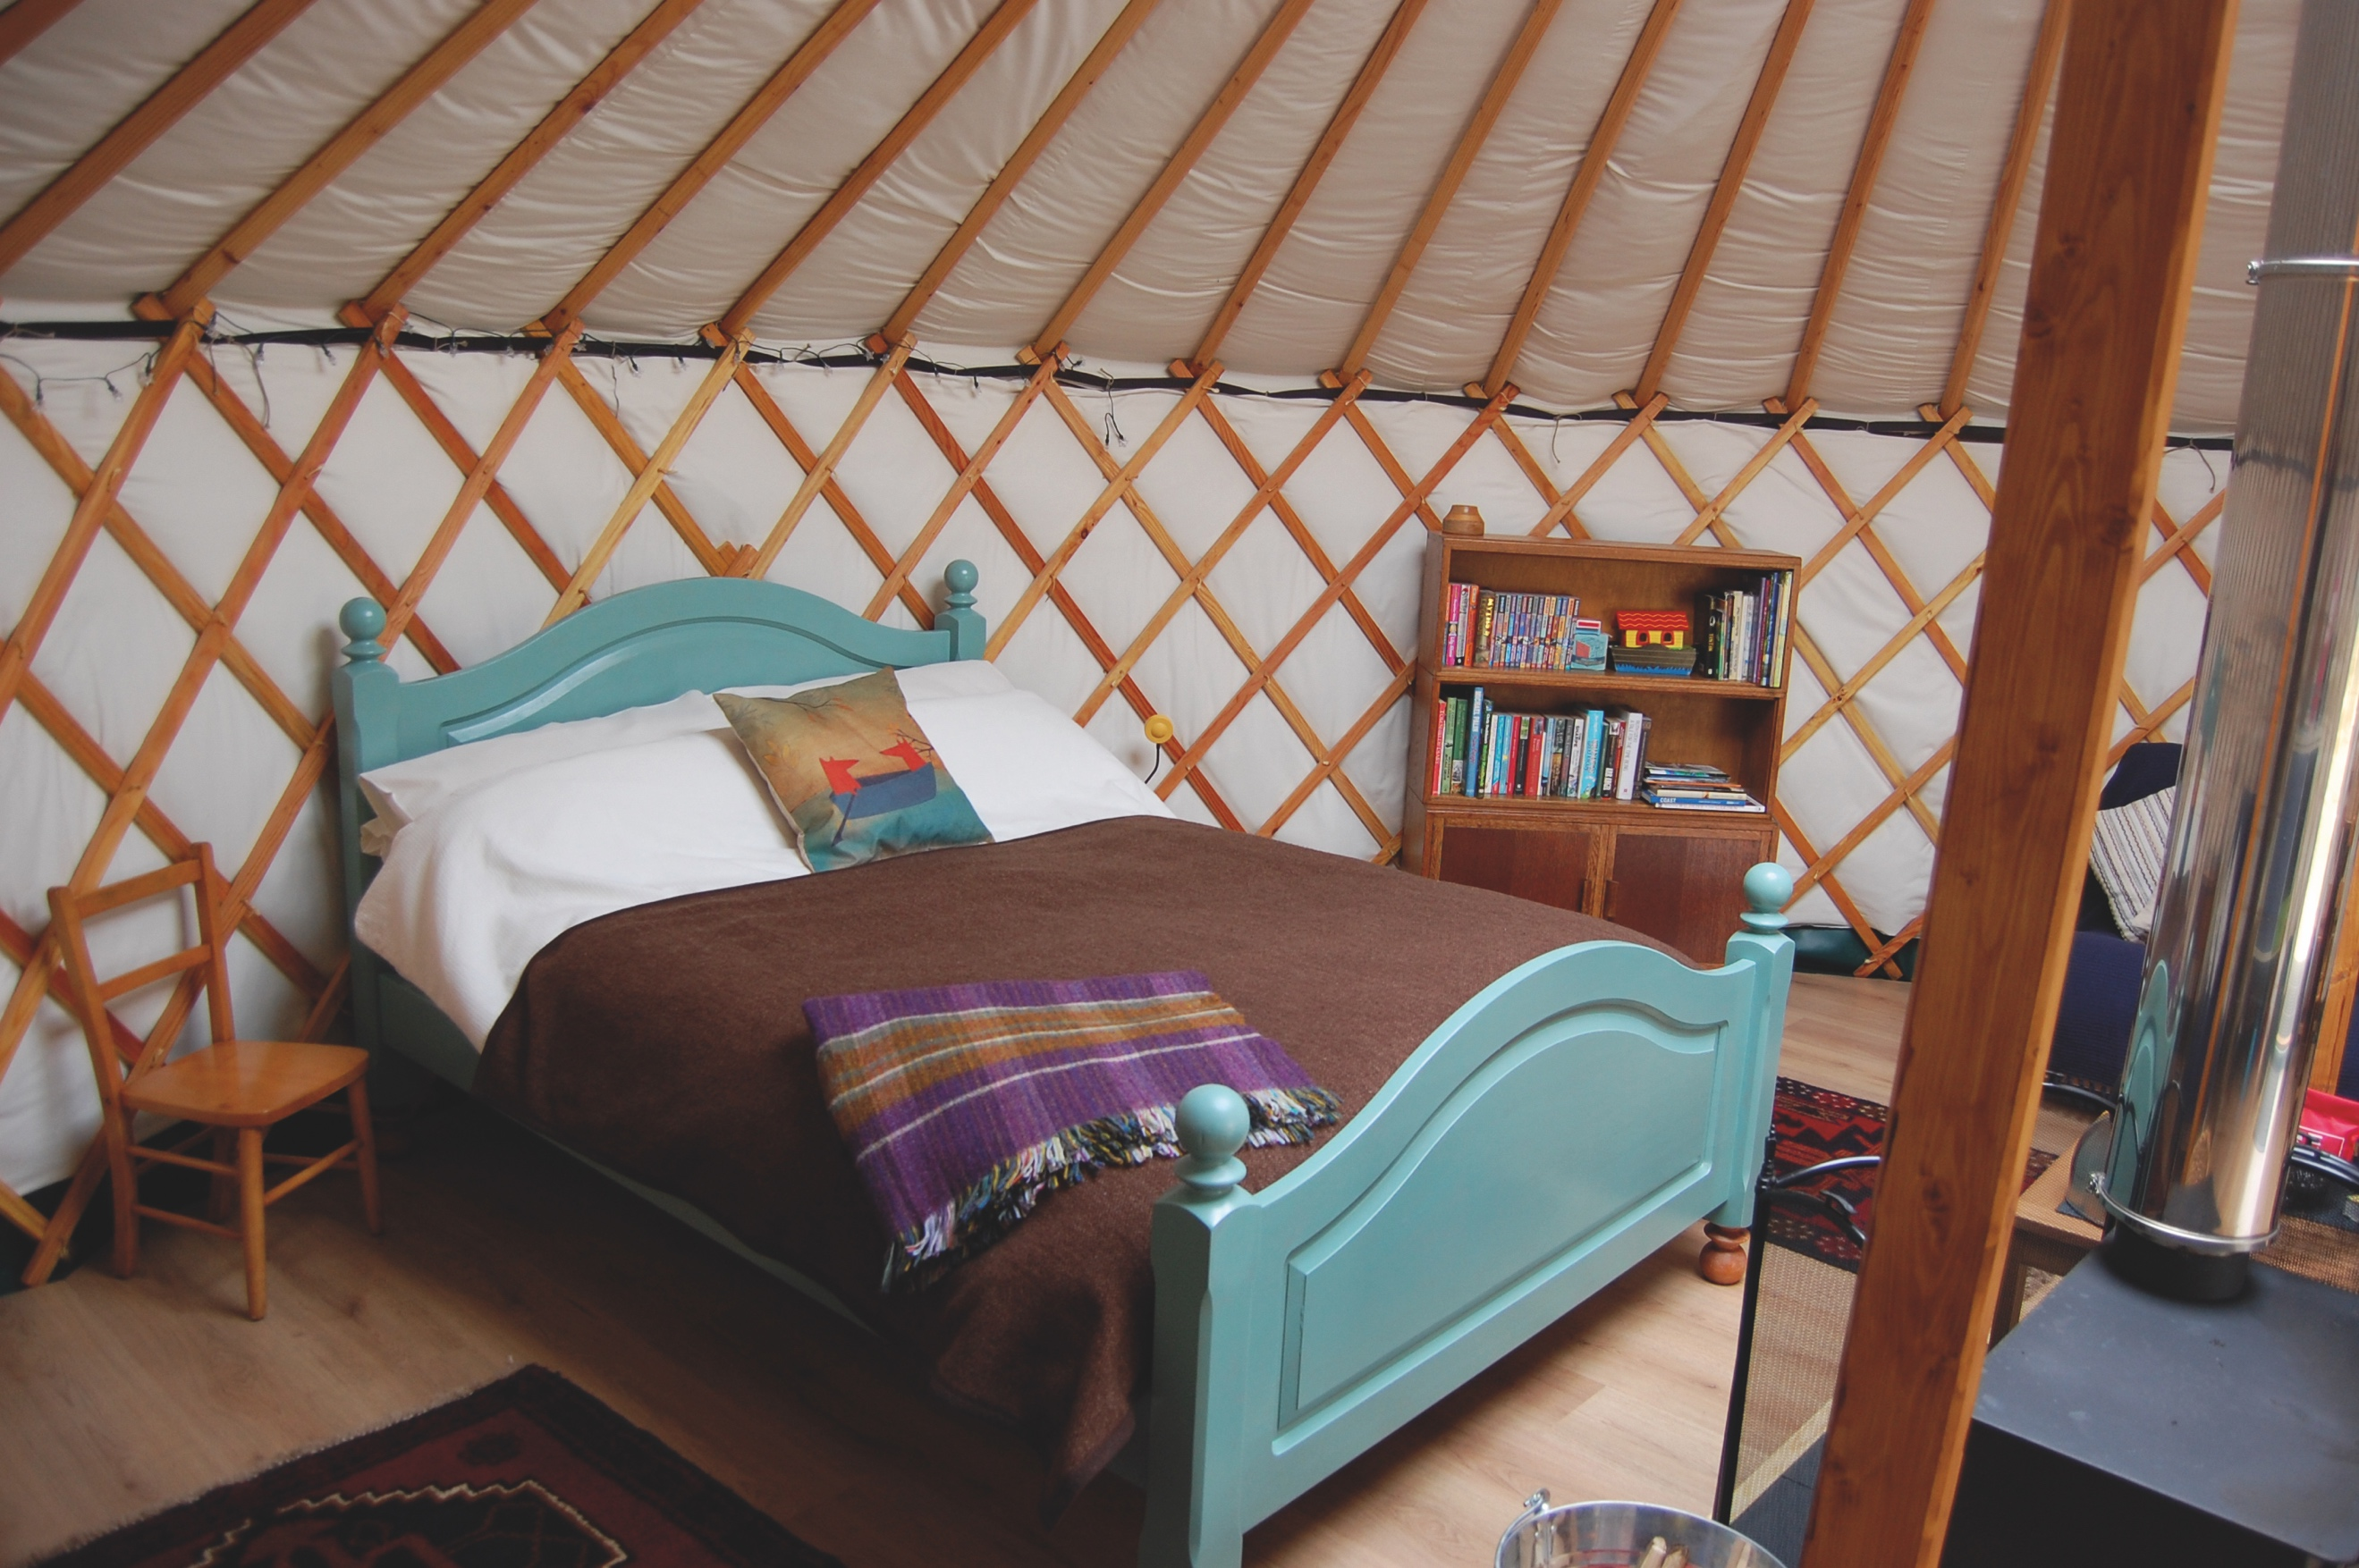
All winners will feature in the 50th Anniversary Edition of the AA Caravanning and Camping Guide. Each of the 800 sites included in the guide have been visited by one of the AA’s experienced Campsite Inspectors, grading sites from one to five Pennants, based on their facilities and hospitality. Only the parks of the very highest standard are awarded the coveted Gold Pennant award. Each entry within the guide includes location, ratings, contact details, directions, prices, opening times, facilities and a description to help select the right site for your needs.
The AA Caravan and Camping Guide 2018 is available from amazon.
The winners of the 2018 AA Caravan and Camping Awards are:
AA CAMPSITE OF THE YEAR 2018
ENGLAND AND OVERALL WINNER: Old Oaks Touring Park, Glastonbury, Somerset
SCOTLAND: Trossachs Holiday Park, Aberfoyle, Stirling
WALES: Red Kite Touring Park, Llanidloes, Powys

AA REGIONAL CAMPSITES OF THE YEAR 2018
SOUTH WEST: Trevalgan Touring Park, St Ives, Cornwall
SOUTH EAST: Whitefield Forest Touring Park, Ryde, Isle of Wight
HEART OF ENGLAND: Cakes & Ale, Leiston, Suffolk
NORTH WEST: Skelwith Fold Caravan Park, Ambleside, Cumbria
NORTH EAST: Herding Hill Farm, Haltwhistle, Northumberland

HOLIDAY CENTRE OF THE YEAR 2018
Woodside Bay Lodge Retreat, Wooton Bridge, Isle of Wight

MOST IMPROVED CAMPSITE OF THE YEAR 2018
Wheathill Touring Park, Wheathill, Shropshire

SMALL CAMPSITE OF THE YEAR
Seal Shore Camping & Touring Site, Kildonan, Isle of Arran

GLAMPING SITE OF THE YEAR
Runach Arainn Glamping, Kilmory, Isle of Arran

***Ends***
For press enquires or more information please contact Chris Webb on 01256 491521 or Chris.Webb@theAA.com

