PRESS RELEASE
Strictly embargoed until 26 September 2017

Welsh restaurant is named top spot for wine in the UK

Ynyshir Restaurant and Rooms wins AA Hospitality’s Wine Award 2017

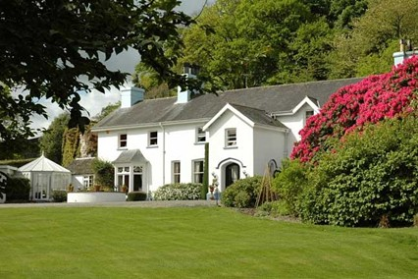

Ynyshir Restaurant and Rooms was last night (September 25) awarded the prestigious title of Wine Award of Wales and overall Wine Award Winner for the UK in 2017 last night at the annual AA Hospitality Awards.

Now in its 20th year, the glittering AA Hospitality Award ceremony at the Grosvenor House Hotel celebrates the UK’s top hotels, restaurants, and pubs and the people behind them. It also marks the release of the 2018 editions of the AA’s range of lifestyle guides; the AA Hotel Guide and AA Best Restaurants Guide.

Ynyshir is a Michelin star, four AA rosette restaurant with rooms that has flavour and simplicity as the focus of every dish that Chef Patron, Gareth Ward creates. The team uses the best ingredients and techniques to get the best from them, to in Ward’s words - offer tasting menus of ‘Alternative British Snap’ packed with flavour.

With a simple and accessible wine list, there are a wide variety of regions listed and some new and interesting producers that focus on flavour. The team at Ynyshir have put a lot of time into sourcing varietals and understanding producers.

Ynyshir General Manager, Amelia Eiriksson, said: “This is awesome for us and very unexpected! Our list is made up of things that we love to drink, with a few incredible classics in there and lots of new terroir driven wines. It matches our food - if it tastes amazing it goes on the list!”

An AA Hotel Inspector said of Ynyshir: “The dining room at Ynyshir offers the very best selection of wines to accompany their highly accomplished food.”

Wine Award Winner, England 2017: The Five Fields, Chelsea

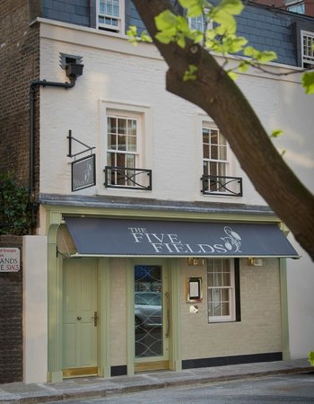
Taylor Bonnyman, Chef Patron of The Five Fields, encapsulates the spirit of the capital with his cooking. With a foundation built on British produce and seasonality, the cooking incorporates influences from London’s broad cultural complexion and outward-looking philosophy.

This understated Modern British restaurant has a fixed-price menu using rare herbs and seasonal produce. Head Sommelier, Mathias Camilleri, assisted by his professional and knowledgeable team, has compiled a value driven list of around 500 bins. The classic wines of Europe and the New World are strongly represented, as are many exciting smaller producers and emerging regions.

The Five Fields, Chelsea have aimed to create a versatile, eclectic bottle list to suit any taste and occasion. A wine list with plenty of personality and energy, classic and cult producers mingle with some off-the-beaten-track references, and is accompanied by an imaginative glass selection.

An AA Hotel Inspector said of The Five Fields: “Bonnyman's experience in kitchens across the globe provides The Five Fields with intelligent and exemplary cooking with the wine list to match.”

Wine Award Winner, Scotland 2017: Restaurant Andrew Fairlie, Gleneagles

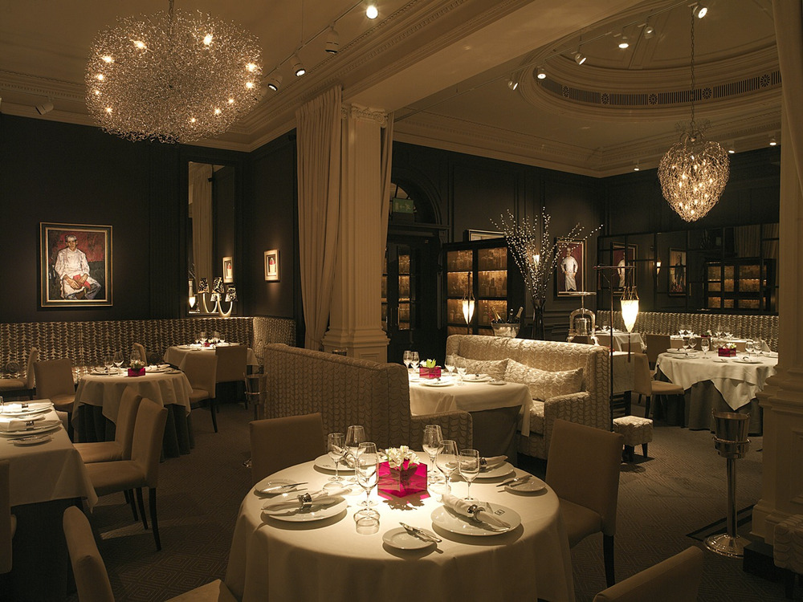
Described as Scotland’s best restaurant, and the only one in the country to hold two Michelin stars. Andrew Fairlie is one of Britain’s most celebrated chefs, and his exquisite restaurant is a sumptuous setting for a meal that will live long in the memory, combining the very best in French and Scottish cooking.

The wine list is luxurious and extensive and is paired perfectly with each serving of food giving their guests the ultimate wining and dining experience.

Andrew Fairlie and his team is dedicated to serving dinner six nights a week. Guests receive a warm welcome from civilised young professionals, into an opulent, evening only space hidden behind a discreet private entrance in the heart of Gleneagles. An atmosphere of assuredness, where thoughtful service and attention to detail are ranked as highly as creative cooking. Expect a great night out in a relaxed and comfortable 'salon' environment.

An AA Hotel Inspector said of Restaurant Andrew Fairlie: “The team's ability to match the standard of their food with their selection of wines is commendable.”

About the AA Wine Award
Introduced in 1998, this award recognises and outstanding contribution to promoting wine understanding and appreciation. Nominees are judged on the quality of their wine list and their ability to inspire customers to make wider and more adventurous choices in selecting wines. The award sponsored by Matthew Clark.

Andrew Oxley, Head of Hotel Services at The AA said: “Each of these establishments has impressed us by their hand-selected and imaginative wine lists and their expertise in fine and accessible wines”

…Ends…

For press enquiries including images and interview availability, please contact:

020 7361 7860
liz.mallett@midaspr.co.uk / zekra.rahman@midaspr.co.uk

