PRESS RELEASE
Strictly embargoed until 26 September 2017 at 00:01

THE BELL AT RAMSBURY CROWNED
AA PUB OF THE YEAR ENGLAND 2017
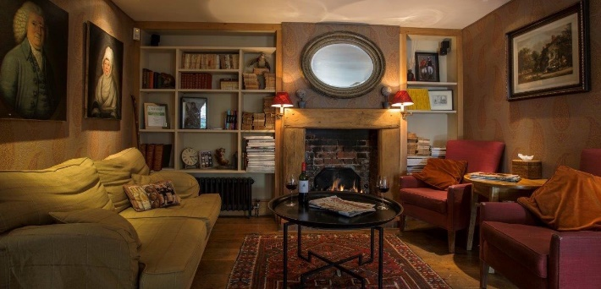
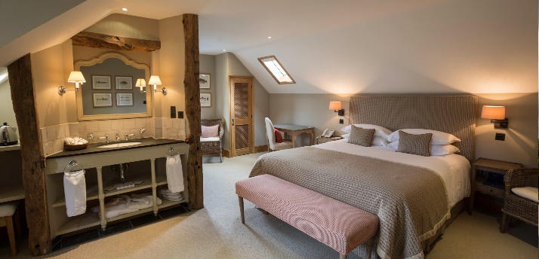
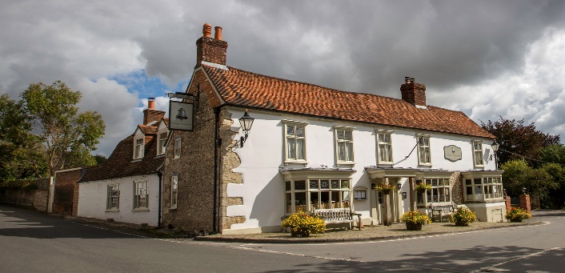

The Bell at Ramsbury was last night (September 25) named the Pub of the Year – England 2017 at the AA Hospitality Awards.

Now in its 20th year, the glittering awards ceremony at the Grosvenor House Hotel celebrates the UK’s top hotels, restaurants, and pubs and the people behind them. It also marks the release of the 2018 editions of the AA’s range of lifestyle guides; the AA Hotel Guide and AA Best Restaurants Guide.

The AA Pub of the Year Award, introduced in 2001, is the AA’s ultimate accolade for pubs in the UK. Winners of this prestigious award stand out as truly excellent all-round pubs or inns. They successfully combine the provision of enjoyable food, a great pub atmosphere and a warm welcome with a high standard of management.

Matt Saxton, Manager of The Bell, said:
"To receive the AA Award for the Best Pub in England is an amazing achievement.
This is a trying time for the catering industry and I’m incredibly proud of how my team has shone through it all. I am also really thankful to all of our guests that have supported us, and our owners that have backed our ideas to make our estate greater. Watch this space there is lots more to come."

An AA Hotel Inspector said of The Bell:
“An inn with a lot to offer – including comfy rooms, a welcoming bar and a café.”

…Ends…

For press enquiries including images and interview availability, please contact:

020 7361 7860
liz.mallett@midaspr.co.uk / zekra.rahman@midaspr.co.uk

Note to Editors

About The Bell at Ramsbury
The Bell at Ramsbury is a 300-year-old former coaching inn, in the beautiful village of Ramsbury near Marlborough. Located in the centre of this thriving community, The Bell is well loved by those who live locally as well as people looking for somewhere special to dine. The Bell became part of the Ramsbury Estate in 2010 and then underwent an extensive refurbishment. The philosophy of celebrating the local area and investing back into it meant using talented local craftsmen to create a warm, welcoming and refined pub.

Over the last few years the team have been working towards their goal of sourcing as much from their own estate or from the local area as possible. Fruit and vegetables hand selected from the acre of walled kitchen garden, sausages and dry cured bacon from our own smokehouse, dry aged beef from the estate's herd of beautiful south and north Devon cattle and water meadow lamb reared on the banks of the river Kennet on the estate.

During the season we are lucky enough to have venison from the estate's sustainable woodland and as many game birds as we want.

Taking this ethos further has meant The Bell is also able to pour award winning Ramsbury single estate spirits as their house serve. Grain vodka and gin are made a stones throw from The Bell using the estates own wheat, water from their own source and botanicals also sourced on the estate. Attached to the distillery is the much loved Ramsbury Brewery and a variety of its craft beers are on tap in The Bell. Lastly, we only cook with the estate's own extra virgin cold pressed rapeseed oil.

The Bell at Ramsbury, The Square, Ramsbury, Marlborough SN8 2PE

