**PRESS RELEASE**

**Strictly embargoed until 26 September 2017 at 00:01**

**THE OLD INN CROWNED**

**AA HOTEL OF THE YEAR N. IRELAND 2017**

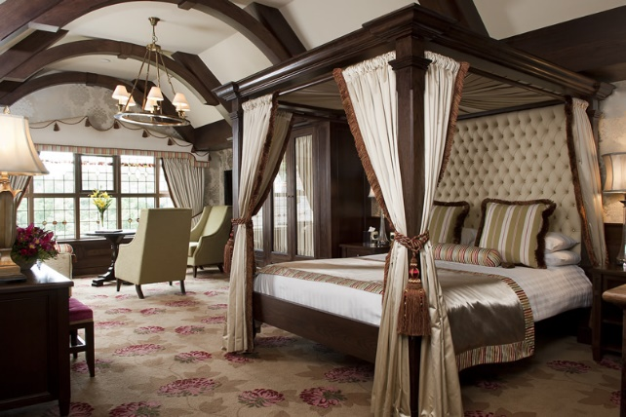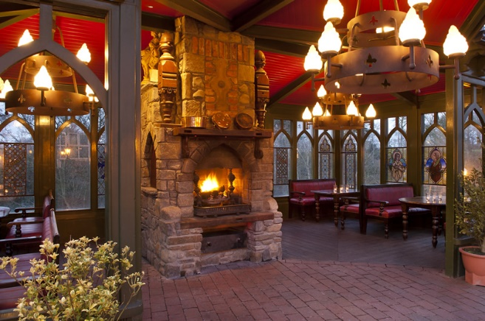

**The Old Inn** was last night (September 25) named the Hotel of the Year – N. Ireland 2017 at the AA Hospitality Awards.

Now in its 20th year, the glittering awards ceremony at the Grosvenor House Hotel celebrates the UK’s top hotels, restaurants, and pubs and the people behind them. It also marks the release of the 2018 editions of the AA’s range of lifestyle guides; the AA Hotel Guide and AA Best Restaurants Guide.

The AA Hotel of the Year Award, introduced in 1992, is the AA’s ultimate accolade for hotels in the UK. It is awarded to hotels that are recognised as being outstanding examples in their particular market. From the small family-run hotel to the most ambitious commercial ventures, hotels of every size and style are potential winners.

**Paul Rice, Managing Director of The Old Inn, said:**

*“When we heard the news of being The AA’s Northern Ireland Hotel of the Year for 2017 we were of course delighted. It recognises the individuals throughout the hotel for their warm personalities and the skill and execution of delivering top class food, drinks, accommodation. It is also great recognition for the sales and administration team for ensuring our brand and our company remain strong in a challenging market.”*

**An AA Hotel Inspector said of The Old Inn:**

*“Behind the quaint thatched exterior of The Old Inn lies an untold elegance and grandeur.”*

**…Ends…**

**For press enquiries including images and interview availability, please contact:**



**020 7361 7860**

[**liz.mallett@midaspr.co.uk**](mailto:liz.mallett@midaspr.co.uk) **/** [**zekra.rahman@midaspr.co.uk**](mailto:zekra.rahman@midaspr.co.uk)

**Note to Editors**

**About The Old Inn**

Owned by the Rice family for 34 years, this thatched coaching Inn has been trading continuously for over 400 years. Millions of pounds of reinvestment by the Rice family has meant that the inn has become a local icon, growing from strength to strength. There remains a strong focus on local staff, local producers and promoting Northern Ireland’s charm.

**15-25 Main St, Crawfordsburn, Bangor BT19 1JH**