PRESS RELEASE
Strictly embargoed until 26 September 2017 at 00:01

THE DOUNESIDE HOUSE CROWNED
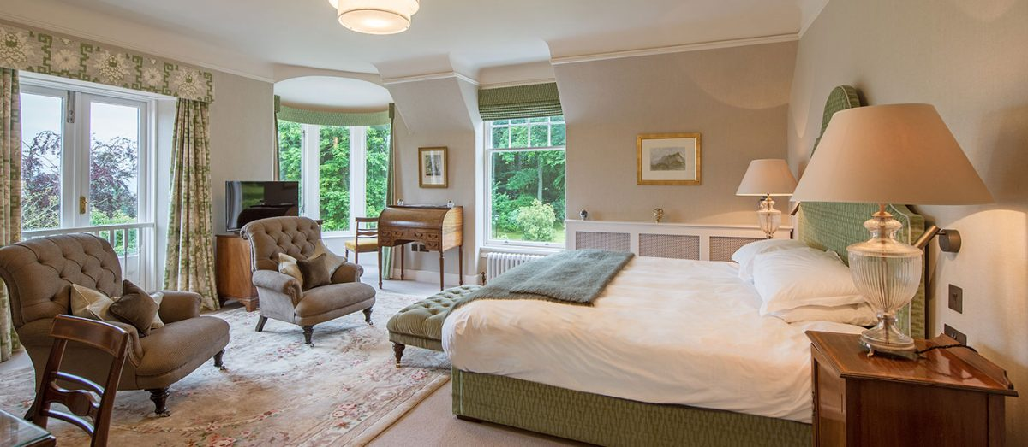
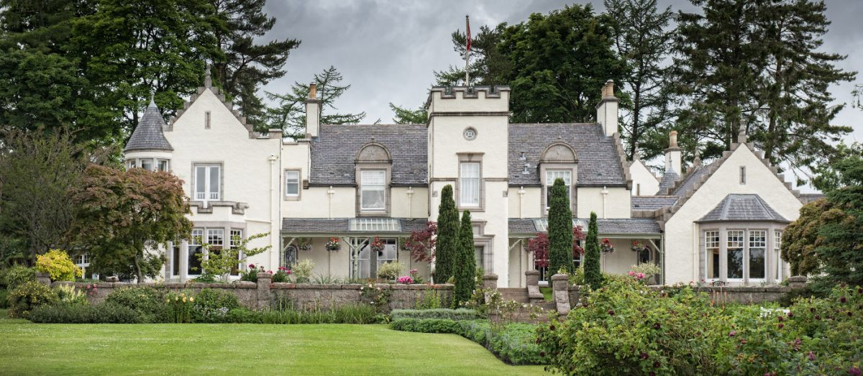
AA HOTEL OF THE YEAR SCOTLAND 2017

The Douneside House was last night (September 25) named the Hotel of the Year – Scotland 2017 at the AA Hospitality Awards.

Now in its 20th year, the glittering awards ceremony at the Grosvenor House Hotel celebrates the UK’s top hotels, restaurants, and pubs and the people behind them. It also marks the release of the 2018 editions of the AA’s range of lifestyle guides; the AA Hotel Guide and AA Best Restaurants Guide.

The AA Hotel of the Year Award, introduced in 1992, is the AA’s ultimate accolade for hotels in the UK. It is awarded to hotels that are recognised as being outstanding examples in their particular market. From the small family-run hotel to the most ambitious commercial ventures, hotels of every size and style are potential winners.

Marcel Wassen, General Manager of Douneside House, said:
“We are absolutely delighted to win this award. It is a reflection of the hard work of the whole team; without their dedication, commitment and passion this would not have been possible.”

An AA Hotel Inspector said of Douneside House:
“The Douneside House presents customers with warm, friendly and engaging staff as well as excellent standards throughout.”

…Ends…

For press enquiries including images and interview availability, please contact:

020 7361 7860
liz.mallett@midaspr.co.uk / zekra.rahman@midaspr.co.uk

Note to Editors

About Douneside House
Douneside House is a luxury country house hotel in Royal Deeside, Aberdeenshire. It was opened in July 2016 by HRH Prince Michael of Kent, following a £5m renovation of the main house, health club and on-site holiday cottages. Douneside was the original family home of the MacRoberts, well known locally for their significant philanthropy. The MacRobert family photos, antiques and heirlooms are thoughtfully placed throughout the hotel.

Douneside House is now owned by a charitable trust (The MacRobert Trust). 100% of all profits made by Douneside are either reinvested in the property or gifted to UK charities. There are 13 bedrooms in the main building, 6 apartments and 4 cottages within close proximity. There is an on-site health club with a swimming pool, sauna, jacuzzi and a gym.

The MacRobert Trust is also very focussed on creating a sustainable business and supporting the local economy. Douneside is powered by a biomass and solar PV scheme, and its gardens produce most of the fruit and veg used in the House, making it one of Scotland’s largest hotel kitchen gardens.

Douneside House, Tarland, Aboyne AB34 4UL

