PRESS RELEASE
Strictly embargoed until 26 September 2017 at 00:01

BRYN TYRCH CROWNED
AA PUB OF THE YEAR WALES 2017

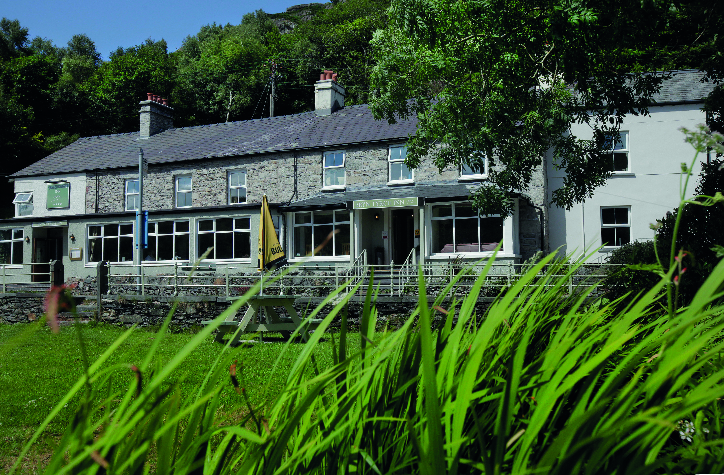

Bryn Tyrch was last night (September 25) named the Pub of the Year – Wales 2017 at the AA Hospitality Awards.

Now in its 20th year, the glittering AA Hospitality Award ceremony at the Grosvenor House Hotel celebrates the UK’s top hotels, restaurants, and pubs and the people behind them. It also marks the release of the 2018 editions of the AA’s range of lifestyle guides; the AA Hotel Guide and AA Best Restaurants Guide.

The AA Pub of the Year Award, introduced in 2001, is the AA’s ultimate accolade for pubs in the UK. Winners of this prestigious award stand out as truly excellent all-round pubs or inns. They successfully combine the provision of enjoyable food, a great pub atmosphere and a warm welcome with a high standard of management.

Rachel Roberts, Marketing Director of Bryn Tyrch, said:
“We are very proud and honoured to get this award. This reflects a real team effort from all the team and we thank them for all their hard work and for our clients for believing and supporting us.”

An AA Hotel Inspector said of Bryn Tyrch:
“A charming old inn with mountain views.”

…Ends…

For press enquiries including images and interview availability, please contact:

020 7361 7860
liz.mallett@midaspr.co.uk / zekra.rahman@midaspr.co.uk

Note to Editors

About Bryn Tyrch
Bryn Tyrch is a second generation independently owned family run inn, in the heart of Snowdonia.

Ten years ago Rachel and Neil took over the helm putting in a major refurbishment programme and took it from a hikers retreat to a one rosette 4 star inn. Major emphasis was also placed on hospitality and this has been reflected in the Welsh Award for hospitality awarded in 2016/17.

The aim was to prove that you could provide quality food and accommodation in Snowdonia and bring quality hospitality jobs to the area.

Bryn Tyrch, Capel Curig, Conwy LL24 0EL

