PRESS RELEASE
Strictly embargoed until 26 September 2017 at 00:01

THE DINING ROOM CROWNED
AA RESTAURANT OF THE YEAR SCOTLAND 2017
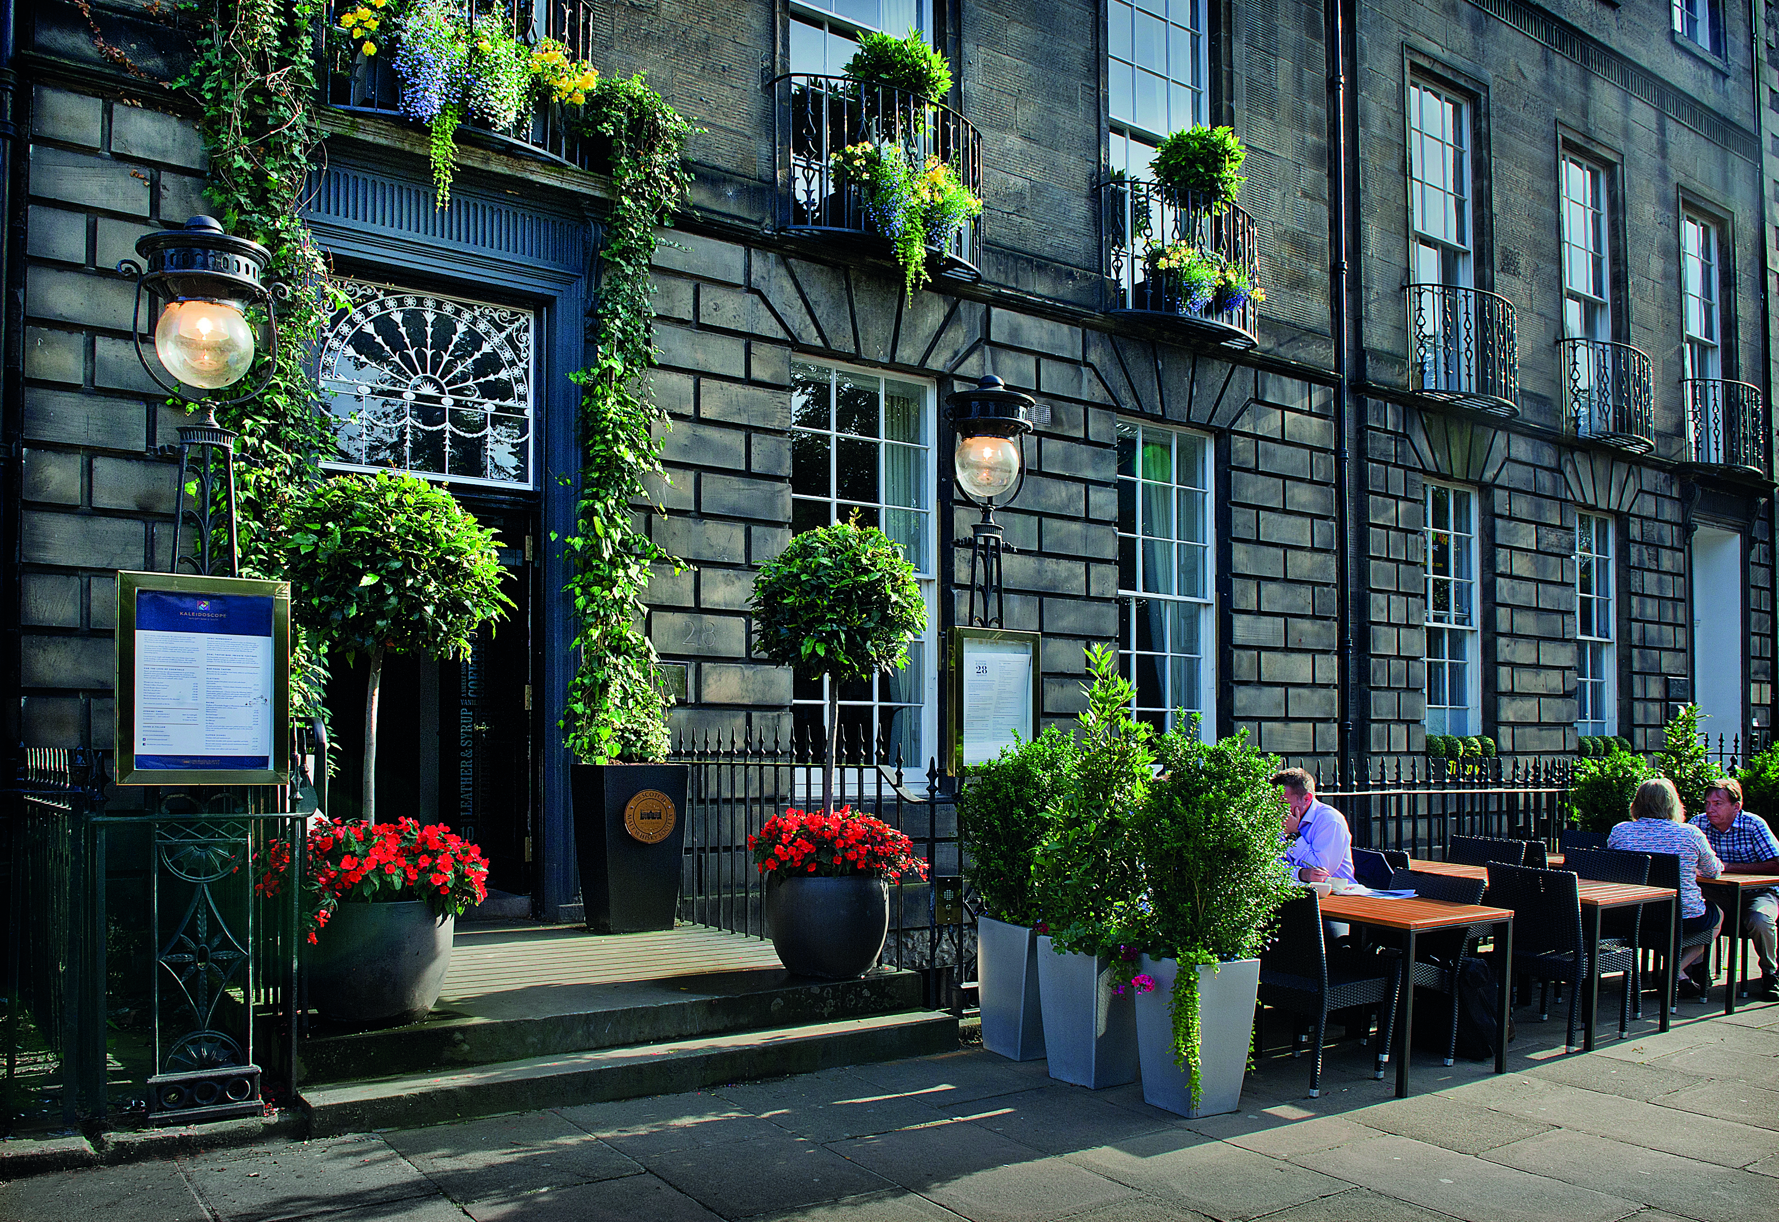
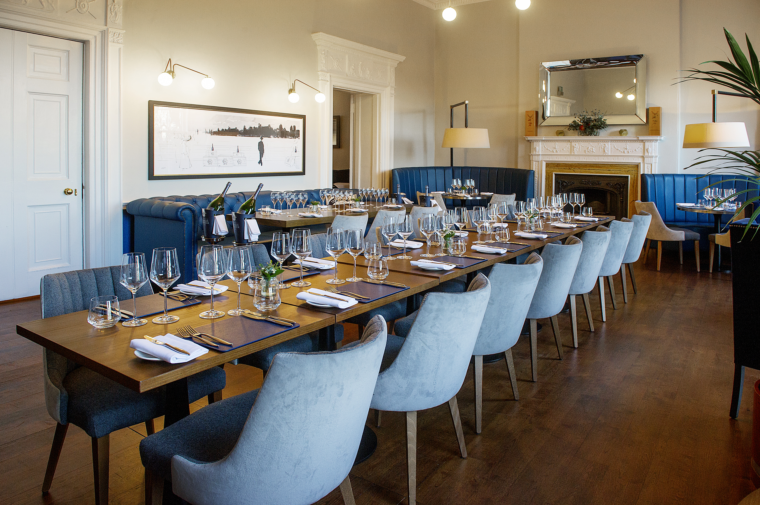

The Dining Room was last night (September 25) named the Restaurant of the Year – Scotland 2017 at the AA Hospitality Awards.

Now in its 20th year, the glittering awards ceremony at the Grosvenor House Hotel celebrates the UK’s top hotels, restaurants, and pubs and the people behind them. It also marks the release of the 2018 editions of the AA’s range of lifestyle guides; the AA Hotel Guide and AA Best Restaurants Guide.

The AA Restaurant of the Year award, introduced in 2000, recognises restaurants that provide cuisine of a truly excellent standard. This includes demonstrating innovation and ambience, whilst also providing a high standard of hospitality.

Jan-Willem Damen, Operations Director of the Dining Room, said:
“We are extremely proud to have been given this award. It is a recognition of 12 years of unwavering dedication by a kitchen team led throughout by Exec Chef James Freeman, to create stunning dishes with locally sourced Scottish ingredients.

“Manager Francois Guillemet and his team try and bring an element of entertainment to our guests, through the personable but unfussy service, the exquisite wines and our SMWS whisky pairings on the Taster Menu.

“The concept of The Dining Room has stood the test of time, offering fine dining to our guests whilst giving them the opportunity to explore the art of food and whisky pairing. Having an unrivalled selection of single cask whiskies available means that this concept will only grow in strength.”

An AA Hotel Inspector said: "The Dining Room’s partnership with The Scotch Malt Whiskey Society offers a dining experience steeped in French classicism.”

…Ends…

For press enquiries including images and interview availability, please contact:

020 7361 7860
liz.mallett@midaspr.co.uk / zekra.rahman@midaspr.co.uk

Note to Editors

About The Dining Room
The Dining Room started in 2004 as a restaurant for members of The Scotch Malt Whisky Society at the new flagship Edinburgh venue on Queen Street, in Edinburgh’s New Town. After three years the restaurant was opened to the general public.

Until August 2016, the restaurant was situated on the ground floor of the five-story town house venue, seating up to 36 people. After this date, the entire venue was refurbished and the Dining Room was expanded in order to cope with growing demand. Head Chef James Freeman has been in charge since the opening of the venue. James operates with a very small team and always is keen to use fresh local ingredients in the dishes.

The Scotch Malt Whisky Society is a Members club which specialises in single cask whisky and spirits, bottling over 450 different single casks of predominantly malt whisky each year. Members can sample the whisky in the venues and whisky plays an important part in the experience guests get in The Dining Room. Each diner is offered an amuse paired with a sample of SMWS whisky, just as a fun and surprising start to the evening. Whisky makes an occasional appearance on the menu in dishes like SMWS Whisky cured salmon, but it is not a dominant factor on the menu. If people want to indulge in the whisky side, the five-course taster menu gives an option of five whiskies paired to the five-course menu.

The Dining Room, 28 Queen St, Edinburgh EH2 1JX

