PRESS RELEASE
Strictly embargoed until 26 September 2017 at 00:01

THE FREEMASONS AT WISWELL CROWNED
AA RESTAURANT OF THE YEAR ENGLAND 2017
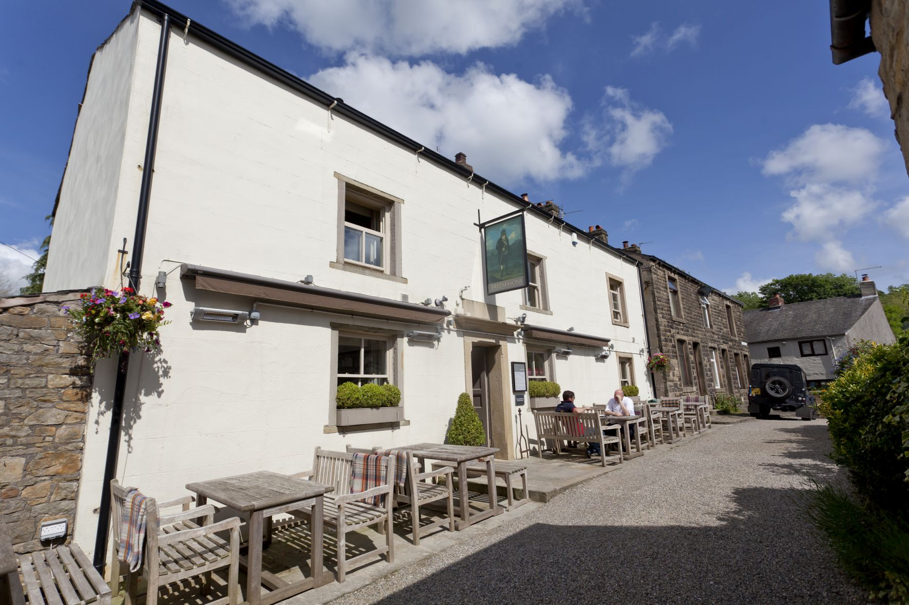
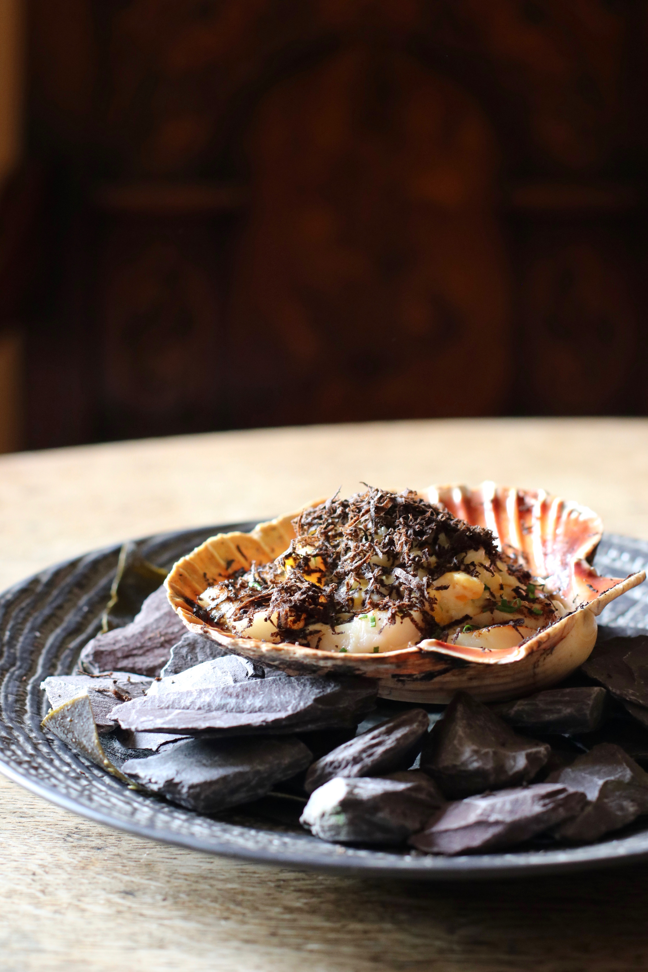

The Freemasons at Wiswell was last night (September 25) named the Restaurant of the Year – England 2017 at the AA Hospitality Awards.

Now in its 20th year, the glittering awards ceremony at the Grosvenor House Hotel celebrates the UK’s top hotels, restaurants, and pubs and the people behind them. It also marks the release of the 2018 editions of the AA’s range of lifestyle guides; the AA Hotel Guide and AA Best Restaurants Guide.

This AA Restaurant of the Year, introduced in 2000, recognises restaurants that provide cuisine of a truly excellent standard. This includes demonstrating innovation and ambience, whilst also providing a high standard of hospitality.

Steven Smith, Chef Owner said:
“I’m not going to go with the cliché, ‘we’re really pleased to have won’ because of course we are. It’s so much more than that. As a pub, we’re here for the long term and this award not only creates a legacy for The Freemasons, it’s a building block from which we plan to move onward and upwards. When I started out over a decade ago, I wanted to stake out a place for myself in this industry and become known for the quality of my dishes and menus. This is a very proud moment for me, Aga and the team, and really puts The Freemasons on the map for foodies across the country, as well as our loyal customers and regular visitors.”

An AA Hotel Inspector said of The Freemasons at Wiswell: “Exciting virtuoso cooking in a relaxed village inn”.

…Ends…

For press enquiries including images and interview availability, please contact:

020 7361 7860
liz.mallett@midaspr.co.uk / zekra.rahman@midaspr.co.uk

Note to Editors

About The Freemasons at Wiswell
Chef Owner Steven Smith and his partner Agnieszka Tyczka took over at The Freemasons over seven years ago. At the time, the pub served traditional pub fayre, including fish and chips, scampi in a basket etc. Over the first few years, Steve and Aga worked tirelessly to build a superb team, both front and back of house, whilst creating a new menu, which used local, seasonal produce and took inspiration from its location. The menu has kept some of the traditional dishes that its long-standing customers expected to see, such as steak and fish and chips, but also launched a tasting menu, alongside an a la carte menu, a vegetarian menu and a Sunday lunch menu.
The last few years have seen the pub rack up accolade after accolade, including the No. 1 pub spot in the Waitrose Good Food Guide, top five in the top 50 Gastropubs, inclusion in The Sunday Times Top 100 Restaurants and The National Restaurant Awards Top 100, and Best Food Pub in the Great British Pub Awards.

8 Vicarage Fold, Wiswell, Clitheroe BB7 9DF

