PRESS RELEASE
Strictly embargoed until 26 September 2017

AA HONOURS PHILIPPE ROSSITER WITH WINNER OF AA LIFETIME ACHIEVEMENT AWARD 2017

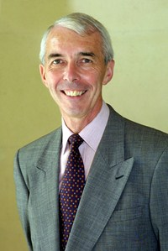

Philippe Rossiter, former Institute of Hospitality Chief Executive, was last night (September 25) awarded the prestigious Lifetime Achievement title at the annual AA Hospitality Awards.

Now in its 20th year, the AA Hospitality Awards at the Grosvenor House Hotel celebrates the UK’s top hotels, restaurants, and pubs and the people behind them. It also marks the release of the 2018 editions of the AA’s range of lifestyle guides; the AA Hotel Guide and AA Best Restaurants Guide.

Philippe Rossiter has continuously been a dedicated member to the hospitality sector and held the post of CEO at the Institute of Hospitality for ten years. He is a devoted individual and to mark his 70th birthday this year ran both the Paris and London marathons. He courageously also made his way on foot from one capital to the other between the two events.
This incredible charity challenge was designed to recognise Rossiter’s French and British origins, whilst also raising money for Hospitality Action and Springboard, two key industry charities.

Andrew Oxley, Head of Hotel & Hospitality Services at The AA said: “Philippe Rossiter’s passion for hospitality has been striking to those who have worked with him for many years and we are delighted to formally recognise long-term contribution to the industry.”

…Ends…
For press enquiries including images and interview availability, please contact:

020 7361 7860
liz.mallett@midaspr.co.uk / zekra.rahman@midaspr.co.uk

