PRESS RELEASE
Strictly embargoed until 26 September 2017

AA HOSPITALITY CROWNS TZVETA IVANOVA ITS HOUSEKEEPER OF THE YEAR 2017

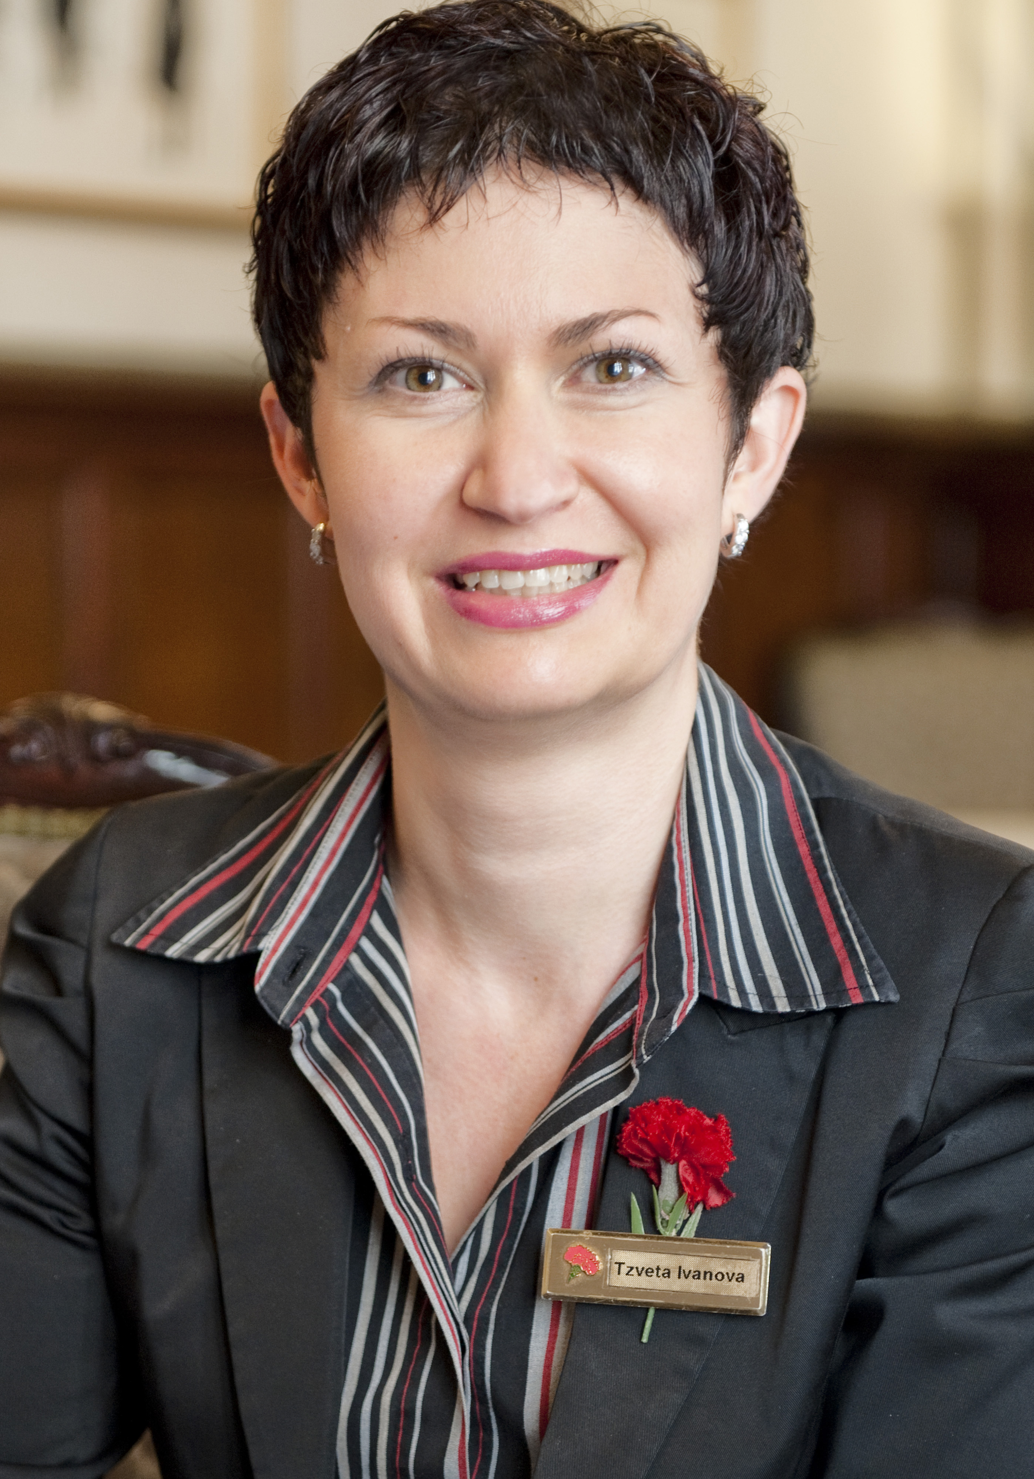

AA Hospitality last night (September 25) crowned Tzveta Ivanova, Executive Head Housekeeper at The Milestone Hotel, Kensington, ‘Housekeeper of the Year 2017’ at its annual awards ceremony.

Now in its 20th year, the AA Hospitality Awards at the Grosvenor House Hotel celebrates the UK’s top hotels, restaurants, and pubs and the people behind them. It also marks the release of the 2018 editions of the AA’s range of lifestyle guides; the AA Hotel Guide and AA Best Restaurants Guide.

The Housekeeper of the Year award recognises outstanding commitment and performance, identifying a Housekeeper who goes above and beyond the call of duty.

Tzveta, who has been The Milestone Hotel’s Executive Housekeeper for the last nine years, studied music at university in her home country of Bulgaria and decided to move to London in 1999. She is responsible for the operational and strategic management of the housekeeping department (around 35 members of staff) as well as an astonishing range of housekeeping duties around the hotel. We estimate that she has made approximately 33,000 beds in her time at the hotel and prides herself of the ‘tiny noticeable touches’ that make a guest’s stay special.

Tzveta said: “Recognition of my staff members and colleagues makes my day. I absolutely love it when guests share with me how fantastic they think we are at our jobs. Reading satisfactory comments on guest comment cards, reviews on TripAdvisor etc it’s just the best feeling in the world knowing you’ve made other people’s holidays something to remember for years to come. The trick of making the perfect bed is ‘well trained and magical hands.”

An AA Hotel Inspector said of Tzveta Ivanova: “Ms Ivanova has clearly demonstrated her passion for the industry, achieving success for the Milestone Hotel and as an individual.”

.
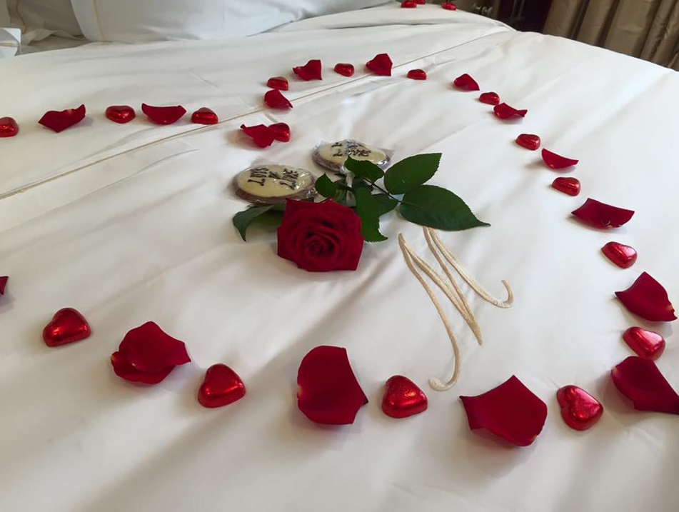
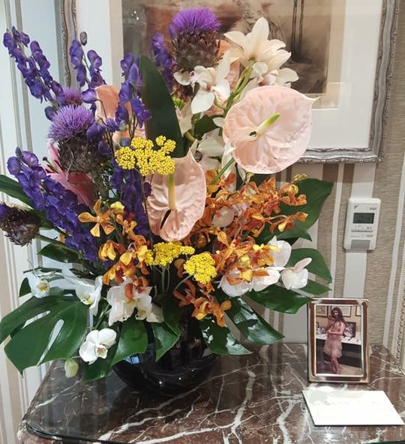
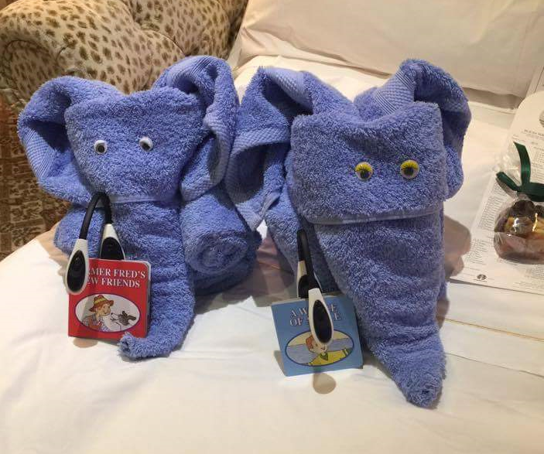

(Above from left: a romantic rose bed decorations for anniversaries; ‘towel elephants’ to make guests smile; a gorgeous flower arrangement. All examples of the ‘tiny noticeable touch’ that make a guest’s stay at the Milestone Hotel special).

…Ends…

For press enquiries including images and interview availability, please contact:

020 7361 7860
liz.mallett@midaspr.co.uk / zekra.rahman@midaspr.co.uk

