PRESS RELEASE
Strictly embargoed until 26 September 2017

From silver screen to going green, Oakley Court wins AA Eco Award 2017

- Electric car charging stations, self-drive boats and complimentary bikes
- Used as a film-set for the Rocky Horror Show and Hammer Horror films
- Attracted a visit from Her Majesty, the Queen.
- ‘Soil to plate’ ethos with ingredients from a 2-acre kitchen garden

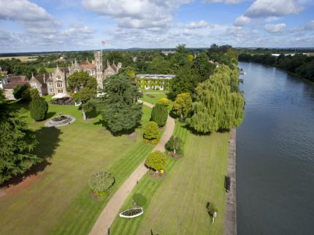
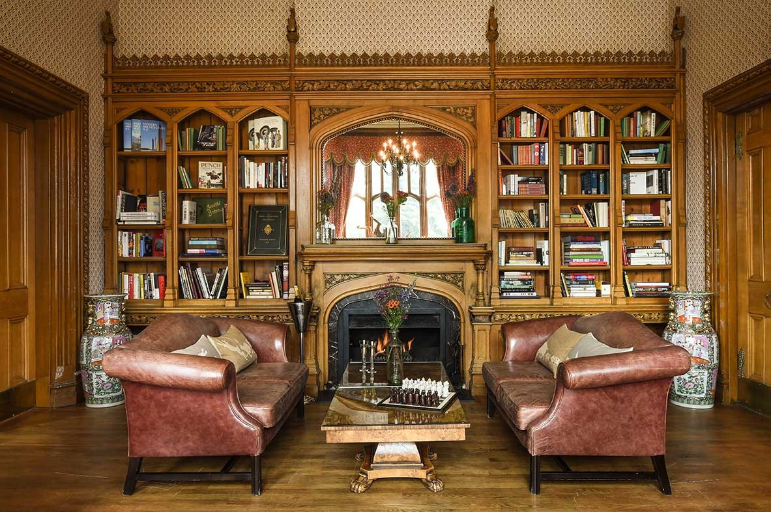
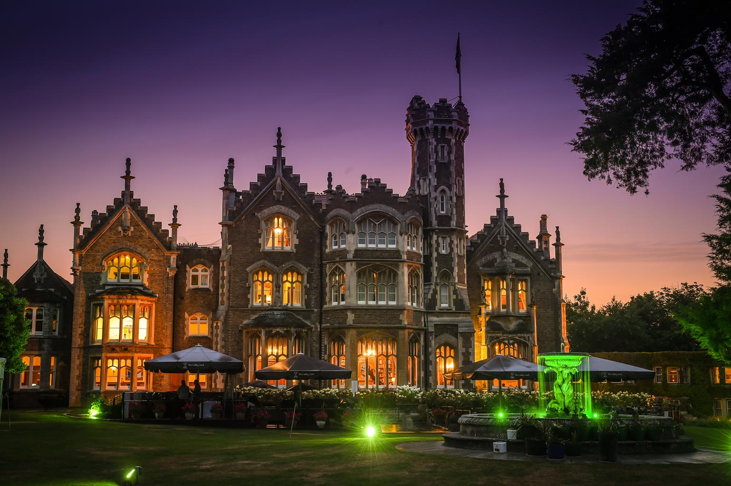

Oakley Court Windsor was last night (September 25) awarded the prestigious title of ‘Eco Hotel of the Year 2017’ at the annual AA Hospitality Awards.

The award-winning hotel offers guests a unique stay in its famous 33-acre grounds, that in addition to the stunning Victorian Gothic architecture of the main building, includes a 2-acre kitchen garden, nature walk, bee hives, smokehouse, complementary bikes and electric self-drive boats. Used as a film-set for the Rocky Horror Show and Hammer Horror films this iconic building is now leading the way for eco-friendly hospitality.

Now in its 20th year, the AA Hospitality Awards at the Grosvenor House Hotel celebrates the UK’s top hotels, restaurants, and pubs and the people behind them. It also marks the release of the 2018 editions of the AA’s range of lifestyle guides; the AA Hotel Guide and AA Best Restaurants Guide.
The Eco Award recognises a clear commitment to sustainability, demonstrated through good practice and policy to make a positive contribution to reducing impact on the environment. Oakley Court’s green ethos ranges from dining to water management, guest activities and nature preservation. Sustainability initiatives include:
- Installation of Windsor’s first CHP unit, which has helped reduce carbon emissions at the hotel by 30%.
- Tesla charging stations for electric cars and provision of electric car hire.
- Electric self-drive boats that allow exploration of the Thames in an eco-friendly way.
- A ‘soil to plate’ ethos where kitchen garden ingredients are served in the awarding-winning restaurant.
- Wildlife preservation and bee-keeping in the hotel’s extensive grounds.
Andrew Oxley, Head of Hotel & Hospitality Services at The AA said: “Oakley Court sets a high standard of eco-conscious luxury which shows respect to its lovely scenic setting and for the environment in general.”

…Ends…

For press enquiries including images and interview availability, please contact:

020 7361 7860
liz.mallett@midaspr.co.uk / zekra.rahman@midaspr.co.uk

Notes to Editors

About The Oakley Court

Built in 1859 this splendid Victorian Gothic mansion is enviably situated in extensive grounds that lead down to the Thames. All bedrooms are spacious, beautifully furnished and many enjoy river views. Extensive public areas include a range of comfortable lounges and the Dining Room Restaurant. The comprehensive leisure facilities include a fully equipped gym, indoor swimming pool, Jacuzzi, sauna, steam room, tennis court, and 9-hole golf course

The Oakley Court, Windsor Road, Water Oakley, Windsor, Berkshire, SL4 5UR

