PRESS RELEASE
Strictly embargoed until 26 September 2017

AA HOSPITALITY CROWNS RITZ CHEF JOHN WILLIAMS MBE CHEF OF THE YEAR 2017

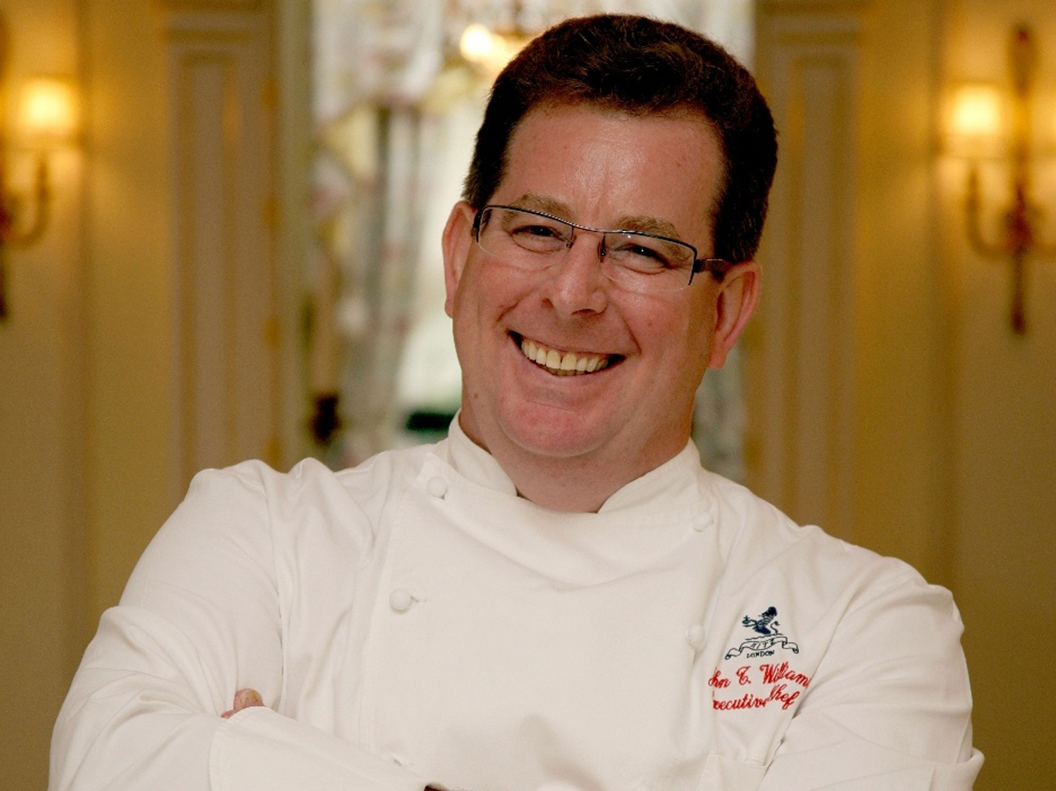

AA Hospitality last night (September 25) crowned John Williams MBE, Executive Chef of the Ritz, its ‘Chef of the Year 2017’ at its annual hospitality awards.

Now in its 20th year, the AA Hospitality Awards at the Grosvenor House Hotel celebrates the UK’s top hotels, restaurants, and pubs and the people behind them. It also marks the release of the 2018 editions of the AA’s range of lifestyle guides; the AA Hotel Guide and AA Best Restaurants Guide.

A popular and coveted title, this unique award offers all AA Rosette-awarded chefs the chance to decide which of their peers deserves the ultimate recognition of their performance over the past twelve months.

John Williams MBE, Executive Chef of the Ritz heads up a team of 64 chefs at the Ritz Restaurant and has been working at the iconic hotel since 2004. Creating dishes that draw upon French cooking and the iconic character of the Ritz, John is in charge of breakfast, lunch, dinner, afternoon tea and room service at the world-famous establishment and is passionate about using seasonal British ingredients.

Andrew Oxley, Head of Hotel & Hospitality Services at The AA said: “John’s remarkable career is an example to anyone who wants to become the very best in the culinary world.”

The son of a fisherman on Tyneside, John began his career in London when not yet 17 at the Royal Garden hotel. By 27, he was premier sous chef with Mario Lesnik at Claridge’s in London, before moving on to the Berkeley and then the Ritz. He is currently also chairman of the Royal Academy of Culinary Arts.

…Ends…
For press enquiries including images and interview availability, please contact:

020 7361 7860
liz.mallett@midaspr.co.uk / zekra.rahman@midaspr.co.uk

