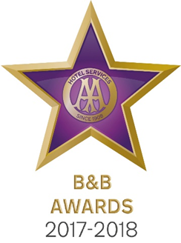

9 May 2017

**UNIQUE KENT B&B CELEBRATES AT AA BED AND BREAKFAST AWARDS 2017**

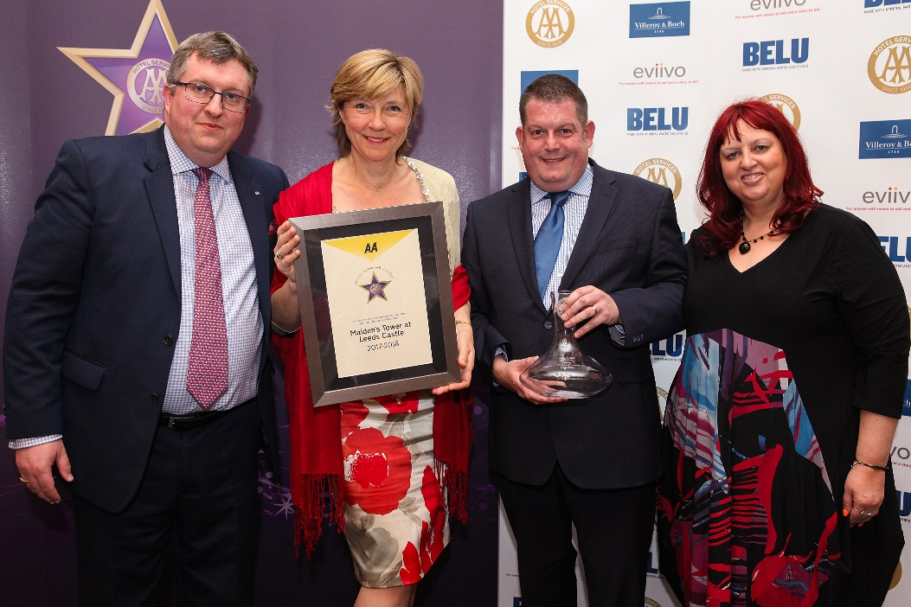

Pictured – Andrew Oxley, AA Hotel Services, Debbie Matthews and Mark Flavell from Maiden’s Tower and Giovanna Grossi, AA Hotel Services

The Great British Bed and Breakfast was celebrated yesterday at the AA B&B Awards 2017. Among the award winners was Maiden’s Tower B&B at Leeds Castle in Kent which was named AA Unique B&B of the Year 2017.

All the winners were nominated by AA Inspectors who inspect and rate over 2000 B&Bs throughout the United Kingdom. The awards, presented at the annual ceremony at the London Landmark Hotel, include guest accommodation for England, Wales, Scotland and Northern Ireland as well as the awards for Unique Bed and Breakfast, Restaurant with Rooms, Friendliest Bed and Breakfast and new for 2017 the B&B Story Award sponsored by eviivo. The winners received their award certificate together with an engraved Villeroy and Boch decanter for all their guests to see.

Guests at Maiden’s Tower get the unique chance to experience being royalty for their stay. The 16th Century stone tower on the Castle Island is surrounded by the tranquil waters of the moat and set within glorious grounds. Each of the five luxury en-suite bedrooms, named after the medieval queens who owned Leeds Castle, are beautifully decorated in period style with stunning views and opulent bathrooms. Guests who stay on a Sunday night are offered a free hawk walk with the Castle Falconers while midweek guests are offered a complimentary punt around the moat giving them a unique angle to view the historic castle.

Debbie Matthews said, ‘I am delighted that Maiden’s Tower has won the title of AA Unique Bed and Breakfast of the Year 2017. The team here are passionate about providing a memorable stay to our guests and this accolade is a testament to their cheerful and polite approach. Whether welcoming guests on arrival, serving them breakfast or looking after the cleanliness of their bedrooms. We could not have asked for more than to know the AA, as a well-beloved institution, recognise our service as being unique and special.’

- Ends -

Media contact Katie Stephens at the AA Press Office on 01256 492895 or [press.office@theaa.com](mailto:press.office@theaa.com).

Photos from the awards ceremony are available on the awards website <http://www.aahospitalityawards.com/image-gallery/2017>

AA Star ratings, from one to five, are used to assess guest accommodation. The following is a brief summary of standards expected from guest accommodation within their ratings.

|  |  |
| --- | --- |
|  | Minimum quality requirements for cleanliness, maintenance, hospitality, facilities and service. A cooked or substantial continental breakfast is served in a dining room or eating area, or bedroom only. |
|  | Courteous service, well-maintained beds, and breakfast prepared with a good level of care. |
|  | A friendly welcome and good-quality, well-presented beds and furniture. A choice of good-quality, freshly cooked food is available at breakfast. |
|  | Attentive, more personalised service. At least half of the bedrooms are ensuite or have private bathrooms. Very good beds and high quality furniture. Breakfast offers a greater choice, and fresh ingredients are cooked and presented with a high level of care. |
|  | Awareness of each guest's needs with nothing being too much trouble. All bedrooms are ensuite or have a private bathroom. Excellent quality beds and furnishings. Breakfast includes specials/home-made items, high quality ingredients, and fresh local produce. |