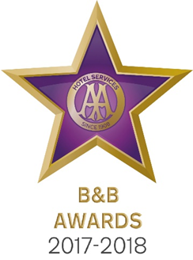

9 May 2017

**LLANSTEFFAN B&B CELEBRATES AT AA BED AND BREAKFAST AWARDS 2017**

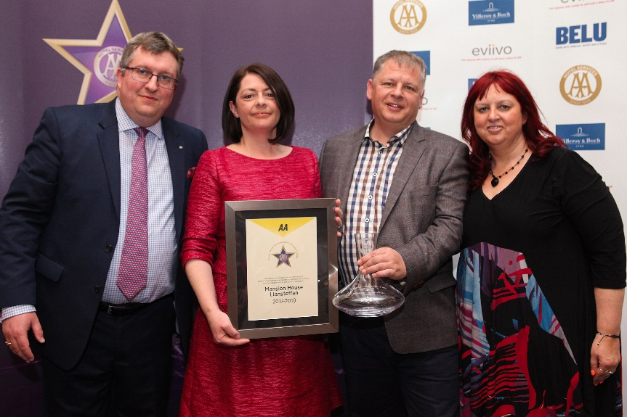

Pictured – Andrew Oxley, AA Hotel Services, Wendy and David Beany from Mansion House and Giovanna Grossi, AA Hotel Services

The Great British Bed and Breakfast was celebrated yesterday at the AA B&B Awards 2017. Among the award winners was David and Wendy Beaney from Mansion House, Llansteffan which was named AA Guest Accommodation of the Year for Wales 2017.

All the winners were nominated by AA Inspectors who inspect and rate over 2000 B&Bs throughout the United Kingdom. The awards, presented at the annual ceremony at the London Landmark Hotel, include guest accommodation for England, Wales, Scotland and Northern Ireland as well as the awards for Unique Bed and Breakfast, Restaurant with Rooms, Friendliest Bed and Breakfast and new for 2017 the B&B Story Award sponsored by eviivo. The winners received their award certificate together with an engraved Villeroy and Boch decanter for all their guests to see.

David and Wendy quite literally fell in love at Mansion House when they had their wedding there 21 years ago. Little did they know that after a 15 years of travelling the world that when they decided to settle back in Wales it would be as owners of their wedding venue. With breath taking views of the Towy Estuary and stunning architecture, Mansion House lends a sense of grandeur to every stay. All rooms have been individually designed to make the most of the original features such as fireplaces, cornicing and tall Georgian windows. Guests not only receive a warm, friendly welcome from hosts David and Wendy, but also benefit from a two AA Rosette restaurant.

David Beaney said, ‘We never imagined, whilst building our business plan on the dining table in Sydney, Australia exactly five years ago, that we would achieve such an accolade in such a short space of time. We have defined strong financial target for ourselves each year and slowly have incorporated realistic professional goals for the team and the business. This award had not even come onto our goal list yet! We are grateful for the support of our strong team of professionals and our wonderful families.’

- Ends -

Media contact Katie Stephens at the AA Press Office on 01256 492895 or [press.office@theaa.com](mailto:press.office@theaa.com).

Photos from the awards ceremony are available on the awards website <http://www.aahospitalityawards.com/image-gallery/2017>

AA Star ratings, from one to five, are used to assess guest accommodation. The following is a brief summary of standards expected from guest accommodation within their ratings.

|  |  |
| --- | --- |
|  | Minimum quality requirements for cleanliness, maintenance, hospitality, facilities and service. A cooked or substantial continental breakfast is served in a dining room or eating area, or bedroom only. |
|  | Courteous service, well-maintained beds, and breakfast prepared with a good level of care. |
|  | A friendly welcome and good-quality, well-presented beds and furniture. A choice of good-quality, freshly cooked food is available at breakfast. |
|  | Attentive, more personalised service. At least half of the bedrooms are ensuite or have private bathrooms. Very good beds and high quality furniture. Breakfast offers a greater choice, and fresh ingredients are cooked and presented with a high level of care. |
|  | Awareness of each guest's needs with nothing being too much trouble. All bedrooms are ensuite or have a private bathroom. Excellent quality beds and furnishings. Breakfast includes specials/home-made items, high quality ingredients, and fresh local produce. |