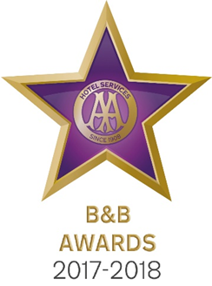

9 May 2017

**POOLEWE B&B CELEBRATES AT AA BED AND BREAKFAST AWARDS 2017**

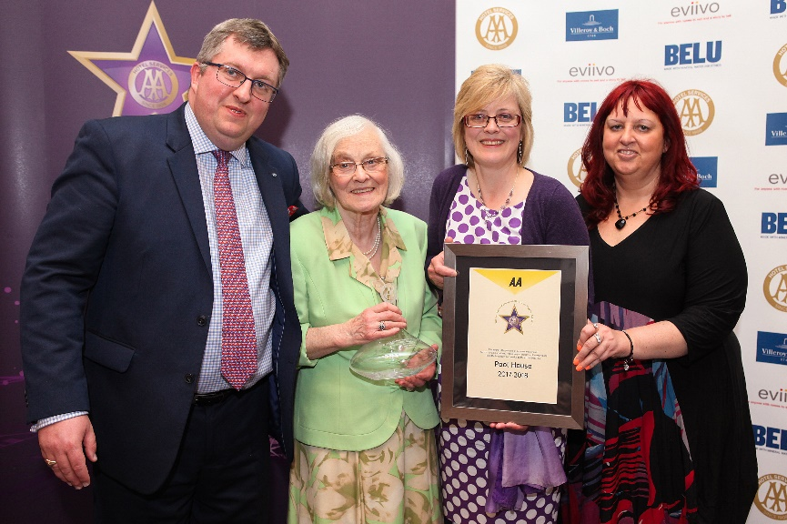

Pictured – Andrew Oxley, AA Hotel Services, Margaret Harrison and Mhairi Harrison-Moir from The Pool House and Giovanna Grossi, AA Hotel Services

The Great British Bed and Breakfast was celebrated yesterday at the AA B&B Awards 2017. Among the award winners was the Harrison family from Pool House in Poolewe which was named AA Guest Accommodation of the Year for Scotland 2017.

All the winners were nominated by AA Inspectors who inspect and rate over 2000 B&Bs throughout the United Kingdom. The awards, presented at the annual ceremony at the London Landmark Hotel, include guest accommodation for England, Wales, Scotland and Northern Ireland as well as the awards for Unique Bed and Breakfast, Restaurant with Rooms, Friendliest Bed and Breakfast and new for 2017 the B&B Story Award sponsored by eviivo. The winners received their award certificate together with an engraved Villeroy and Boch decanter for all their guests to see.

Peter and Margaret Harrison met 58 years ago when they both worked at The Midland Hotel in Manchester. With 60 years of experience in the hospitality industry they are now ably assisted by daughters Elizabeth and Mhairi who both have over 30 years of experience. Pool House is over 300 years old and has been a hunting lodge for the chieftain of the Clan Mackenzie and, during WW2 was the HQ for the Russian Arctic and North Atlantic convoys leaving Loch Ewe. The stunning sea and rivers views from all the guest rooms provide an air of calm and tranquillity for all who stay there.

Peter Harrison said, ‘What a huge surprise the family had when we opened the mail. A cold “dreich” day in Scotland became so much better. The family are delighted to receive this prestigious award and look forward to sharing this fabulous news with our guests.’

- Ends -

Media contact Katie Stephens at the AA Press Office on 01256 492895 or [press.office@theaa.com](mailto:press.office@theaa.com).

Photos from the awards ceremony are available on the awards website <http://www.aahospitalityawards.com/image-gallery/2017>

AA Star ratings, from one to five, are used to assess guest accommodation. The following is a brief summary of standards expected from guest accommodation within their ratings.

|  |  |
| --- | --- |
|  | Minimum quality requirements for cleanliness, maintenance, hospitality, facilities and service. A cooked or substantial continental breakfast is served in a dining room or eating area, or bedroom only. |
|  | Courteous service, well-maintained beds, and breakfast prepared with a good level of care. |
|  | A friendly welcome and good-quality, well-presented beds and furniture. A choice of good-quality, freshly cooked food is available at breakfast. |
|  | Attentive, more personalised service. At least half of the bedrooms are ensuite or have private bathrooms. Very good beds and high quality furniture. Breakfast offers a greater choice, and fresh ingredients are cooked and presented with a high level of care. |
|  | Awareness of each guest's needs with nothing being too much trouble. All bedrooms are ensuite or have a private bathroom. Excellent quality beds and furnishings. Breakfast includes specials/home-made items, high quality ingredients, and fresh local produce. |