

9 May 2017

**COMBER B&B CELEBRATES AT AA BED AND BREAKFAST AWARDS 2017**

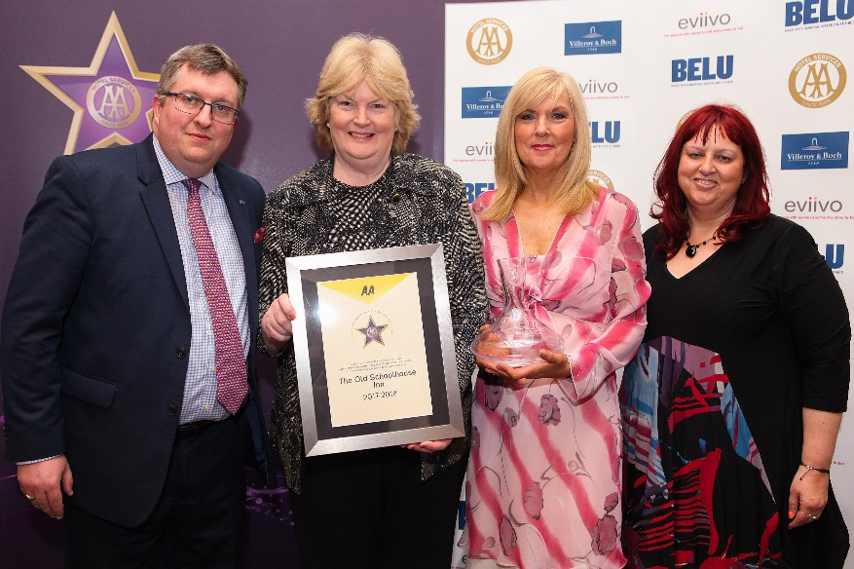

Pictured – Andrew Oxley, AA Hotel Services, Avril Brown and Sharon Alhalab from The Old Schoolhouse and Giovanna Grossi, AA Hotel Services

The Great British Bed and Breakfast was celebrated yesterday at the AA B&B Awards 2017. Among the award winners was Terry and Avril Brown from The Old Schoolhouse Inn in Comber which was named AA Guest Accommodation of the Year for Northern Ireland.

All the winners were nominated by AA Inspectors who inspect and rate over 2000 B&Bs throughout the United Kingdom. The awards, presented at the annual ceremony at the London Landmark Hotel, include guest accommodation for England, Wales, Scotland and Northern Ireland as well as the awards for Unique Bed and Breakfast, Restaurant with Rooms, Friendliest Bed and Breakfast and new for 2017 the B&B Story Award sponsored by eviivo. The winners received their award certificate together with an engraved Villeroy and Boch decanter for all their guests to see.

Terry and Avril Brown purchased the Old Schoolhouse as a school in 1984 and transformed it into a lovely 8 bedroomed Inn. Each of the rooms are named after American Presidents of Ulster descent. Guests not only benefit from the genuine Irish welcome but also Avril’s sumptuous breakfasts including her famous Guinness Wheaten Bread and dinner in the two AA Rosette restaurant run by Avril and Terry’s son Will and his partner Karena. Nothing is too much bother and the team aim to make all guests feel at home during their stay.

Avril said, ‘We are highly elated and delighted to have won this prestigious award.’

- Ends -

Media contact Katie Stephens at the AA Press Office on 01256 492895 or [press.office@theaa.com](mailto:press.office@theaa.com).

Photos from the awards ceremony are available on the awards website <http://www.aahospitalityawards.com/image-gallery/2017>

AA Star ratings, from one to five, are used to assess guest accommodation. The following is a brief summary of standards expected from guest accommodation within their ratings.

|  |  |
| --- | --- |
|  | Minimum quality requirements for cleanliness, maintenance, hospitality, facilities and service. A cooked or substantial continental breakfast is served in a dining room or eating area, or bedroom only. |
|  | Courteous service, well-maintained beds, and breakfast prepared with a good level of care. |
|  | A friendly welcome and good-quality, well-presented beds and furniture. A choice of good-quality, freshly cooked food is available at breakfast. |
|  | Attentive, more personalised service. At least half of the bedrooms are ensuite or have private bathrooms. Very good beds and high quality furniture. Breakfast offers a greater choice, and fresh ingredients are cooked and presented with a high level of care. |
|  | Awareness of each guest's needs with nothing being too much trouble. All bedrooms are ensuite or have a private bathroom. Excellent quality beds and furnishings. Breakfast includes specials/home-made items, high quality ingredients, and fresh local produce. |