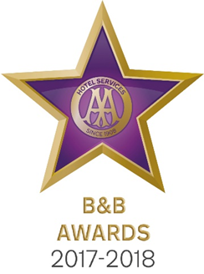

9 May 2017

**LAKE DISTRICT B&B CELEBRATES AT AA BED AND BREAKFAST AWARDS 2017**

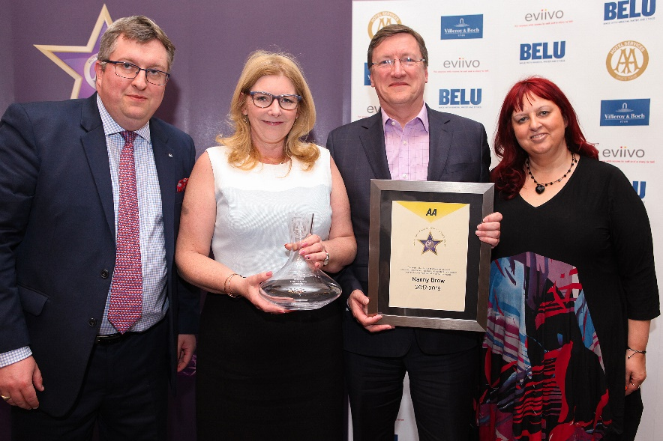

Pictured – Andrew Oxley, AA Hotel Services, Susan and Peter Robinson, Nanny Brow and Giovanna Grossi, AA Hotel Services

The Great British Bed and Breakfast was celebrated yesterday at the AA B&B Awards 2017. Among the award winners was Susan and Peter Robinson from Nanny Brow in Ambleside which was named AA Guest Accommodation of the Year for England.

All the winners were nominated by AA Inspectors who inspect and rate over 2000 B&Bs throughout the United Kingdom. The awards, presented at the annual ceremony at the London Landmark Hotel, include guest accommodation for England, Wales, Scotland and Northern Ireland as well as the awards for Unique Bed and Breakfast, Restaurant with Rooms, Friendliest Bed and Breakfast and new for 2017 the B&B Story Award sponsored by eviivo. The winners received their award certificate together with an engraved Villeroy and Boch decanter for all their guests to see.

Susan and her family moved to Nanny Brow in 2009 and since then, she has worked tirelessly to create an establishment that fully reflects her desire to create a luxurious and peaceful location in the heart of the Lake District. Built in 1904, Nanny Brow is one of the finest Arts and Crafts properties in the area and has been painstakingly refurbished by Susan. The period features are offset by modern luxury with beautiful ensuite bathrooms, sumptuous beds and free wifi. Guests also benefit from award winning breakfasts served in the original dining room.

Set in five acres of grounds, Nanny Brow sits on its own craf with unrivalled views of the Brathay Valley, the hills behind Tarn Hows, Wrynose Pass and the high fells of Langdale. Nanny Brow is a lifelong passion for Sue and nothing is too much trouble for any of her guests.

Susan Robinson said of her award, ‘We are shocked but deeply honoured and thrilled to be held in such high esteem by an organisation such as the AA. I am grateful to my loyal and dedicated staff who have worked so hard over the years and without whom we wouldn’t be receiving this award.’

- Ends -

Media contact Katie Stephens at the AA Press Office on 01256 492895 or [press.office@theaa.com](mailto:press.office@theaa.com).

Photos from the awards ceremony are available on the awards website <http://www.aahospitalityawards.com/image-gallery/2017>

AA Star ratings, from one to five, are used to assess guest accommodation. The following is a brief summary of standards expected from guest accommodation within their ratings.

|  |  |
| --- | --- |
|  | Minimum quality requirements for cleanliness, maintenance, hospitality, facilities and service. A cooked or substantial continental breakfast is served in a dining room or eating area, or bedroom only. |
|  | Courteous service, well-maintained beds, and breakfast prepared with a good level of care. |
|  | A friendly welcome and good-quality, well-presented beds and furniture. A choice of good-quality, freshly cooked food is available at breakfast. |
|  | Attentive, more personalised service. At least half of the bedrooms are ensuite or have private bathrooms. Very good beds and high quality furniture. Breakfast offers a greater choice, and fresh ingredients are cooked and presented with a high level of care. |
|  | Awareness of each guest's needs with nothing being too much trouble. All bedrooms are ensuite or have a private bathroom. Excellent quality beds and furnishings. Breakfast includes specials/home-made items, high quality ingredients, and fresh local produce. |