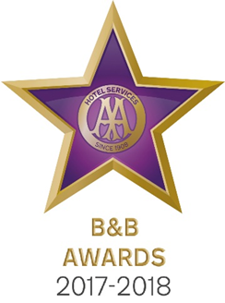

9 May 2017

**ISLE OF ISLAY B&B NAMED AA FRIENDLIEST BED AND BREAKFAST 2017**

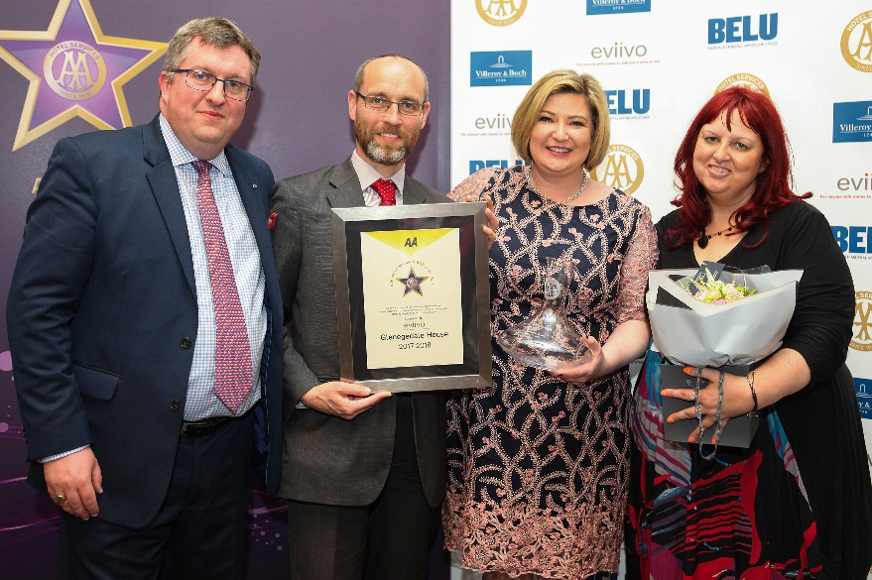

Pictured – Andrew Oxley, AA Hotel Services, Ian Hardwick from eviivo, Emma Clark from Gelegedale House and Giovanna Grossi, AA Hotel Services

An Isle of Islay B&B has been named the AA’s Friendliest Bed and Breakfast for 2017 sponsored by evivvo. Graeme and Emma Clark from Glenegedale House in Glenegedale collected their award yesterday at the AA Bed and Breakfast Awards in London. The Clarks triumphed over the 23 other finalists to win the coveted title.

All the winners were nominated by AA Inspectors who inspect and rate over 2000 B&Bs throughout the United Kingdom. The awards, presented at the annual ceremony at the London Landmark Hotel, include guest accommodation for England, Wales, Scotland and Northern Ireland as well as the awards for Unique Bed and Breakfast, Restaurant with Rooms, Friendliest Bed and Breakfast and new for 2017 the B&B Story Award sponsored by eviivo. The winners received their award certificate together with an engraved Villeroy and Boch decanter for all their guests to see.

Graeme and Emma strive to ensure every guest’s stay at Glenegedale House is the best they have ever had. The individually designed, sumptuous bedrooms all have flat screen TVs, beautiful Egyptian cotton bedding and luxurious white fluffy towels. Guests can relax in the morning room or sitting room and marvel at the stunning views over the Mull of Oa and the Atlantic Ocean. Graeme and Emma are on hand to offer advice on planning days out to make the most of the wonderful Isle of Islay. With award winning breakfasts using locally sourced ingredients guests are truly set up for their day exploring the stunning countryside.

Emma Clark said, ‘We are thrilled and honoured to have our commitment to the service of our guests recognised by such a prestigious award ceremony.’

- Ends -

Media contact Katie Stephens at the AA Press Office on 01256 492895 or [press.office@theaa.com](mailto:press.office@theaa.com).

Photos from the awards ceremony are available on the awards website <http://www.aahospitalityawards.com/image-gallery/2017>

AA Star ratings, from one to five, are used to assess guest accommodation. The following is a brief summary of standards expected from guest accommodation within their ratings.

|  |  |
| --- | --- |
|  | Minimum quality requirements for cleanliness, maintenance, hospitality, facilities and service. A cooked or substantial continental breakfast is served in a dining room or eating area, or bedroom only. |
|  | Courteous service, well-maintained beds, and breakfast prepared with a good level of care. |
|  | A friendly welcome and good-quality, well-presented beds and furniture. A choice of good-quality, freshly cooked food is available at breakfast. |
|  | Attentive, more personalised service. At least half of the bedrooms are ensuite or have private bathrooms. Very good beds and high quality furniture. Breakfast offers a greater choice, and fresh ingredients are cooked and presented with a high level of care. |
|  | Awareness of each guest's needs with nothing being too much trouble. All bedrooms are ensuite or have a private bathroom. Excellent quality beds and furnishings. Breakfast includes specials/home-made items, high quality ingredients, and fresh local produce. |